2.4.01 Offer
The Offer form implements offer preparation for a selected project or sub-project. An offer can only be prepared for external projects. This form consists of information about the offer amount, the person preparing the offer, the offer date and the corresponding offer position.
Tip: For more on this subject see chapter 4.4.01 Offer recording.
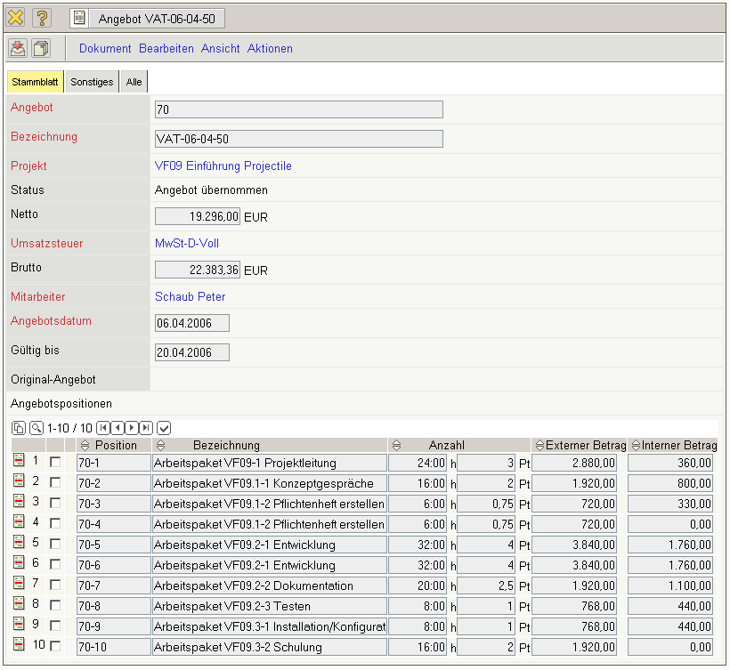
The form consists of the following elements:
On the “Main Data” tab:
- Offer: This numerical field assigns a unique identification number to the offer header, which is automatically suggested from the system.
- Description: This alphanumerical field specifies the offer header and is used for printing the offer forms.
- Project: In this field the project is selected, for which an offer will be prepared. Projects can be defined and modified in the project form. An offer can only be prepared for an external project.
- Status: This field is determined from the system and defines the status of the offer, through the actions using the action function. After creating a new offer, this offer is designated the status “No Offer”, when finalising the offer “Offer Included”, and after cancellation, “Offer Cancelled”.
- Net: In this field the net amount of the offer position is automatically entered by the system.
- Value-Added Tax: In this field the valid value-added tax for this offer is entered with the select menu. By default, this field is pre-occupied with the valid value-added tax to which the assigned country in the configuration form is effective. The value-added tax can be defined and modified in the value-added tax form.
- Offer Total: In this field the total amount of the offer position is automatically entered by the system.
- Employee: In this field the person who prepared the offer can be selected. Employees can be administered in the employee form.
- Offer Date: This field specifies the date of the offer preparation. By default, the current date is pre-occupied from the system.
- Valid until: This field specifies up to which date the offer is valid.
- Original Offer: This document link links, if applicable, to the old “cancelled” offer, when the action “Create New Offer out of Cancellation” is used.
- Offer Positions: This element consists of a list of all assigned offer positions.
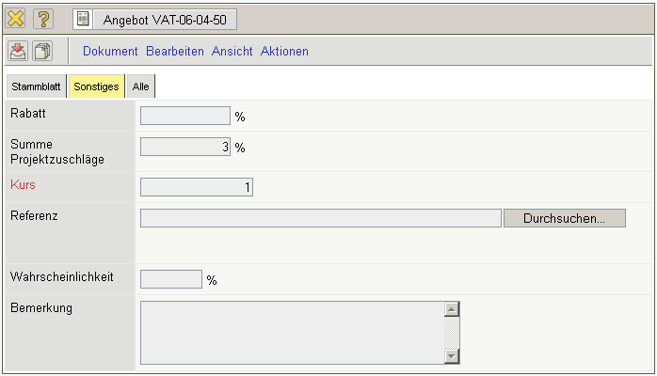
On the “Misc” tab:
- Discount: This field is used as a default, when a discount position should be generated. The discount can be stored in Customer (document type contact), is inherited to the project of the customer and is included when the invoice is issued.
- Project Surcharge Sum: This field is taken from the calculation of the project (“Budget” tab) and is compiled from the three stored surscharges. These surcharges can be used for additional charging to the offer.
- Rate: In this field the rate for the local currency is defined here. The rate is preselected from the system and can be modified for the appropriate general conditions.
- Reference: The files corresponding to the offer can be attached here.
- Offer Probability: This field is used for storing the offer probability (regarding the offer acceptance) and can be used for the order evaluation charts.
- Comments: This field is designated for comments regarding an offer.
The document type consists of the following actions:
- Include Jobs: Using this action, all jobs assigned to the defined offer are displayed. After confirming the action, the document jobs including all jobs from the selected projects is opened. After selecting the jobs, these are included to the offer as offer positions.
- Include Budget Items: Using this action, all budget items for the defined offer are displayed. After confirming the action, the document budget, including all the items of the selected project is opened.
After selecting the data, this data is included in the offer as offer positions.
- Include External Services: USing this action, all from the system defined external services are displayed. After confirming the action the document external services including all entries, are opened. After selecting the data, this data is included in the offer as offer positions.
- Print Offer (grouping dialogue) and/or Print Form Letter Data Source: Using this action, the complete offer can be generated as an html page or in RTF format. This generated document can be printed from the browser or through a standard text editor. Alternatively, serial letter functionality can also be used (not included in the standard version).
- Finalise Offer: Using this action, the offer can be transfered into the system. This action then assigns the “Offer Included” status. Note: For each project only one valid offer can be defined.
- Cancel Offer: Using this action, the offer can be “cancelled”. If faulty data is entered or if an offer is not or only partially accepted from the customer, this function can be used to define the offer as invalid. Using the action, “New Offer out of Cancellation” a new offer using this offer as a basis, can be created.
- Delete Offer: Using this action, the cancelled offers can be deleted. Warning: All corresponding offer positions will also be deleted.
- New Offer out of Cancellation: Using this action, a new offer with identical structure as the cancelled offers can be created. This offer can also,if applicalbe, be modified and transfered anew.
- New Invoice out of Offer: Using this action, an invoice can be directly generated through the offer. This invoice contains identical positions an can be modified from the user.
- Remove Link to Original: This functionality deletes the link to the original document, if the offer is created as a copy of a “cancelled” offer.
- Generate Discount Position : This action generates an offer position for the stored percentile discount value. Based on the total amount of the offer, the appropriate discount amount is displayed as negative in the position and is therefore deducted.
- Add Discount to all Positions: This action sets the specified percentile discount value in the individual offer positions and reduces the external amount of the position to this value.
- Generate New Confirmation: This action generates an offer confirmation from the transfered offer. All positions from the offer are transfered to the offer confirmation.

