2.03.08 Status Report
Using the Status Report form allows evaluating a project at any given time. These subjective and/or qualitative characteristics are exchanged through quantitative key figures automatically for reporting. Using the information of this form and the evaluation system, an rtf-file is produced, which consists of information about the evaluation and decision demand, time/effort and cost information and Earned-Value-Analysis.
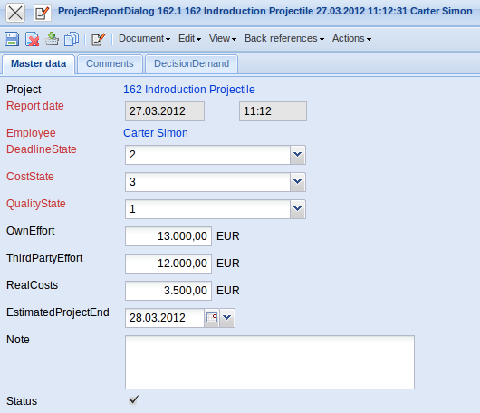
The form consists of the following elements:
On the “Master Data” tab:
- Number: This alphanumerical field specifies the status report distinctly in the system.
- Project: This field defines the project, to which the defined process belongs. A process can be assigned to a parent project as well as a sub-project. The projects can be defined and modified in the project form.
- Report Date: The field report date specifies the date and time of the status report. By default, the current date is pre-occupied from the system.
- Employee: The employee responsible for the status report is pre-occupied here. The employees are administered in the Employee form.
- Deadline Status : The deadline status of the project is entered here from the user. In the standard the status 0 - Favorable, 1- Scheduled, 2 - Problematic und 3 - Critical are stored. The status can be defined and modified in Collections (ProjectReportStates).
- Cost Status: The cost status of the project is entered here from the user. In the standard the status 0 - Favorable, 1- Scheduled, 2 - Problematic und 3 - Critical are stored. The status can be defined and modified in Collections (ProjectReportStates).
- Quality Status: The quality status of the project is entered here from the user. In the standard the status 0 - Favorable, 1- Scheduled, 2 - Problematic und 3 - Critical are stored. The status can be defined and modified in Collections (ProjectReportStates).
- Internal Service Rest: The presumable remaining costs for internal services for the project are stored as forecast here.
- External Service Rest: The presumable remaining costs for external services for the project are stored as forecast here.
- Real Costs Rest: The presumable remaining costs for real costs for the project are stored as forecast here.
- Estimated Project End : The presumable end deadkine of the project is stored here.
- Comments: This field is designated for comments concerning the status report.
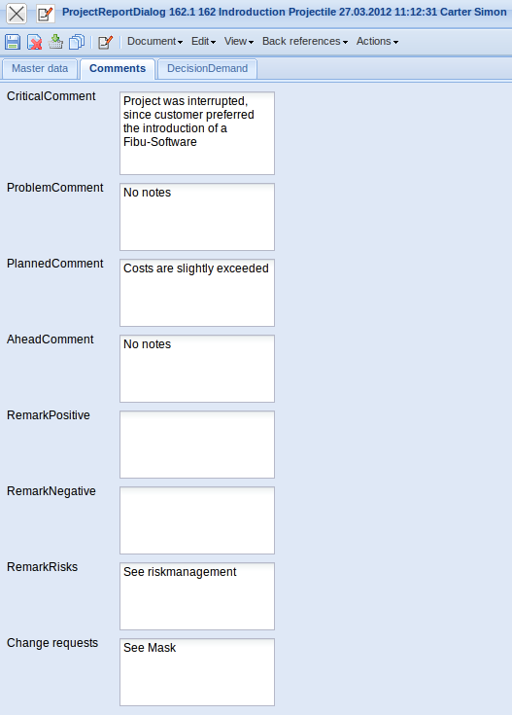
On the “Comments” tab:
- Comments - Critical, Problematic, Scheduled and Favorable: If applicable, comments concerning the status messages deadlines, cost and quality (see Master data) are stored. .
- Positive and Negative Remarks: Positive und negative remarks for the progress of the project can be stored here.
- Critical Factors/Risks: Critical factors and/or risks for the progress of the project can be stored here. The risk management module is a further possibility to administer risks for the project.
- Change Requests: Change requests for the project can be stored here. The project change form offers a further possibility to store change request for the project.
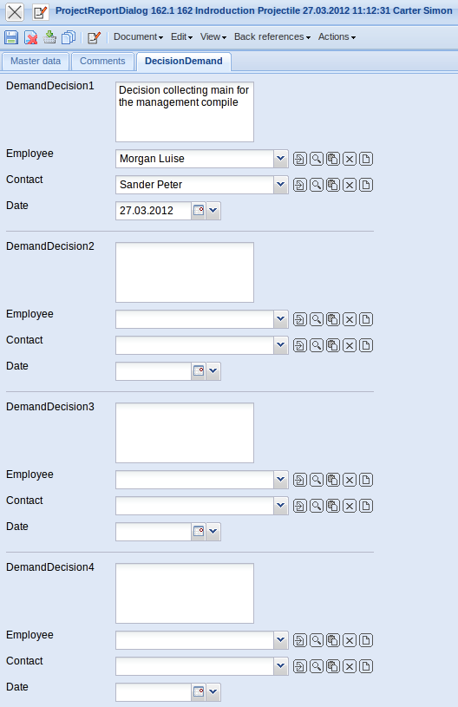
On the “Decision Demand” tab:
- Demand Decision (1 bis 3): The decision demand for the project can be stored here.
- Employees (1 bis 3): The employees responsible for the decision demand can be stored here.
- Date (1 bis 3): The due date for the decision can be stored here.
The form consists of the following action:
- Print Status Report: Using this action, a complete status report can be generated in rtf-format. The created document can be printed through the browser or in a standard text editor.

