2.03.07 Item Sheet
Using the item sheet form, project-related invoicing/charging of external services and/or items are possible. The amount of defined external services (for example, items or licenses) in the the Main Data module are assigned to a project. The sales price is pre-occupied with the suggested retail price of the item and the appropriate total price is displayed.
Tip: For more on this subject see chapter 4.09.01 Item Sheet Recording.
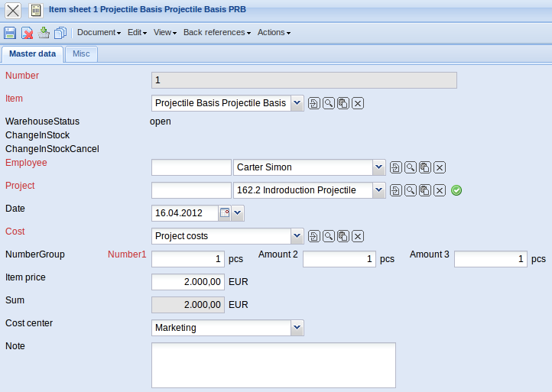
The document type consists of the following elements:
On the “Master data” tab:
- Number: This numerical field specifies distinctly the external costs. This number is suggested from the system.
- External Services: This alphanumerical field specifies the external services, which are billed project-ralated. These external services are administered in the external services form.
- Employee: In this field, the employee who recorded the data record for the external service is selected. By default, this field is pre-occupied with the employee, who has logged on to the system. Employees can be administered in the Employee form.
- Project: The field Project specifies the project, to which the external costs are assigned. Projects can be defined and modified in the Project form.
- Date: This field describes the date of the charges (Weiterbelastung). This entry is automatically performed through the system.
- Cost: This field specifies the cost type for the external service. The cost type can be defined and modified in the Cost Type form.
- Amount: This field specifies the amount of items and/or external services are billed for this project.
- Net: In this field, the sales price per item or external service is defined. This field is pre-occupied with the suggested retail price of the external service.
- Total costs: This field specifies the total amount of the external costs (the results of the amount multiplied with the sales price).
- Comments: This field is designated for comments.
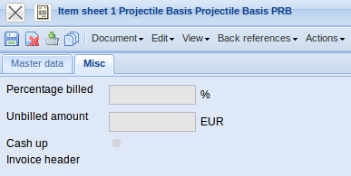
On the “Misc” tab:
- Percentage billed: In this field the percentage of the complete billed invoice is displayed.
- Unbilled amount: In this field the amount remained to be billed is displayed.
- Cash up: This element specifies, if the external costs are already billed. This box is automatically set, when the external costs are transfered to an invoice and this invoice has been billed.
- Invoice Header: Here the appropriate invoice can be accessed through a link.

