2.3.05 Trips
Using the trip form, project-related trips and their costs, which the driver of an automobile in the scope of the project has caused, can be recorded. The trip costs can be assigned through selecting an already recorded trip through the identification of this trip and are also displayed with their corresponding cost type in the document type travel. Generally, it is possible to determine the trip costs through km-flat rates (distance from mileage in km-old and km-new), through the billing type hours (the difference from trip begin and trip end) or a combination of both. The appropriate rates are stored in the configuration form.
Tip: For more on this subject see chapter 4.3.03 Travelcost recording.
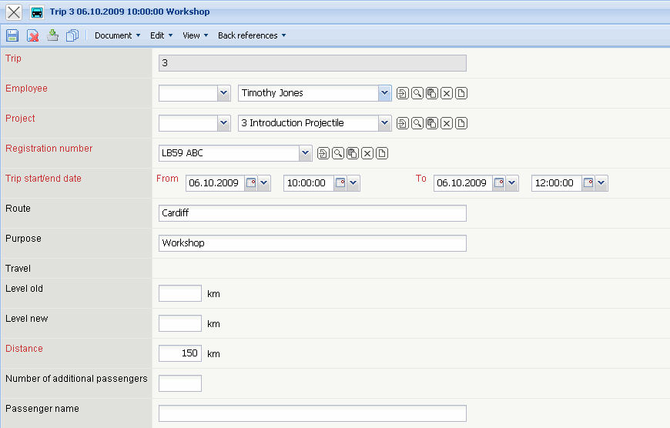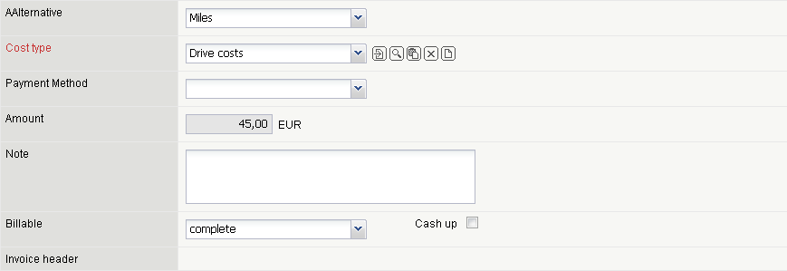
The form consists of the following elements:
- Trip: This numerical field specifies the trip destinctly through an identification number, which is automatically suggested from the system.
- Employee: The driver or person who created the driver's logbook is defined in this field. The displayed selection menu can be defined and modified in the Employee form.
- Project: The field project specifies the project, to which the trip is assigned. Projects can be defined and modified in the Project form.
- Vehicle: In this field an automobile is assigned to a trip. Automobiles can be defined and modified in the Vehicles form.
- Start: This field specifies the date and the time of the beginning of the trip.
- End: This field specifies the date and the time of the end of the trip.
- Route: Using this field, entering information for the driving route is possible and must be filled out if the travel costs are used as a tax statement or as as a driver's logbook.
- Purpose Using this field, entering information for the prurpose of the trip is possible and must be filled out if the travel costs are used as a tax statement or as as a driver's logbook.
- Travel This field specifies a trip, to which the tour can be assigned. All trips are displayed, which were recorded to the selected project. A trip can be defined in the Trip form.
- Old Mileage in km (Level): This field specifies the mileage in kilometer for the selected vehicle before the trip begin.
- New Mileage in km (Level): This field specifies the mileage in kilometer for the selected vehicle after the end of the trip.
- Distance: This field specifies the driven distance. This difference can be calculated through the fields old mileage in km and new mileage in km or can be directly determined in the field.
- Billing Method This field specifies the billing method of the trip costs. If km is selected for the invoice, the trip costs (internal/external) are calculated through the traveled distance multiplied with the stored km-flat rates in the configuration form. If hours are entered for the invoice, the trip costs (internal/external) are calculated using the time interval through trip begin and trip end, multiplied with the hourly rates stored in the configuration form. If both km and hours are selected for the invoice, both billing methods are added together.
- Cost Type: This field specifies the type of costs for the trip. The types of cost can be defined and modified in the Cost Type form. The cost type is also used as criteria for the target/performance comparison in the invoicing chart.
- Payment Method: This flag determines if the company of employee prepaid the cost for the trip.
- Amount: This field contains the internal costs for the selected trip. These costs are determined (if the box km-flat rate is checked) through the km-difference and the km-flat rate or otherwise through the difference of the hours and the travel hourly rates. These flat rates are stored in the configuration form.
- Comments: This field is designated for comments.
- Billed This element specifies if the trip is already billed. This check box is automatically set from the system, when the trip in transfered to an invoice and this invoice is billed.

