2.3.03 Travel
The Travel form is used for recording project-related business trips for an employee in the frame of a certain project. The daily benefits flat rates of the employees are calculated from the travel duration (difference from travel begin and travel end) and considering the daily benefits allowances and travel allowances. The amount entered from the receipts and traveling costs can also be assigned. Also, the meal posts for overnight stays are considered.
Tip: For more on this subject see chapter 4.3.02 Travelcost recording.
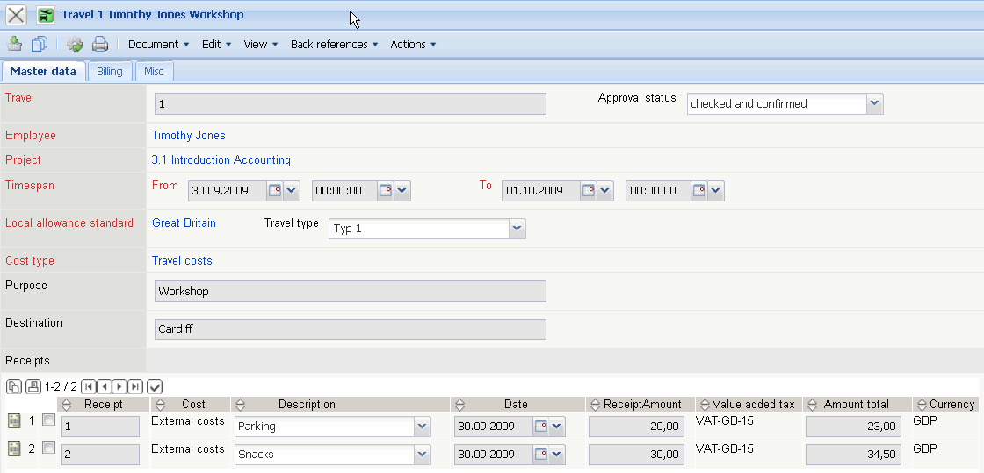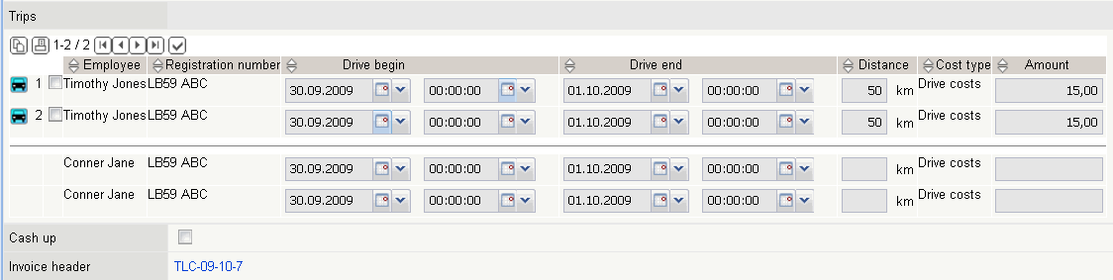
The document type consists of the following elements:
On the “Master Data” tab:
- Travel: This field specifies the business trip distinctly in the system.
- Employee: This field assigns the trip to the employee who caused the travel costs. Employees can be administered in the employee form.
- Project: This field specifies the project, to which the trip is assigned. Projects can be defined and modified in the project form.
- Start: This field specifies the starting time and starting date of the trip.
- End: This field specifies the end date and the end time of the trip. The difference between the starting and ending date determines the daily benefits for the employee.
- Local Allowance Standard: In this field the valid flat rates for the trip can be selected. The daily benefits and overnight flat rates effective by law can be defined and modified in the Flat Rate form.
- Travel Cost Type: The travel cost types from the trip are assigned here. These types are used for taxation of the travel costs (for example, no tax benefits are granted for working for a customer longer than three months).
- Cost Type: This field specifies the cost type of the trip. The cost types can be defined and modified in the cost type form. The cost type is also used as criteria for the target/performance comparison in the invoice chart.
- Method of Payment: This flag determines if the company or the employee prepaid the costs of the trip.
- Purpose: In this field the purpose of the trip in entered. This entry is needed for travel expense accounting.
- Travel Destination This field specifies the travel destination. This entry is needed for travel expense accounting.
- Flat rates: This field displays the amount for the daily benefits and overnight flat rates. If applicable, the meal post “breakfast in hotel” is deducted here.
- Driving Expenses: This field displays the amount of the driving expenses for the defined trip.
- Travel Expenses: This field displays the amount of the travel costs (overnight stays, service, ... ) for the defined trip.
- Total Costs: The field total costs shows an overview of the sum of all (internal) individual costs for the trip. This field is composed of the addition of the costs for flat rates, driving and travel costs.
- Trips: This element consists of a list of all assigned tours for the trip (see also Trip form).
- Receipts: This element consists of a list of all assigned receipts for the trip (see also Receipt form).
- Cash up: This element specifies, if the trip is already balanced. This flag is automatically set from the system when the trip has been transfered to an invoice and this invoice is billed.
- Inspection Status: This status field is needed to test the workflow. The status transfers are set during the testing phase (not tested, test requested , tested and confirmed, ...).
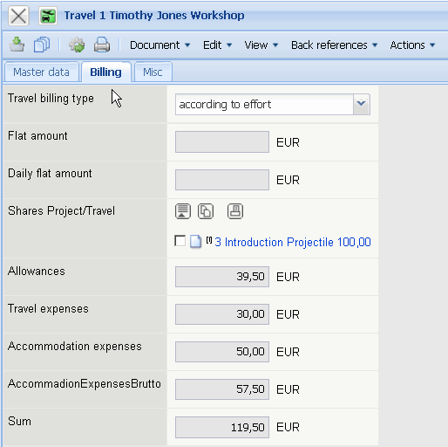
On the “Billing” tab:
- Type of travel expenses, Allowances: The rules for billing the trip for the project can be stored here (no billing, allowance, by time/effort). The corresponding pre-selection can be stored in the project.
- Dividing Trip/Project: This field is used for assigning a trip to several projects. This assignment occurs only percentile.
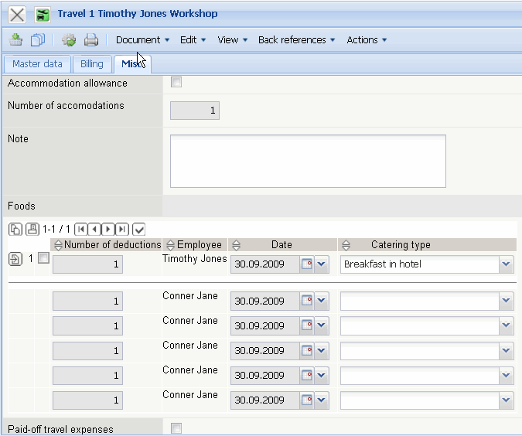
On the “Misc” tab:
- Accommodation Allowance: This field is activated if the accommodation costs are calculated using the allowance for the overnight stay are taken from the Flat Rate form, when billing travel costs.
- Number of Accommodations : If the trip is billed using the accommodation allowance, the number of overnight stays are defined here. This number is pre-selected from the system using the daily difference from the trip begin and the trip end and is, if applicable, modified.
- Number of Passengers : This field specifies the number of passengers for the trip. Extended km-flat rates can be granted (see also Configuration) for trips when using an automobile.
- Passengers: This field specifies the passenger who are entered by name.
- Comments: This field is designated for comments concerning the trip.
- Meals: This element contains a list of all corresponding meals for the trip. These meals are used when meals are included in the hotel costs or with business meals, which should be deducted as monetary benefits (see also Configuration) .
The document type consists of the following actions:
- Request Travel Information: This action initiates the inspection workflow for trips.
- Set inspection status: With this action the inspection status can be set manually.
- Travel Cost Billing : Using the action complete travel cost report can be generated from the system. This document is based on a rtf-template and can be modified in a standard text editor.

