2.3.02 Working Times/Absences
This form is used for recording the working times and absenteeism for the defined date through entering the duration of a certain occupation type. With this document type, the working times can still be recorded, if the time recording of a project employee was not used or if absenteeism, as illness or vacation, must still be recorded. In the fast entry, longer absenteeism (for example, several weeks of vacation) can be recorded.
Tip: For more on this subject see chapter 4.3.06 Present/Absent recording.
Note: Alternatively, the absences vacation and illness can be entered in absence recording.
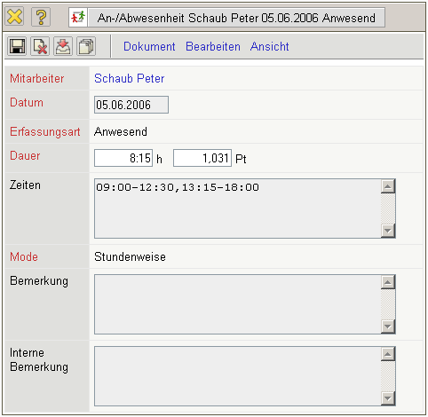
The form consists of the following elements:
- Employee: When selecting an employee working time or absenteeism is distinctly assigned to the employee. Employees can be defined in the employee menu.
- Date: This field specifies the date, to which the working times or absenteeism should be recorded. Generally this field is pre-occupied with the current date.
- Type of Entry: This field defines the type of absenteeism which is to be recorded. In the standard version, either vacation or illness can be selected. Further absenteeism, as a business trip, vocational school or maternity leave can be defined from the administrator in Collections.
- Duration: This field specifies the daily working time or the daily absenteeism of the employee.
- Times: This field defines the from-to times (if the entry in TimeTracker has been recorded).
- Mode: This element is used, when data recording in TimeTacker, considering the configuration for defining absences (either on an hourly basis or only whole and partial days).
- Comments and Internal Comments: These fields are designated for two type of comments. The comment is used for several standard analyses.
The document type consist of the following action:
- Quick Entry (in Recording Mode): With this action longer absences (vacation or illness) can be recorded in a block.

