2.03.01 TimeTracker
The TimeTracker processes time recording for the work and project times. In TimeTracker, all jobs for the project employee are listed, which are not yet closed and for which the employee is responsible. In this component, absences/leave (vacation, illness, ...) and estimations (remaining time/effort and/or degree of completion) can be recorded. A further possibility is the notification of a completed task.
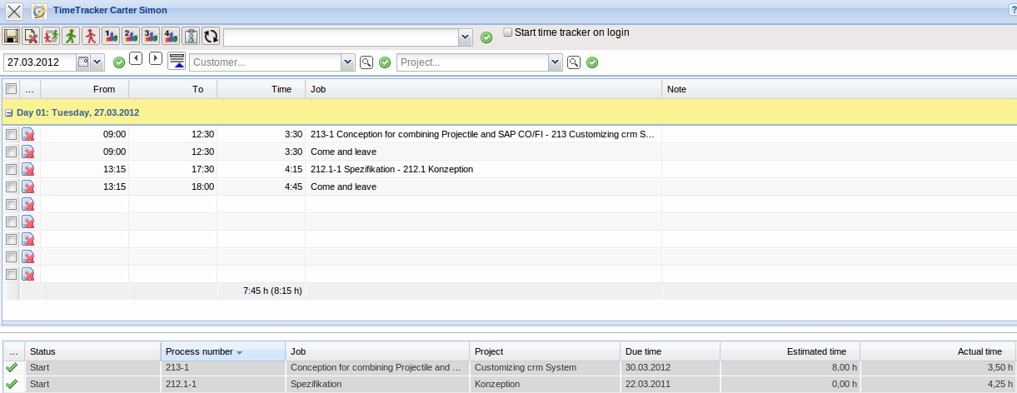
The upper area of the TimeTracker is used for tabular recording of the daily working time and/or the project working time. “arrival” times and “leaving” times and the work services (also times for jobs) are recorded. Either a time interval or the duration of the interval must be entered in order to record the time. After entering the times, a job or “arriving”/“leaving” is selected and is confirmed with the save button. The upper area consists of the following buttons:
- Saving: The entered data is saved using this button.
- Arriving and Leaving: Arriving and leaving times are recorded with this button. When clicking this button the work interval is produced from the earliest and latest time entry.
- Arriving: Arriving times are recorded with this button. When clicking this button, the current date in the system is used as the start date for working time recording.
- Leaving: Leaving times are recorded with this button. When clicking this button, the current date in the system is used as the end date for working time recording.
- Analysis Chart: Using these buttons ( ,, ...) outputs a personalized chart related to the recorded time entries for the logged on user. The administrator can integrate maximum three analyses charts in the TimeTracker (see also administration Guide).
- Create Job: Using this button a new job can be created through the TimeTracker. Times can be immediately recorded here.
- Refresh: Using this button reloads the contents of the TimeTracker.
Using the date selection box directly below, it is possible to record times for other days. The displayed jobs can be filtered through a certain project or contact with the filter menu.
The lower area of the TimeTracker is used for time recording from the job times with stopwatch functionality and can be used as a to-do list (the illustration above is an example configuration).
- Number: This column specifies the job number. Clicking the sorting symbol (arrows) sorts the jobs with the number, either ascending or descending. This functionality is available for every column in this area.
- Job: This column specifies the jobs with, if applicable, a link to the jobs.
- Project: This column specifies the project to which the job belongs.
- Customer: This column specifies the customer of the job.
- Due Date: This column specifies the due date of the job. Due date is the date of the planned end of the job.
- Planned Time: This column specifies the duration of the job.
- Actual Time: This column specifies the complete time of the job.
- Completion: The degree of completion for the job can be estimated in this column. After saving this value, the system automatically determines the remaining time/effort in hours.
- Rest[h]: The remaining time/effort for the job can be estimated in this column. After saving this value, the system automatically determines the degree of completion.

