2.13 Knowledge and Information Management System "Infomarket"
Projectile contains optionally a web-based information system for knowledge management. Every user can enter and add information and/or articles in the infomarket. For regular usage the system does not need moderators or editors.
The infomarket can be accessed through the search form, which also displays the favorite and newest information. Either, information can be linked to or a term can be entered into the search machine.
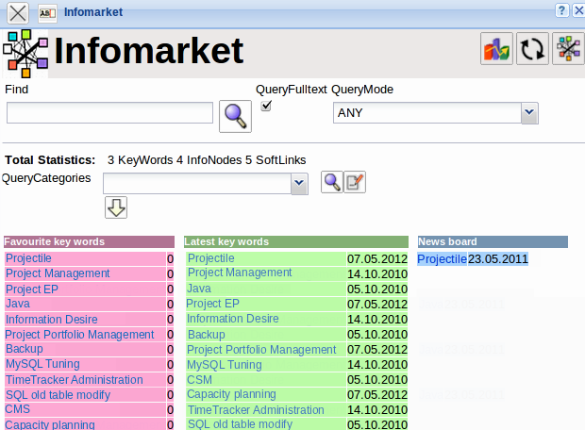
In the following example, all direct and indirect information regarding Projectile is listed. The information becomes the basis for “knowledge” through connections. Infomarket has hard link and soft link connections.
In the example above, the words project management and Information Desire are hard links, which either link to another entry in infomarket or request another user to contribute information to this entry. The URL (www.infodesire.com) and the link to a Projectile document (Project EP) are hard links as well, and do not reference to direct information in infomarket, but to a homepage and a project document in the system.
The terms on the right side (Project EP, Project Portfolio Management, Project Management, Information Desire) are soft links and specify information, which were called from the current entry. As with the human brain, connections which are used more often are more emphasised. I.e., these connections are listed higher to the top of the link list and are easier to find.


