2.07 Archive und History
Projectile contains optionally, trash/waste basket and archive functionality, as well as history on data record level.
Tip: For more on this subject see chapter 3.07 Archive and History.
When using the archive, all deleted and/or archived data records from Projectile are saved as XML files on the web server during the deleting process. With help of the archive, this data can be selected and transfered back to the database.
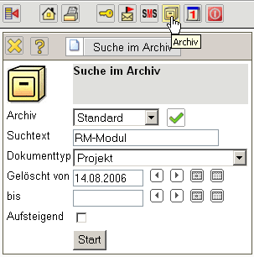
History protocols all modifications of a data record. Included is creating new data records, modifications on field level and deleting data records. The data from history is administered in the Projectile database and ends with the delete process, i.e. when a document is restored after being deleted through the trash/waste basket functionality, the original history of the document does nolonger exist.


