2.02.14 Portfoliomanagement
The Portfolio form applies to the administration of the project portfolio-management for any selected project and qualitative characteristics, i.e. planning, regulating and controlling selected projects of an organisation.
The basis of the project portfolio-management is compiling projects. In this form, projects can be compiled and the axes for the analysis can be predefined.
Tip: For more on this subject see chapter Portfoliomanagement.
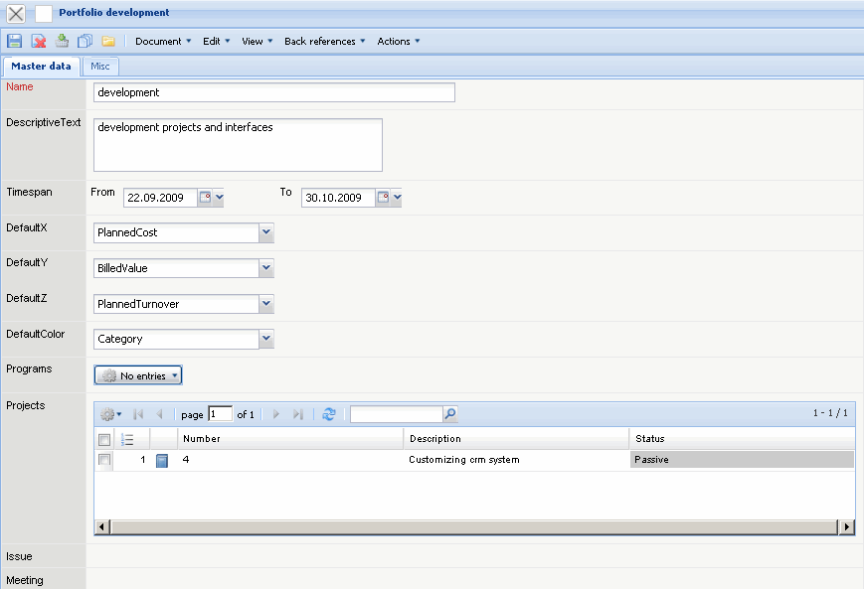
The form consists of the following elements:
On the “Master data” tab:
- Name: This alphabetic field specifies the portfolio uniquely in the system.
- Description: This field specifies the portfolio (long text, 255 characters).
- Standard-X, Standard-Y and Standard-Z: These values allow defining the standard axes for the portfolio for the porfolio analysis. The key figures for the axes are for example, planned time/effort, actual time/effort, planned costs, actual costs, planned revenue, offer value, invoice amount, probability and degree of completion.
- Standard Color: This value allows defining the category for the color of the bubbles in the bubble-chart (portfolio analysis). These categories are, for example, the project category, priority and the project status.
- Projects: In this selection box any amount of projects can be combined to a portfolio.
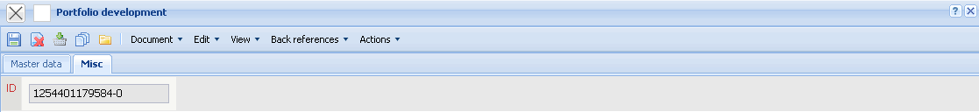
On the “Misc” tab:
- ID: This field contains the internal ID number.
The document type consists of the following actions:
- Portfolio Chart: Using this action a portfolio analysis for the selected portfolio can directly be opened.

