2.02.10 Project-related Employee Rates
The Project-Related Employee Rates form administers the occupation rates, which are adjusted for a defined project. When these rates are defined for a project or sub-project, these values override the global employee rates (see also costing and pricing).
Tip: For more on this subject see chapter 4.1.05 Occupations.
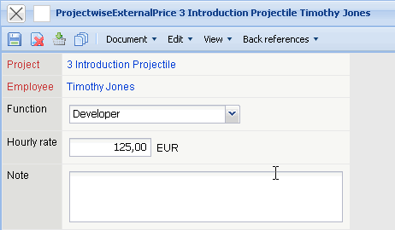
The form consists of the following elements:
- Project: This field specifies the corresponding project.
- Employee: This field specifies the employee, for whom the project is adjusted. Changes made here, do not change the original employee rate.
- Function: This field is pre-occupied with the function of the employee and can be changed for the defined project.
- Hourly Rate: The charge/cost rate are defined here. This is then used when billing the customer for this project.
- Note: This field is designated for comments.

