2.02.10 Project-Related Occupation
The Project-Related Occupation form administers the occupation rates, which are adjusted for a defined project. When these rates are defined for a project or sub-project, these values override the global occupation rates (see also costing and pricing).
Tip: For more on this subject see chapter 4.1.05 Project-Related Occupation.
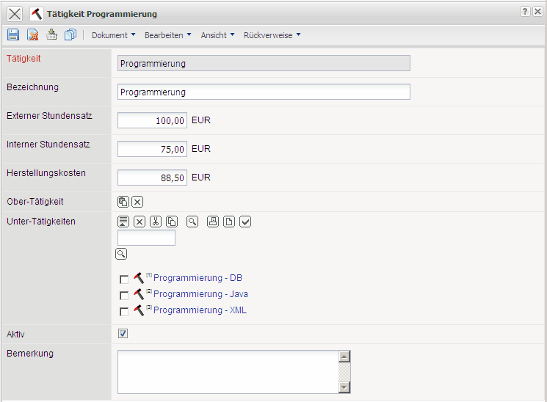
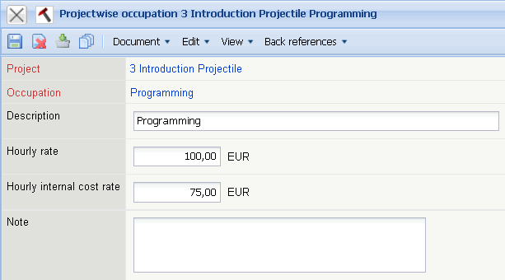
The form consists of the following elements:
- Project: This field specifies the corresponding project.
- Occupations: This field specifies the occupations for which this project is adjusted for. Changes which are made here, will not change the original occupation rates.
- Description: This field specifies the description of the occupation and can vary from the standard description.
- External Hourly Rates: The cost/charge rate is defined here. The customer is billed for this project with these rates.
- Internal Hourly Rates: The internal charge/cost rate is defined in this field.
- Comments: This field is designated for comments.

