2.02.09 Budget
The budget menu administers the project-related budgets in the system. Here, a budgetary item can be defined through any cost type for a project. Internal budgets (cost estimates/planned costs)and/or external budgets (items, which should be charged project-related, e.g travel expenses or commuting expenses)can also be defined. These budgetary items are compared with the recorded costs in the system as the basis for various target/performance comparisons.
!!!!!!!!!! Hierbei können interne Budgets (also Kostenvorgaben/Plankosten) und/oder externe Budgets (Posten, die projektbezogen weiterbelastet werden sollen, wie Reise- oder Fahrtkosten) definiert werden. Diese Budgetposten werden im System mit den erfassten Kosten verglichen, als Basis unterschiedlicher Plan/Ist-Vergleiche.
Tip: For more on this subject see chapter4.2.06 Budgetverwaltung.
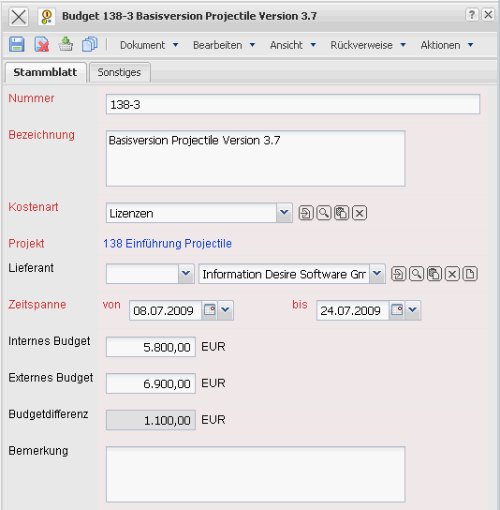
The menu consists of the following elements:
On the “Master Data” tab:
- Budget/Number In the field budget and number a unique number is assigned to the budgetary item. The field number is also editable after creating the budgetary item.
- Definition: This field specifies the definition of the budgetary item.
- Cost Type: This field defines the type of cost for the defined budgetary item. These cost types are compared later with the recorded costs within the frame of the target/performance comparisons and can be defined and modified in the types of cost menu.
- Project: This field defines the project, to which the defined budgetary item belongs. A budgetary item can be assigned to a parent/main project as well as a sub-project. The projects can be defined and modified in the project menu.
- Supplier: This field specifies the supplier for the defined budget. When incoming invoices (external invoice) are recorded for this project, the system matches the amounts with the budget (and gives a warning when budget is exceeded).
- Begin: The field begin specifies the beginning for the validity of the budgetary items. When selecting a project, this field is pre-selected with the beginning of the assigned project.
- End: The field end specifies the end for the validity of the budgetary items. When selecting a project, this field is pre-selected with the end of the assigned project.
- Internal Budget: This field defines the internal budget (the cost objective/estimate) (Kostenvorgabe) for the selected budgetary item.
- External Budget: This field defines the external budget (the amounts, which should be charged (weiterbelastet) project-related) for the selected budgetary items. These external budgets are entered into the plan-revenue of the project and can be transfered to the offer.
- Budget Difference: This field calculates the difference between the internal and external budget.
- Comment: This field is destignated for comments concerning the budgetary items.
On the “Misc” tab:
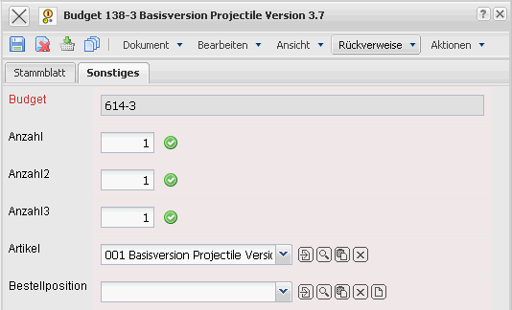
- Amount, External Service: The amount and the type of external services can be entered here, if the budgetary items are related to the external services (for example databases, hardware, ...). After clicking the green arrow, the system defines the internal and external budget from the purchase price and the sales prices of the external service.

