2.02.06 Project Timing/Order Relationship
The Project Timing/Order Relationship form (earlier jump sequence) administers the temporal relationship between two different jobs and/or milestones, which belong to the same projects. The here defined jump sequences and/or order relationship between the predecessor and successor, are the basis for the networked/linked Gantt charts (see also document type project analysis in the analysis module) and are for the extended/advanced planning possibilities on the basis of the network planning technique.
Note: The jump sequences can be defined in the project using the action “01 - Project Planning” .
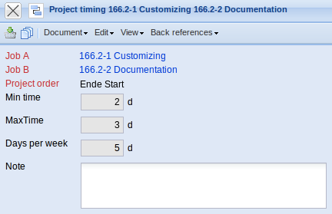
The form consists of the following elements:
- Job A: This field defines the predecessor for which the jump sequences apply. Only jobs and milestones which belong to a selected project, can be assigned.
- Job B: This field defines the successor for which the jump sequences apply. Only jobs and milestones which belong to a selected project, can be assigned.
- Project order: The field Project Order determines the chronological jump sequences of the jobs of the same project. Altogether, there are four standard relationships to choose from: Start-Start, Start-End, End-Start, End-End. The first criteria relates to the predecessor job, the second to the successor job. Actually, only the process relationship (Ablaufbeziehungen) start-start (test can only start, when development has started) and end-start (development can only start when the specification has been completed) has relevance.
- Min Time: Considering the jump sequence, this value specifies the minimum idle time in days between the jobs. Example: At least two days (work days in a 5-day week) should lie between discussing the concept and creating the specification sheet.
- Max Time: Considering the jump sequence, this value specifies the maximum idle time in days between the jobs. Example: Three days at the most (work days in a 5-day week) should lie between discussing the concept and creating the specification sheet.
- Days per week: Here it can be controlled if the weekends should be defined as idle time. If the value is set to 5, the idle time is only Monday through Friday. If this field is not occupied, the default value 7 is used. Example: There should be 2 days between the first and second coat of paint for a door. It is not important if this drying period is in the week or on the weekend => Days per Week = 7.
- Note: This field is designated for comments.

