2.02.05 Deadline
The Deadline form is used for estimating the expected date (due date) in which the milestone should be reached/accomplished. With these estimations, the data pool/base for the milestone trend analysis of the analysis module is set. Estimations can be made for any report date.
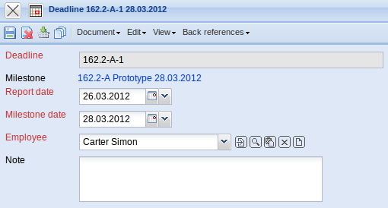
The document type consists of the following elements:
- Deadline: This field is used for entering a number to which the date should belong to.
- Milestone: The field milestone defines the milestones, to which an estimation for the trend date should be made. Milestones can be defined in the milestones form.
- Report Date: This field specifies the report date on which the estimation was made. This field is occupied with the current date from the system. The information from this field are entered in the milestone trend analysis on the horizontal axis and are specified as a symbol on the lines of the respective milestone.
- Milestone Date: The field milestone date defines the estimated date, in which the the respective milestone is expected to reach/achieve. The information from this field are entered in the milestone trend analysis on the vertical axis.
- Employee: This field specifies the editor of the data record (the project employee) who defines the trend date for the selected milestone.
- *Note:** This field is designated for comments concerning deadlines (for example, the reason for a delay).

