2.02.04 Job
The Job form administers the individual jobs in the projects. The jobs are the lowest level in the project structure plan and assign an occupation (task/process) to exactly one employee, who is responsible in the scope of the project. A job can be assigned to a sub-project as well as a parent or main project. This form diplays the time span, the planned time/effort and the billed time of the jobs, as well as the actual end. It is also possible to sort the job using either priority or due date (planned end) using online time tracking.
Tip: For more on this subject see chapter 4.2.04 Administer jobs.
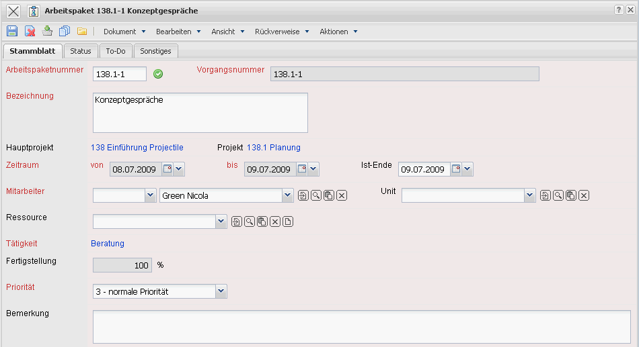
The form consists of the following elements:
On the “Master Data” tab:
- Number: This alphanumerical fields is the number of the defined job and is generally derived from the corresponding project number.
- Description: This field specifies the job description.
- External Order: This field specifies if the job is external (billable). If the toggle box is activated the selected job is an external task, otherwise it is an internal task. With external projects this box is pre-selected for all jobs. Example: An external sub-project development includes a job “test”, which should not be billed to the customer. The external toggle box should then not be set in the job.
- Project: This field defines the project to which the defined job belongs. A job can be assigned to a main project as well as a sub-project. The projects can be defined and modified in the document type Project. Note: It is not mandatory to assign a job to a project; jobs without a project will only be considered by employee-based analyses and not in the project analysis.
- Process: The field process is automatically pre-selected by the system.
- Employee: This field defines the user of the job. The employees can be defined and modified in the document type Employee. With this assignment, performance recording for each employee, only the jobs are displayed for which the employee is responsible and not yet completed.
- Unit: A unit responsible for the job can be entered here. In the next version the job can also only be assigned to this unit. This organisation unit is defined in the unit form.
- Occupation: This field defines the occupation of the employee in the scope of the job. This occupation generally determines the costing and pricing and is also used for the suggestion scheme. The occupations can be defined and modified in the document type Occupations.
- Job Time Span from/to: The field planned begin date specifies the beginning for working through the job and is determined with the planned begin date of the assigned project begin date. The field planned end specifies the due date of the job and is pre-selected with the planned end of the project end.
- External Hourly Rate (fixed and variable): These fields specify the general hourly rate (fixed or variable) for the billing of the defined project. If this field is populated (and the corresponding field in the job is not), all work services will be charged with this rate and the system does not consider the rates from the customer form, employee form or occupations form (see also pricing). The variable rate is then more significant than the fixed hourly rate.
- Priority: This field specifies the priority of the selected job. The greater the priority is, the higher the job is displayed (if the display should be effected by the criteria Priority)
- Actual End: This field specifies the completion date of the job. The job must be closed from the user or project leader after the tasks have been completely worked through. A job must be either closed in the document itself or from the time tracking component.
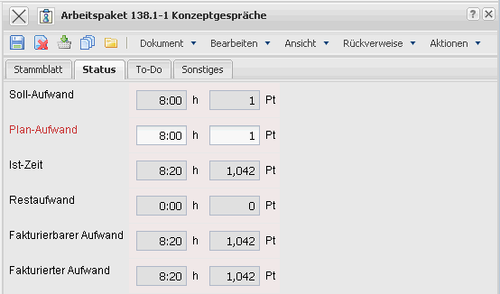
On the “Status” tab:
- Target Time/Effort: This field is determined from the system within the planning frame and defines the probable project duration in hours and/or days. During the planning period this value is updated (analog to the planned time/effort) and after the planning is completed (status transfered to „advance performance“ or „active“) this value will not be changed.
- Planned Time/Effort: In this field the estimated net time/effort of the job is defined. The cumulative plan values of all work projects of a project are the basis for calculation and controlling (plan/target comparison).
- Actual Time: The contents of this field displays how many hours have been posted for these jobs in the time tracking component, so far.
- Rest Time/Effort: This field displays the latest defined remaining time in hours from the tracking and recording component TimeTracker. The value from the jobs are transfered cumulatively into the projects.
- Billable Time/Effort: This value displays the billabe time/effort of the job. This value can be entered in the tracking and recording component or in the dialog „Billable Time“.
- Billable Time/Effort: In this field the amount of hours which have already been posted in the invoice related to the project are displayed. This field is automatically defined when the invoice is processed.
- Degree of Completion: This field specifies the degree of completion or the job.
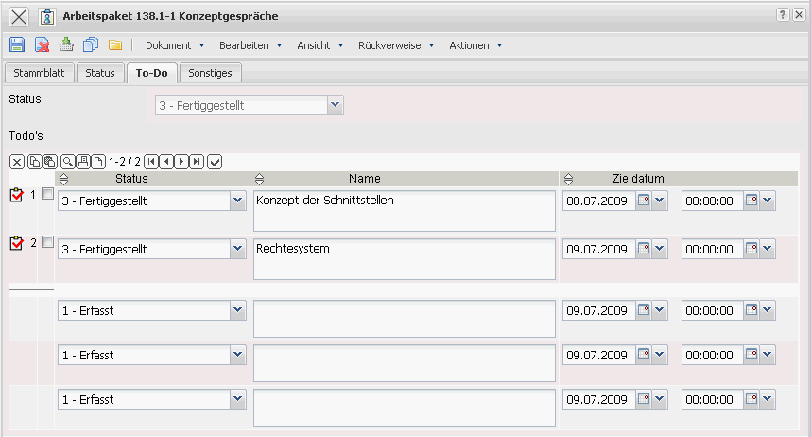
On the “To-Do” tab:
- This tab contains the to-do's of the job and the statur of the to-do's.
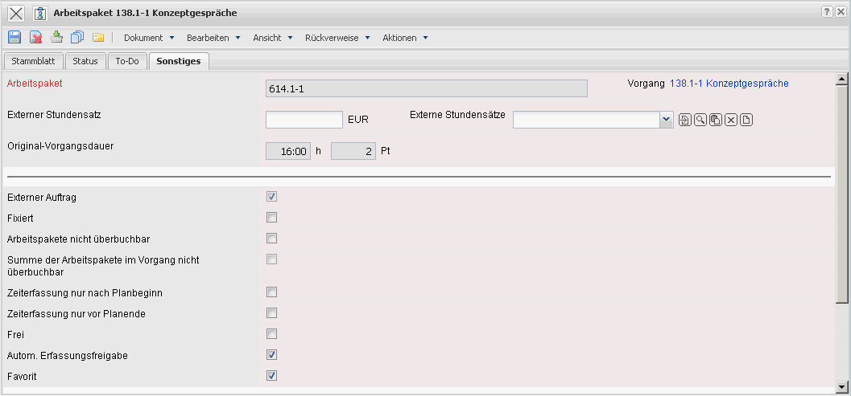
On the “Misc” tab:
- Job not Overbookable: If this field is set, data entry through the planned time/effort in the time tracker is prohibited.
- Sum of the Job in not Overbookable: This toggle box controls the characteristics of the job of the process. If the box is marked, data can only be entered in TimeTracker with the jobs, if the planned time/effort is not exceeded.
- Time Tracking only after Plan Begin: This toggle box controls the characteristics of the jobs of the project. If the box is marked, data can only be entered in TimeTracker with the jobs, if the planned begin is achieved.
- Time Tracking only before Plan End: This toggle box controls the characteristics of the jobs of the project. If the box is marked, data can only be entered in TimeTracker with the jobs, if the planned end is not achieved.
- Locked: With this check box it can be determined if the time/effort of the jobs are locked. This functionality is needed for top down planning or when locking projects in the project planning. This functionality is used in the forward and backward pass, in order to protect this element from being shifted (see also chapter 4-2-1-5 Calculating the Project Plans - Appointment Planning/Agenda) (siehe auch Abschnitt 4-2-1-5 Berechnung der Projektpläne - Terminplanung).
- Free: This element specifies the job as a free task. If this box is marked, principally every employee can use this job through the tracking and recording element (TimeTracker).
- Autom. Entry Approval: If this check box is deactivated, data entry in an active job can be suppressed. This check box is predominantly used with large-scale projects, in order to not release to many jobs to individual employees.
- Favorite: This check box is needed for the favorites administration in TimeTracker.
- Components, Change Requests(optional): When using the module “product documentation”, references to the product structure and the change requests can be stored here.
- Comments: This field is designated for comments concerning the job.
The document type contains the following actions:
- Suggestion Scheme: With this action a suggestion list editing the defined job can be created. From occupations and the time span, the system determines all employees, who according to their skills can be qualified for these tasks and displays their capacities in the respective time span (see also 4.2.2 jobs ) .
- Show Hourly Rates: With this action, internal and external billing rates can be displayed and seen where these are stored.
- Edit Processes: With this action a dialog for editing the process is opened. The, among others, basic values of the process can be edited, various employees assigned to the job and the utilization of the employee can be displayed.

