2.02.03 Process
The Process form administer the tasks of the projects. In Projectile the processes are the summary of the the jobs. This form displays the occupations, the time span and the time/effort (planned, target, actual, rest, billable, billed).
Tip: For more on this subject see chapter 4.2.03 Administer Processes.
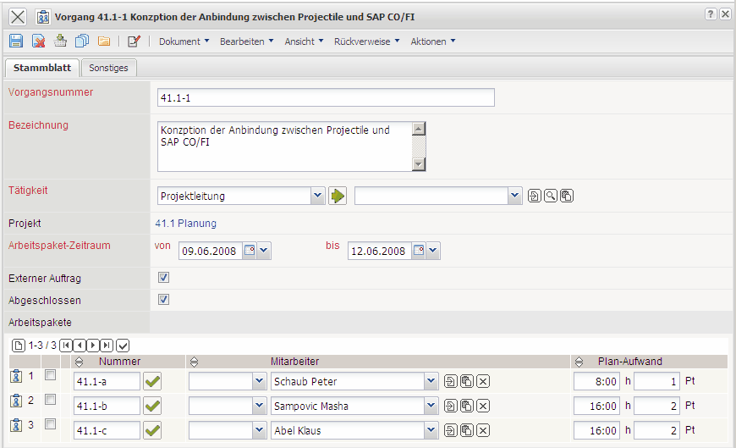
The form consists of the following elements:
On the “Master Data” tab:
- Process number: This element specifies the task as a process. In Projectile a process is the summary of one or more jobs, which include the same occupations and the same time span.
- Description: This field specifies the description of the process.
- Occupations: This field defines the occupations of the employee within the process frame. These occupations generally determine the costing and pricing and are also used for the suggestion scheme. The occupations can be defined and modified in the document type Occupations.
- Project: This field defines the project, to which the defined process belongs. A process can be assigned to a parent project as well as a sub-project. The projects can be defined and modified in the document type Projects.
- Job-Time span from/to: The field plan begin specifies the beginning for working through the process and is determined by the planned begin of the applied earliest scheduled job. The field plan end specifies the due date of the job and is pre-filled with the plan end of the applied latest scheduled job.
- External Order: This field specifies, if the process is external (billable). If the toggle box is activated, the selected process is an external task, otherwise it is an internal task. With external projects this box is pre-selected for all processes.
- Completed: This flag is automatically set from the system when all applied work projects are completed.
- Job: This element contains a list of all applied jobs of the process.
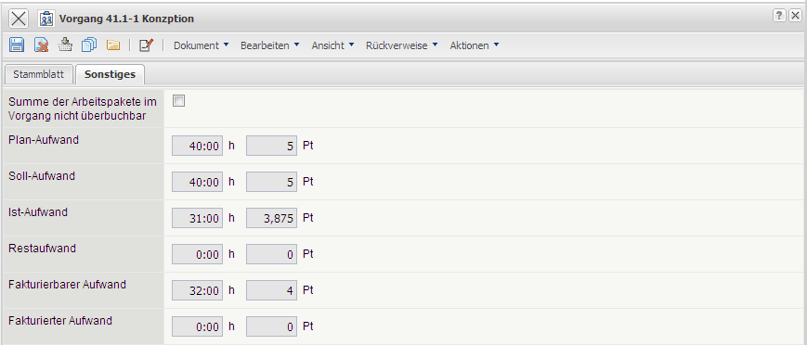
On the “Misc” tab:
- Sum of Work Projects in not Overbookable: This flag controls the characteristics of the job of the process. If the box is marked, data can only be entered in TimeTracker with the jobs, if the planned time/effort is not exceeded.
- Planned-Time/Effort: In this field the estimated net time/effort of the process is defined. The cumulative plan values of all processes of a project are the basis for calculation and controlling (plan/target comparison).
- Target Time/Effort: This field is determined from the system within the planning frame and defines the probable project duration in hours and/or days. During the planning period this value is updated (analog to the planned time/effort) and after the planning is completed (status transfered to “advance performance” or “active”) this value will not be changed.
- Actual Time: The contents of this field displays how many hours have been posted for these tasks in the time tracking component, so far.
- Rest Time/Effort: This field displays the latest defined remaining time in hours from the tracking and recording component TimeTracker. The value from the jobs are transfered cumulatively into the projects.
- Billable Time/Effort: This value displays the billable time/effort of the process. This value can be entered in the tracking and recording component or in the dialog “Billable Time”.
- Billable Time/Effort: In this field the amount of hours which have already been posted in the invoice related to the project are displayed. This field is automatically defined when the invoice is processed.
The document type contains the following actions:
- Edit Process: With this action the dialog for process editing can be opened. Among others the basic values of the process can be edited, various employees can be assigned to the jobs and the capacity utilisation of the employees can be seen here.

