2.02.01 Project
The project form administers the project's master data in the system. The project structure, meaning the structure in the projects and sub-projects, can be defined here. Principally, every project can consist of an unlimited amount of sub-projects and hierarchical levels.
All relevant information about the project and it's relationship to the master project (its hierarchical position in the project structure), the activity, customer, currency, project hourly rate, project leader, the necessary qualifications, assignment to the project team, cost unit and set-up data are defined in this form. Furthermore, the planned figures for beginning and end of the project, the project budget, the project costs and the project duration of the person responsible for the project are displayed here.
Tip: More on this subject in the section Project Data Administration
Note I: Functional permissions for projects (analogue to the units) can be defined (see also Administration Guide)!
Note II: Documents can be directly stored to the projects in Flyer Files!
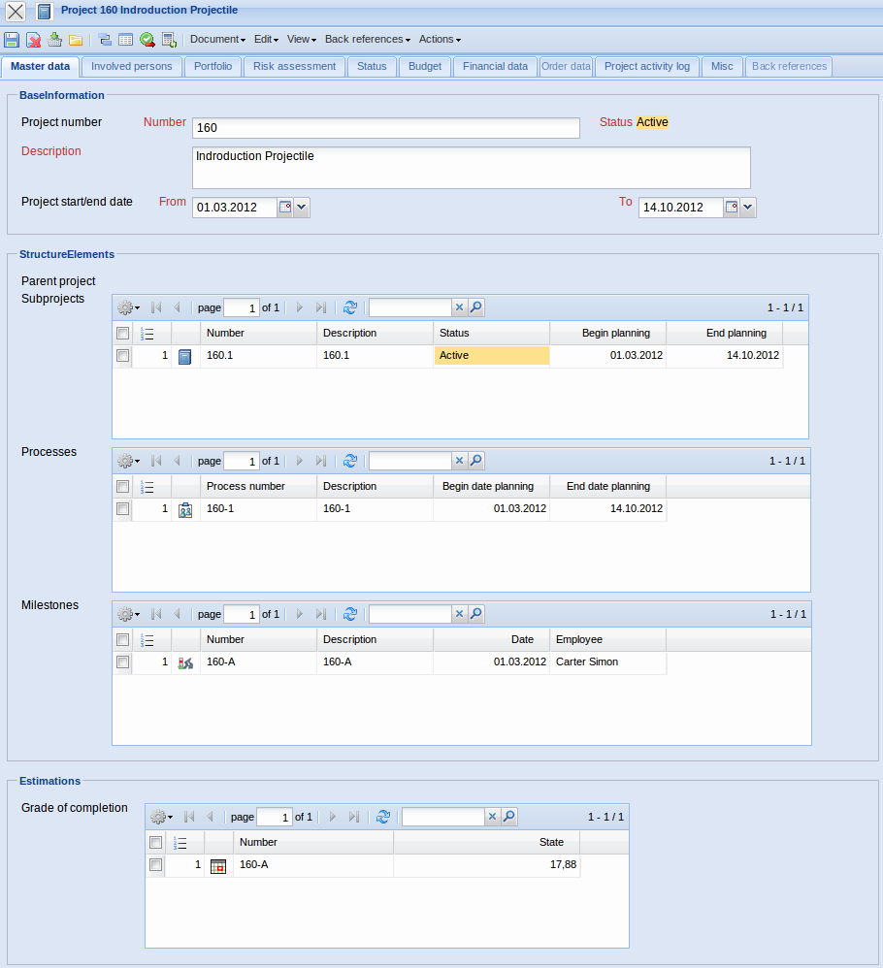
The form consists of the following elements:
On the “Master Data” tab:
- Number: This alphanumerical field specifies the project distinctly in the system. The project number can be modified at anytime; but must be clear in the data pool. This number is usually preallocated with a number range and is inherited to all project-related elements (sub-projects, jobs, milestones, ...).
- Status: This field specifies if the project is active, passive or completed. When creating a new project, this field is preallocated with “passive”. Further characteristics (interrupted, discontinued) can be defined by the administrator.
- Description: This field specifies the project.
- Project Timespan from/to: The field project start date defines the estimated begin of the project and the field project end date defines the estimated end of the project. Entries for these fields are mandatory. With this, the basis for the Charts (Gantt chart, milestone-trend-analysis, ...) of the information system is established.
- Parent Project:The field parent project characterises the existence of a superordinated project. If the element is not populated, then the project itself is a parent project. The project structure is displayed by Project Structuring of the project structure plan. When creating sub-projects, this entry is automatically populated.
- Sub-Project:This field contains a list of all assigned sub-projects. After defining sub-projects, they are automatically assigned as sub-project to the parent project.
- Process: These elements contain a list of all assigned Jobs or Process.
- Milestones: This element contains a list of all assigned Milestones.
- Completion: This element contains a list of all assigned States (Degree of Completion).
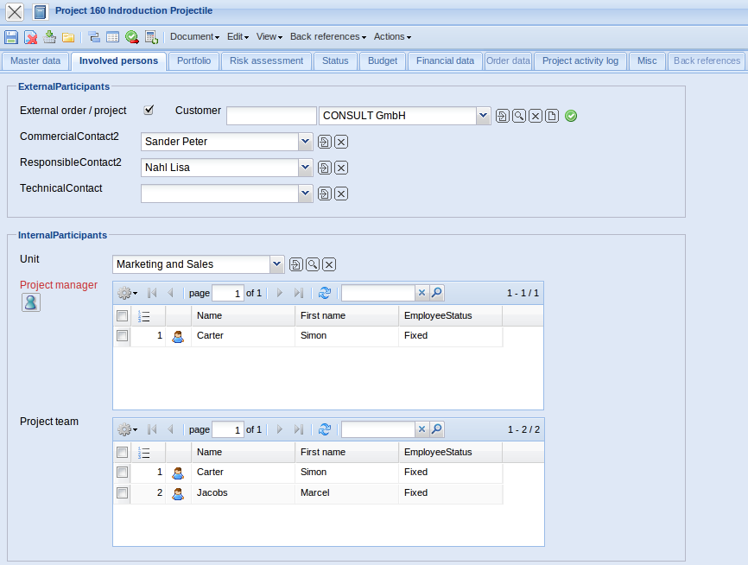
On the “Involved Persons” tab:
- External Order/Project: This field specifies if the project is external. If the select box is activated, the the selected project is an external project, otherwise it is an internal project. If the project is external the system requires the assignment of an ordering customer.
- Customer: This field specifies the customer for the project.
- Contact Person: The field contact person specifies the contact person for the project. This field is populated with the contact person of the customer, when a customer has been selected. The contact person is administered in the form Contact Person.
- Unit: The responsible unit is determined in this field (generally a location or a department). For this project, the leaders of these units have same permissions as a project manager. Units can be processed in Unit.
- Project Manager: This field specifies the project leader of the project. The project leader also automatically becomes the project manager of all defined sub-projects. Therefore, it is guaranteed that the project leader has the permissions to create and modify project data. Usually, an employee only has access to a project, when he/she is admitted to the project team.
- Project Team: Compiling a project team is possible with this selection list. In the process, the project leader of the sub-project and the employee of the assigned Jobs are automatically transfered to the project team.
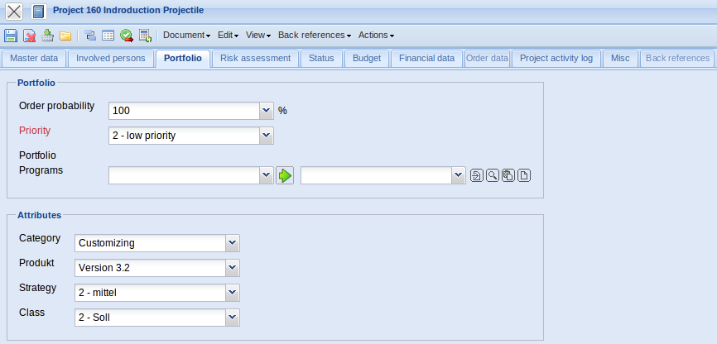
On the “Portfolio” tab:
- Priority: This field specifies the priority of the selected project.
- Portfolio, Program: When the defined project is assigned to a portfolio or program, the corresponding element is automatically displayed here.
- Project Type: This field assigns a defined project type to the project, which can be used as a selection criteria by the analyses.
- Product, Risk, Strategy, Benefit, Class, ... : These fields classify, similar to the project types, the project and are selection criteria for the portfolio management and the project analyses.
Note: These categories are suggestions from the manufacturer and differ in many installations.
- Probability: This field specifies the probability of a passive project becoming an active project (=offer). This probability is added proportionally to the capacity planning and is applied in the suggestion scheme. If a project is activated, the system sets this probability automatically to 100%.
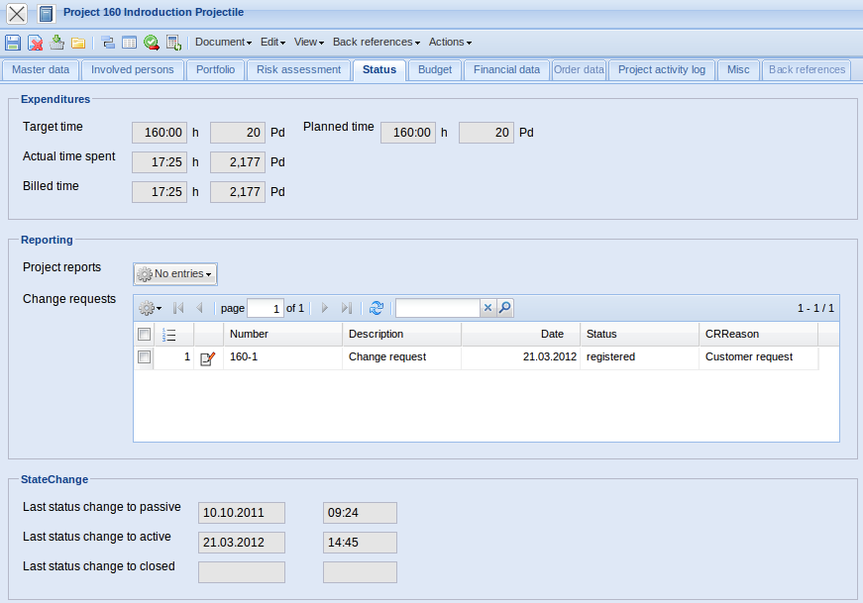
On the “Status” tab:
- Status Reports: The entered status reports are listed chronologically, either ascending or descending. These reports are entered with help of the status report form.
- Project-CRs: The entered change requests for the project are listed here. The changes are entered in the project modification form.
- Target Project Duration: This field is defined, in the time frame of the project, from the system and defines the probable project duration in hours and/or days. During the planning period, this value is updated (analogue to the planned project duration) and if the plan has been completed (status transfer to “advance performance” or “active”) this value will not be changed.
- Planned Project Duration: This field defines the probable project duration. This field is either automatically defined from the user either with the bottom up approach or within the framework of the top down planning. This value is identical with the target project duration until the status transfer to “advance performance” or “active”.
- Actual Project Duration: This field contains the entered times for the assigned project. With each modification in the TimeTracker component, these actual times are transfered into projects and the jobs.
- Billed Hours/Time: This field contains the billed times for the assigned project. These billed times are transfered into projects and jobs with every invoice or cancellation.
- Remaining Time: This field consists of the remaining time for the applied project. This remaining time is transfered into projects and jobs with every entry in the degree of completion or remaining time.
- Last status modification to passive, active and completed: The most important status modifications are listed here (passive - entered, active/advance performance, completed/discontinued). The complete history from all status changes can be found in the form item “View - Show event log”.
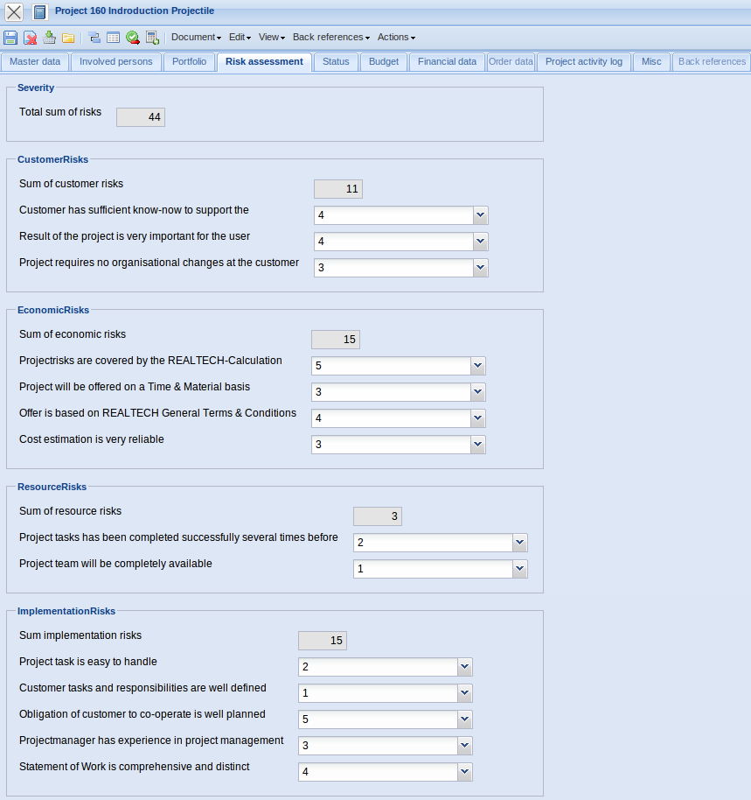
On the “Risk assessment” tab:
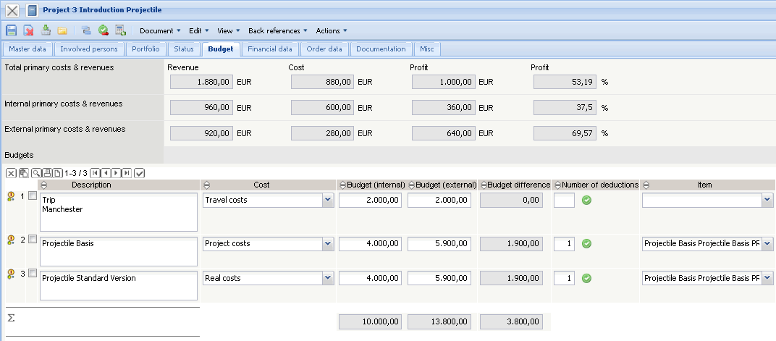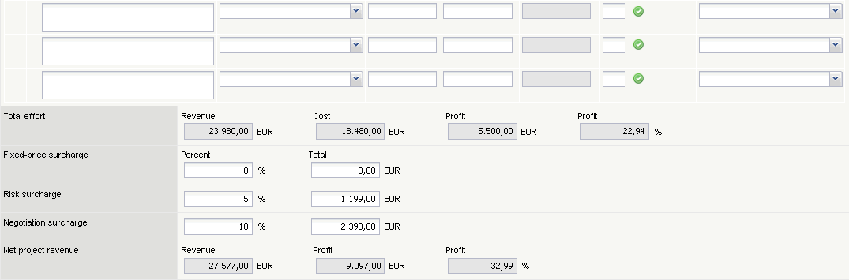
On the “Budget” tab:
- Primary Expenses: (Planned)Revenue: This field defines the planned revenue from the jobs and results from multiplying the planned revenue of the job with the external hourly rate. When a job is defined, this revenue is automatically determined using the bottom up approach. See also bottom up planning and costing (external hourly rate).
- Primary Expenses: (Planned)Costs: This field defines the planned labour costs and results from multiplying the planned revenue of the job and the internal hourly rate. When a job is defined, these costs are automatically determined using the bottom up approach. See also bottom up planning and costing (external hourly rate).
- Primary Expenses: Profit (absolute and percentile): The absolute profit results from subtracting the (planned) revenue minus the (planned) costs. The percentile profits results from the (absolute profit / revenue) x 100.
- Primary Expenses internal/external: Here it is distinguished between the company's own (salaried) and foreign (external and freelancer) personnel. This distinction is made through the employee status of the employee planned for the job.
- Budget: This element contains a list of all assigned budgetary items. Other budgets (secondary expenses) can be stored tabularly.
- Project (Primary Expenses + Secondary Expenses): These fields contain the probable internal project revenue, project costs and the profits (absolute and percental). These costs result from adding the primary expenses to the budgets (secondary expenses).
- Surcharges (for example, fixed prices, risk, negotiation): These fields are designated for surcharges of the (planned) revenue. These surcharges have no influence on the planned costs of the project and are used for preparing the offer/quotation.
- Project (Project + Surcharge): The sums of the planned revenue, costs and profit with the the sum of the surcharges are performed here.
- Offer Value : This value consists of the net amounts of the included offers for the defined project. The offers can be generated with the action “create offer” and are administered with the offer form and offer position form.
- Invoice Amount: This value consists of net amounts of the included invoice for the defined project. The invoice can be generated with the action “create invoice” and is administered with the invoice form and invoice position form.
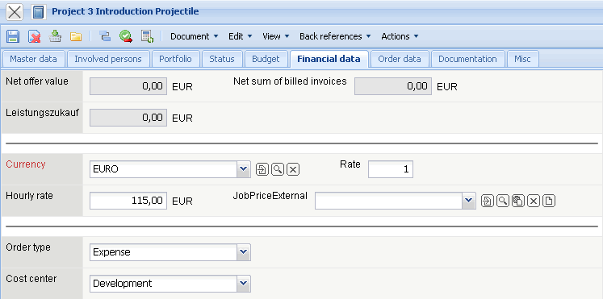
On the “Financial Data” tab:
- Currency: The field currency specifies the project currency. The project currency overwrites the general system currency (see also configuration) and the customer currency (see also customer). By default, this field is preallocated with the currency from the configuration form. After selecting a customer, if applicable, the local currency from configuration is changed to the customer currency. Currencies can be defined and modified in the currency form.
- Rate: After selecting a project currency, the field rate is automatically preallocated with the valid exchange rate of the project currency as the local currency (see also configuration). After preallocation, a differung project rate (for example, for international projects, in which the foreign exchange risk should be minimised)can be defined here. This rate is binding for preparing offers and invoicing. The rates are administered in the rate form.
- External Hourly Rate (fixed and variable): These fields specify the general hourly rate (fixed or variable) for further charges of the defined project. If this field is populated (and the corresponding field in job is not), all work services are calculated with this rate and the system does not consider the rates from the customer form, employee form or the occupations/tasks form (see also pricing). The variable rate is more significant than the fixed hourly rate.
- Order Type: This element is an attribute for later billing of the project (expense or fixed price). In several versions, this field is also used as an attribute for evaluating completed and non-completed services.
- Cost Center: This field defines the cost center to which the selected project is posted. The cost center can be defined and modified in Collections. Note: The cost unit can also be used alternatively or additionally in the project. This attribute can be set from the administrator or manufacturer.
- External/Additional Purchase of Service: The net value of offers (extension of the invoicing module) are automatically listed from the system here.
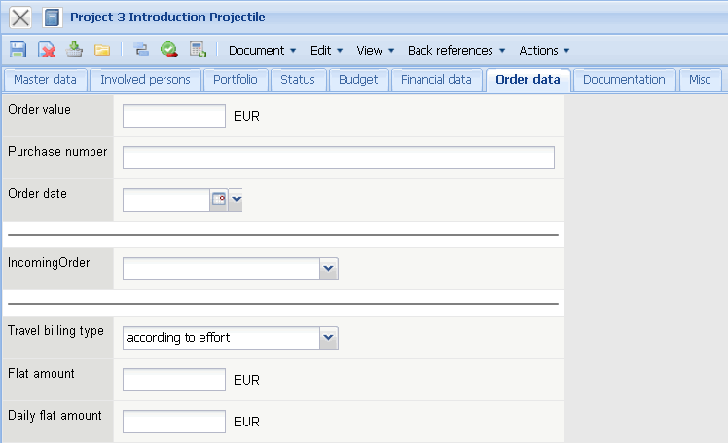
On the “Order Data” tab:
- Order Value: This field can be used for defining the fixed price/flat rate (maximum upper limit for all invoices for this project). If the order value is defined here, the automatically defined value planned-revenue displays only the theoretical project budget, with the basis being the planned value from the jobs and the budget administration. The order value is transfered automatically from the system if an order confirmation is included as defined.
- Order Number, Order Date: The order number and the order date of the project can be entered here. This order information can be used for the invoice print-out. The order number and the order date are transferred from the system, if an order confirmation is defined as included.
- Rebate: A rebate for the project can be stored here. This rebate is preallocated for all invoices of the project.
- Method of Payment: The method of payment for the project can be selected here. These payment methods are transfered from the contact form when defining a customer/client, and can be overridden in the project and invoicing.
- Incoming Order: The type of communication for the incoming order (fax, letter, e-mail, ...) can be entered here.
- Travel Expenses - Type of Billing, Fixed Rate: The preallocation for travel expense billing for the project can be stored here (no billing, fixed price, at cost). These preallocations can be modified per business trip.
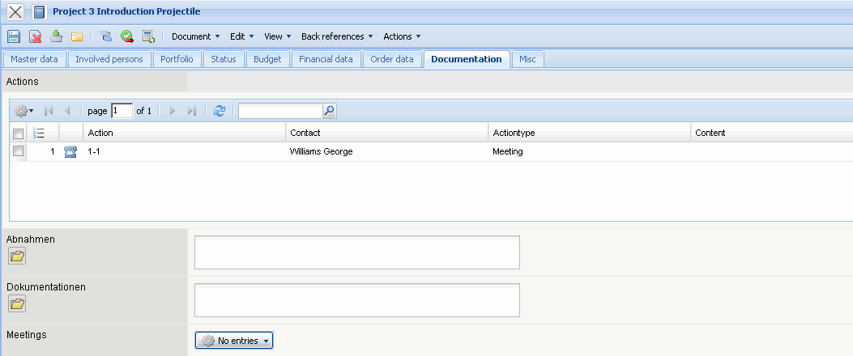
On the “Documentation” tab:
- Issues, Meetings: When using the module “Complex” references to the issues and meetings can be stored here.
- Actions: This field contains all stored actions concerning this project.
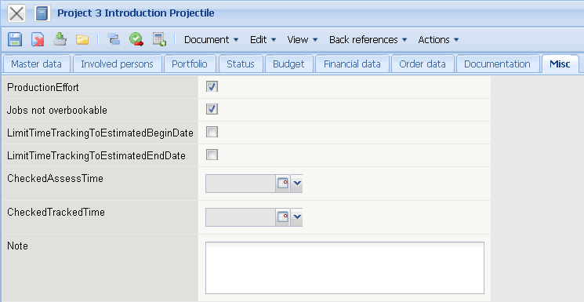
On the “Misc” tab:
- Locked (a hidden field in the standard version): With this check box, it can be defined if the duration/effort of the project or sub-project are locked. This functionality is needed for the top down planning or to lock the projects in the project planning. This functionality is used in the forward and backward pass, in order to protect this element from being shifted (see also chapter 4-2-1-5 Calculating the Project Plans - Appointment Planning/Agenda).
- Jobs not overbooked: This flag controls the properties of the project. If the box is marked, the job in TimeTracker can only be entered as long as the planned time is not exceeded.
- Time recording only after planned begin date: This flag controls the properties of the job of the project. If this box is marked, the job in TimeTracker can only be entered when the planned begin of the job is reached.
- Time recording only after planned end date: This flag controls the properties of the job of the project. If this box is marked, the job in TimeTracker can only be entered as long as the planned end of the project is not reached.
- Operation Activity: This flag controls the properties of the job of the project. This flag is analysis criteria for the capacity analysis and is used, for example, for internal projects or long-term projects, in order not to consider the staff workload.
- Components, Change Requests: When using the module “project documentation” references to the product structure and the change requests can be stored here.
- Comment: This field is designated for comments concerning the project.
The form contains the following actions:
- Project Planning (also -Button) : When using this action the extended project planning on the basis of the network planning technique can be used . (see also chapter 4-2-1-5 Calculating the project plan - appointment scheduling).
- Refresh price table (also -Button) : When using this action all values in the budget tab are recalculated and/or refreshed.
- Set project status: When using this action the project status can be modified. According to the current status of the project, various attributes are available (project passive, open offer, advance performance, project active, project completed, ... ). Status changes affect the complete project structure (also including all sub-projects). For further information see chapter 4.2 Projects.
- Create project-based occupations: When using this action, price tables (see also pricing and project-based occupations) can be defined project-related.
- Show project-based occupations: When using this action all product-related occupations of this project as aolee as all sub-projects are shown.
- Create project-based employee rates: When using this action, price tables (see also pricing and project-related occupations) can be defined project-related.
- Show project-based employee rates: When using this action all employee-related hourly rates for this project, as well as all sub-projects, are shown.
- Create offer: An offer can be directly generated from the project here. The system opens a new offer and pre-fills all the known values of the offer.
- Create invoice: An invoice can be directly generated from the project here. The system opens a new invoice and pre-fills all the known values of the invoice.
- Show invoice document: This action lists all transfered invoice documents for the defined project and the corresponding sub-project. Included are offers, external invoices (purchase/incoming invoices) and (outgoing) invoices.
- Create Project template: With this action, a template can be created from a selected project. This template can be named from the user and is then saved to the web server (iee also 4.2.7 Project Templates).
- Define project actions, show project actions: Here, an action window is opened and a new action can be directly defined to a project. This action can be displayed with the next action (see also Actions).
- Project documentation: With this action the project documentation for the selected project can be displayed.
- Create jobs for a team: With this action a job for each team member can be generated in a project. The job goes over the time span for a project and has no planned duration. Modifications must be made manually. The requirement for this action is at least one member in the project team.
- Save project plan, Show project plans: Create and administer project plans (not in the standard version)

