2.01.32 Time Entry
The Time Entry form administers the appointment entries of the personal calendar (see also 3.02.4 Alternative Work Areas) and the group calendar. Time Entry consists of, amongst others, information about the type of appointment, the time span, the participant and the invitation status, as well as assigning the jobs.
Tip: For more on this subject see chapter 3.04.3 Group Appointment Calendar Team-Calendar.
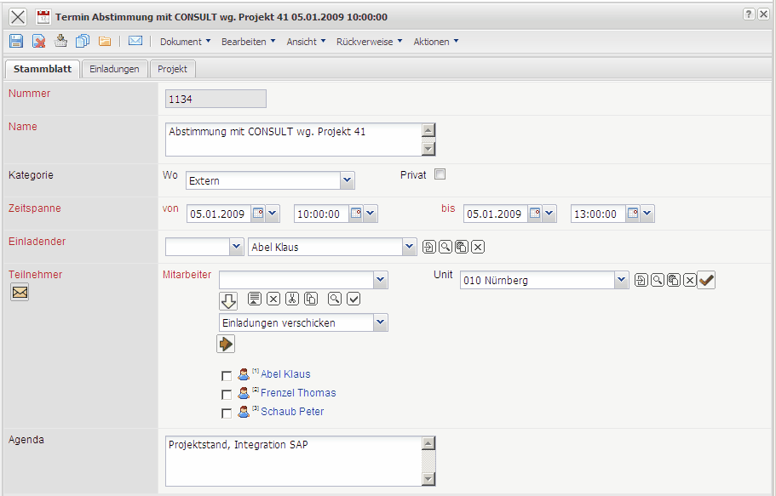
The form consists of the following elements:
On the “Master Data” tab:
- Number: This alphanumeric field specifies the appointment distinctly in the system.
- Name: This field specifies the appointment (short name).
- Category: This selection specifies the appointment as internal or external.
- Private: This flag specifies the appointment as a private appointment.
- Time Span (from and to): The field from defines the probable appointment start and the field to defines the probable appointment end. An entry for these fields are mandatory.
- Inviter: These fields are preallocated from the system and specify the employee, who initiated the appointment. The inviter is also automatically entered in the participant list. The employee is defined in the employee form.
- Participants (Employees): Further internal participant of the appointment (besides the inviter) can be selected. With the help of the action “send invitation”, !!!ballots!!! can be sent to further participants, who then accept or decline the appointment. In order to use this function, workflow “TimeEntryInvitation” must be active.
- Unit: When a unit is selected, all personnel of the unit are entered in the participant list.
- Agenda: Comments concerning the appointment can be entered here.
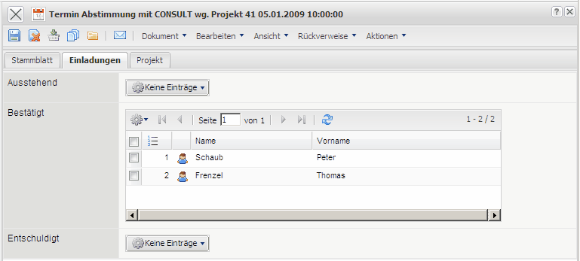
On the “Invitation” tab:
- Outstanding/Pending: If the invitation workflow “TimeEntryInvitation” is used, the participants who have not confirmed or declined are listed here.
- Confirmed: If the invitation workflow “TimeEntryInvitation” is used, the participants who have confirmed are listed here.
- Excused: If the invitation workflow “TimeEntryInvitation” is used, the participants who have declined are listed here.
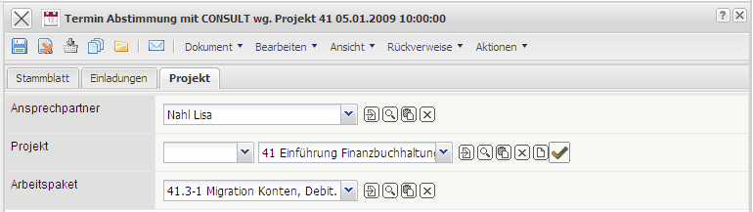
On the “Misc” tab:
- Contact Person: The field contact person specifies the contact person and is automatically preallocated from the system, if the appointment has been created through the contact person (field appointment).The contact persons are administered in the contact person form.
- Project, Job: In these fields, appointments can be linked with projects and jobs. When the project is selected, the system filters the jobs of the selected project.

