2.01.29 Price (Item Price)
The Price form administers the item prices in the system, if any prices differ from the purchase price and selling price. These prices have validity, as well as up to three price stages.
- Tip: For more on this subject see chapter 3.11.09 Item Administration.
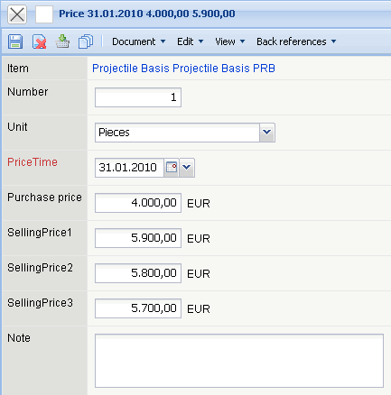
The form consists of the following elements:
- Item (External Service): This field assigns the defined price to an item. The item and/or external services are administered in the item form.
- Amount: This field describes the amount of items for the defined price (here 5 licenses).
- Unit: This field specifies the unit (pieces, weight, hours, measurements, ...) for the item price.
- Purchase Price: The purchase price for the defined item/external service can be entered in this field. This price is required for the internal cost accounting for the project analysis and cost analysis.
- Selling Prices (Standard Price, Customer Price und Special Offer Price): The selling prices for the defined items can be entered in these fields. The prices can be preallocated in the external costs form as the suggested selling prices.
- Note: This field is designated for entering comments.

