2.01.24 Employment Contract
The Employment Contract form administers the work time contracts from employees. With the contracts, the main data for the employees, as, e.g. the contract duration, holiday entitlement, flexible time buffer, daily work hours and the maximum capacity are displayed. The contracts have a defined validity. If no valid contract is assigned, the system uses the master data from the employee administration. Once defined contracts can only be deleted or restricted.
Note: This component is only available if Working Time Administration is licensed.
Tip: For more on this subject see chapter 3.11.07 Work Time Administration.
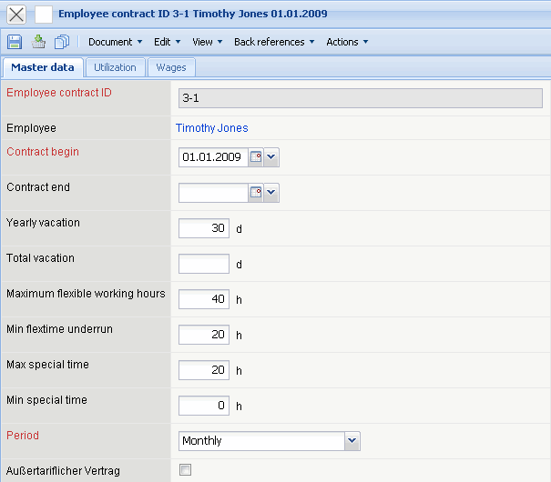
The form consists of the following elements:
On the “Master Data” tab:
- Employment Contract: This field specifies the name of the contract.
- Employee: This field designates a contract to an employee.
- Contract Begin: This field specifies the beginning of the contract. All defined rates and key data of the contract are used only from this defined date. This field is required.
- Contract End: In the field contract end, an end date for the contract can be entered. If an end date is defined, when a contract has expired the system continues to the next valid contract or returns to the defined value in Employee.
- Yearly Holiday Entitlement: This element defines the yearly holiday entitlement of an employee. This entitlement refers to the calendar year (for example, 30 days of holiday per year) and is considered in the account calculation of the employee.
- Holiday Entitlement Sum: This element defines the sum of the holiday entitlement for the duration of the contract of the employee. This entitlement refers only to the duration between contract begin and contract end and is considered in the account calculation of the employee.
- Maximum Flexible Time Buffer: In this field the flexible time buffer of the employee is defined. The sum of the hours refer to the defined periods.
- Allowed Set-Time Lower Deviation: The allowed set-time in which the lower limit has been exceeded, defines how many hours an employee can go below their set-time, without receiving a warning. This value also refers to the defined periods.
- Maximum Special Hours Buffer: In this field the maximum special hours buffer of the employee is defined. After the period, the lower and/or higher limit of this value can be exceeded.
- Allowed Special Hours Lower Deviation: If the employee goes below this defined hour value, the system sends the user a warning.
- Periods: The drop-down box periods defines the duration for the maximum flexible time, allowed set-time lower deviation, maximum special time buffer and the allowed special time lower deviation.
- Non-Tariff Contract: This field specifies employees without a tariff contract. The work time administration considers when posting, only vacation and does not designate a flexible time buffer.
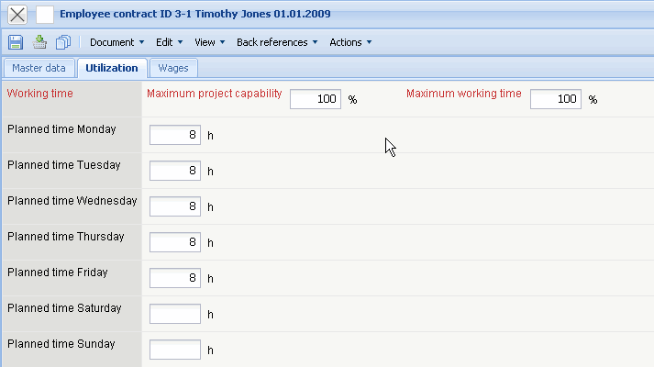
On the “Utilization” tab:
- Max. Capacity: This value specifies to how much percent the user can be planned for within the projects.
- Max. Work Time: This value defines the maximum work time for the employee referring to the standard work time (see also Calendar). For example, a part-time job has the value 50%.
- Set-Time Monday to Sunday: Differing work times per day for the employee and/or employment contract can be defined here. If an employee works part-time and does not work an all workdays, an appropriate settlement can be illustrated here. For example, an employee works 20 hours per week on the first three workdays => Monday = 7h, Tuesday = 7h and Wednesday = 6h.
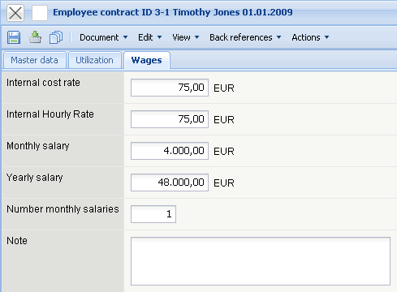
On the “Wages” tab:
- Cost/Charge Rate 1 (Internal Hourly Rate): The internal cost/charge rate of the employee for costing in the system is defined in this field.
- Cost/Charge Rate 2 (Partial Cost Rate): A further cost/charge rate per employee can be utilised with the help of this element (e.g. full and partial cost rate).
- Monthly Wage, Yearly Wage, Amount of Monthly Wages: These fields describe the employee's wages in the contract's time span and are applied when utilising the HR-interface.
- Comments: This field is designated for comments.

