2.01.24 Employee
The Employee form administers the master data of each individual project employee. All information about the employee, e.g. personnel number (ID), the designated user group, the system login password, the employee's status, the location, the employee's name and address, department and function, types of communication, as well as the Working Time Management] are stored here. **Tip:** For more on this subject see chapter [[en:handbuch:kapitel_3:3.11.05 Verwaltung von Tätigkeiten | Occupation Administration and Working Time Management.
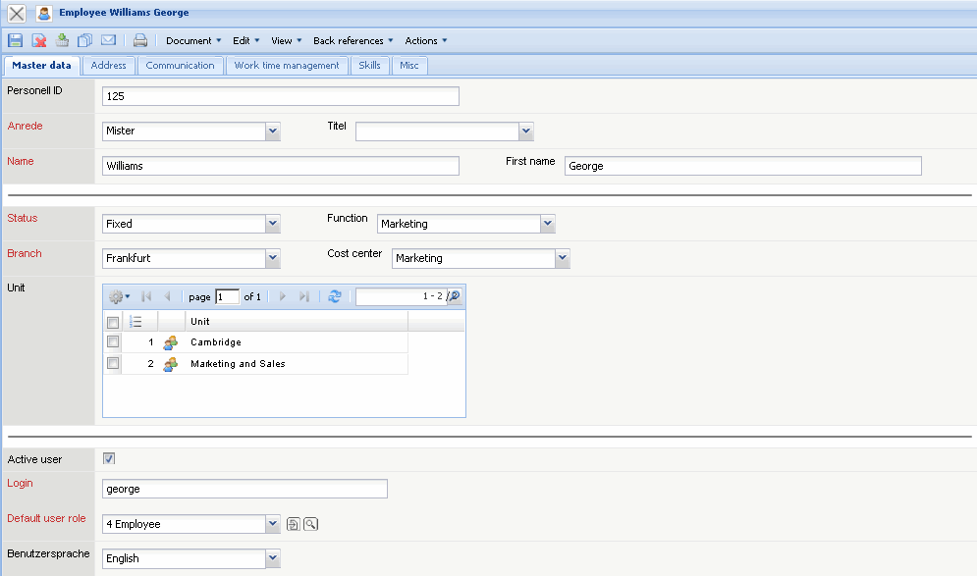
The form consists of the following elements:
On the “Master Data” tab:
- Personnel Nummer (ID): A personnel number (ID) can be entered in this alphanumeric field and is of informal nature.
- Salutation, Title, First Name and Last Name: These fields specify the salutation or/and the title, as well as the first and last name of the employee. The features for the salutation can be defined and modified in Collections.
- Language: This field defines the language of the employee. The language can be defined and modified in Collections. If the corresponding translation is stored in the system, the language of the user will be automatically used when logging in.
- Employee Status: The field Status specifies the status of the employee. For example, permanent employee, freelancer and external employee are, for example, features that can be possibly used.
- Branch Location: The field location specifies the location of the company's headquarters or company's branch, where the employee is employed. The locations can be defined and modified in Collections. The Collections for the locations can be in defined and modified in the calendar form.
- Unit: The units (organisation units, usually locations and/or departments)to which the employees belong can be entered in this field. These units can be used as the basis for the local permission system (see administration guide).
- Active User: This field specifies the status of the employee in System. Only active employees can work with Projectile exclusively.
- Log In: This field is relevant for logging in the system. Each employee must log in to the system with his/her login name and password. The system recognizes the employee through the login data entered in Actions and assigns the corresponding user group to the logged in user. From these assigned access permissions, only the documents for which the employee has access permission is displayed.
- Standard User Group: The element user group assigns the corresponding access permissions to the selected employee. This ensures that only the document types which the respective employee has access permissions to, will be diplayed.
- Language: In this field can be defined the user language.
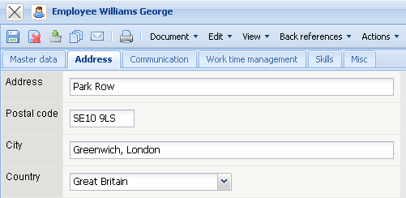
On the “Address” tab:
- Address, Postal Code, City and Country: These fields specify the complete address of the employee. The country can be defined and modified in Collections.
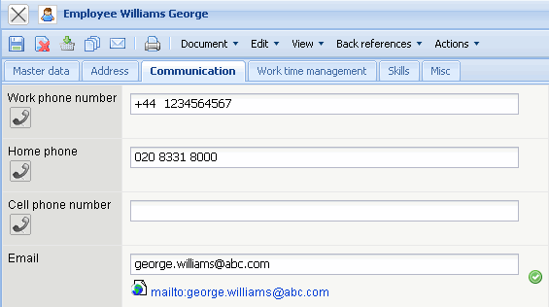
On the ““Communication” tab:
- Telephone, Private, Mobile und Email Address: These fields specifiy ways of communication with the employee via telephone (office, private and mobile/cell) and per email. Clicking the e-mail address opens the user's standard mail program with the stored email address. The e-mail address is also relevant for the time service function.
- Department, Function: These fields specify the employee's department and his/her function within the company. These fields can be defined and modified in Collections.
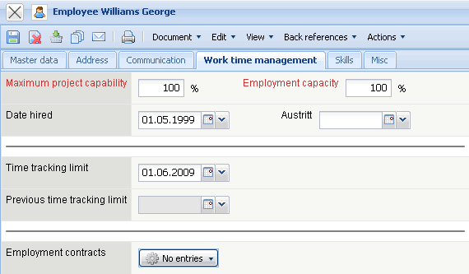
On the “Work Time Management” tab (not standard):
- Maximum Capacity: This field specifies the maximum capacity for an employee's work projects. This percentage rate reflects the maximum proportion of time in which the employee can/should be included for a project. When a project team is compiled in the suggestion scheme, this upper limit is displayed.
- Maximum Working Time: This field specifies the maximum working time of an employee (100% equals full time; 50% equals a part-time job).
- Time Tracking Limit and Previous Time Tracking Limit: Date of last or previous time tracking limit.
- Overtime Account: The field overtime displays the current overtime and undertime of the employee since the last posting date. The calculation of overtime is performed using working time recording (time tracking) and employee master data, regarding the working time (see also working time administration.
- Vacation Account: The field “vacation account” shows the difference between vacation entitlement and vacation already taken. This difference up to the last posting date is transferred here(see posting date Vacation and chapter Working Time Management).
- Flexible Working Time: This element administers the flexible time account of the defined employee (Attention: not a standard function: see also Work Time Administration).
- Paid Time: This field displays all hours of manually entered time posting of the type “paid” (see also Work Time Administration).
- Posting Date for Overtime, Vacation, Flexible Work Time and Special Hours: This date specifies the last posting date of the account overtime, vacation, flexible working hours, special hours (see also Working Time Administration)
- Employment Contract: The employee's contracts are specified in this selection list. Employee contracts can be defined for a time period (see also Working Time Administration):
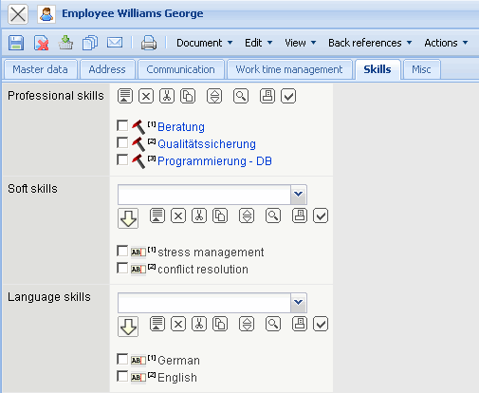
On the “Skills” tab:
- Occupations: Occupations for the suggestion scheme can be assigned in this field. This suggestion scheme assists the user with project planning with help of the project template or through manually defining work packages Jobs (optionally only the employees, who have the designated skill/occupation will be displayed).
- Soft Skills, Language Skills: Further skills of the employee can be assigned in this field.
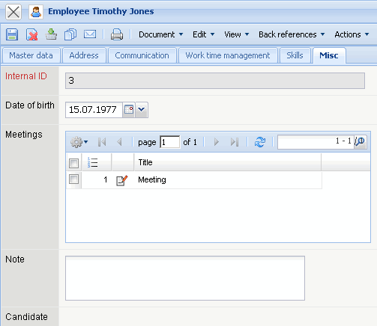
On the “Misc” tab:
- Internal Key: This alphanumerical field specifies uniquely the employees in the System.
- Cost Unit: This field specifies the cost unit of the employee. The cost unit can be defined and modified in Collections.
- Internal Hourly Rate, Partial Cost Rate (possibly, charge/cost rate 1 and 2): This field specifies the costs per work hour of the employee. This value is relevant for detailed internal cost fixing, if no employment contract as been used. If no internal cost/charge rate for an employee is stored in the system, the costs are defined through the internal rates from the Occupations form.
- External Hourly Rate (also time-based): This field specifies the figures for the calculation of the employee per work hour. If a calculation rate for an employee is stored in the System, this rate is considered when calculating the work services (see also pricing).
- Date of Birth: This field specifies the date of birth of the employee.
- Contract Hiring Date: This field specifies the hiring date of the employee.
- Contract Termination Date: This field specifies the termination date of the employee.
- Comments: This field can be used for comments.
The document type contains following actions:
- Set/Modify Password: With the help of this action, it is possible to change the password of the selected employee. Attention: The passwords are written encrypted in the database and cannot be modified. If an employee forgets their password, a new password (or empty password) must be generated, in which the employee should change at the first log in.
The following actions are available, if the work time administration is licenced:
- Add Contract: With this action the employment contract are created.
- Add Time Posting: With this action time posting for employees are newly created.
- Post Time Account: With this action posting between the individual work time accounts can be performed, for example, vacation paid out (debit) or special hours posted to overtime.
- Empty Time Buffer: With this action, all time postings of the employee can be deleted.
- Show Employee Time Posting: With this action, all employee time postings of this employee are displayed.

