2.01.17 Customer-Related Occupations
The Customer-related Occupations form administers the calculated rates (per hour), which differs from the standard rates (usually defined in Occupations), that is used for a designated customer.
Tip: For more more on this subject see chapter 3.11.05 occupation administration and pricing.
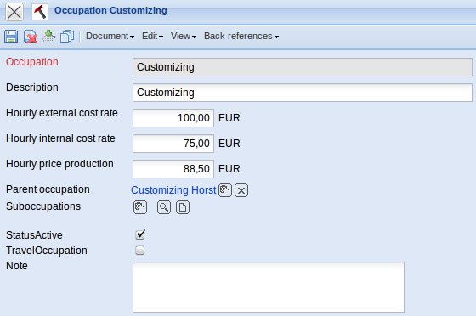
The form contains the following elements:
- Occupation: This field specifies the occupation for which the altered rates exist.
- Description: This field specifies the description of the occupation.
- Hourly external cost rate: The external charge/cost rate per hour for this occupation is defined here. This rate is applied to (if no project-specific alteration exists) the quotation and invoicing.
- Hourly internal cost rate: The internal cost/charge rate per hour for the customer is defined in this field. This rate is only applied if no project-related cost/charge rate or employee-related rate is stored in the system.
- Hourly price production:
- Parent occupation: This field specifies the assigned contact to the altered occupation rates.
- Suboccupations:
- Status Active:
- Travel Occupation:
- Note: This field is designated for comments.

