2.01.17 Decision Maker
The Decision Maker menu administers the persons participating in the sales tunnel (contact person) in the system. The position, the influence, the attitude and various other settings can be entered here.
Tip: For more on this subject see chapter 4.1.04 The Contact System 4.1.04 Das Kontaktsystem.
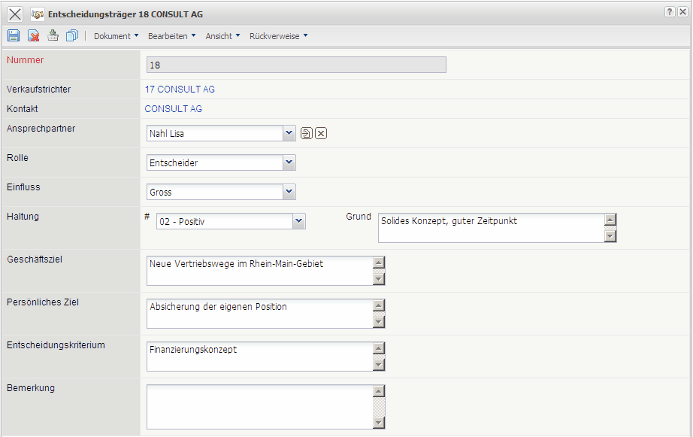
The menu consists of the following elements:
On the “Main” tab:
- Number: The element number defines distinctly the decision makers in the system.
- Distribution Channel: This field assigns a distribution channel to the the decision maker.
- Contact: This field assigns a contact to the decision maker.
- Contact Person: Here the contact's contact person is definied to the decision maker.
- Position: The in Collections (see Administration Guide) defined positions of the decision makers (e.g. user, decision maker, approver, tester/inspector, etc.) are stored in the field position.
- Influence: The in Collections (see Administration Guide) defined influencial characteristics (e.g. large, middle, small, etc.) can be stored in the field influence.
- Attitude and Reason for Attitude: The in Collections (see Administration Guide) defined attitude of the decision maker (e.g. positive, neutral, negative, etc.) can be stored in the field influence. The reason for this attitude can entered in the text field reason.
- Business Objective, Personal Goal und Decision criteria: Further attitudes of the decision maker, such as business objective, personal goal and decision criteria.
- Comments: Comments concerning the decision maker can be entered in this field.

