2.01.15 Sales Pipeline
The Sales Pipeline form administers the possible orders in the system. The classification, as well as need for action, distribution phase, order possibility, probable order value and the total budget can be entered here.
Tip: For more on this subject see chapter 3.11.04 The Contact System.
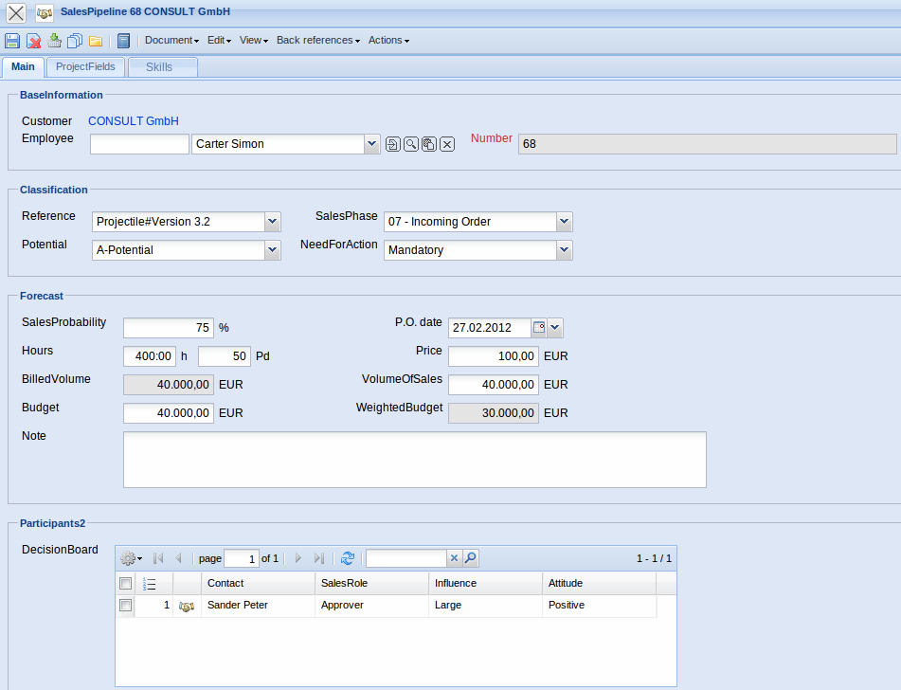
The form consists of the following elements:
On the “Main” tab:
- Customer: This field assigns to the corresponding contact the sales pipeline.
- Employee: This field specifies the publisher of the sales pipeline. The emplyees can be difined or changed in the dokument Employee.
- Number: The element “Number” specifies distinctly the sales pipeline in System.
- Reference: The doposited reference types of the collection can be selected and defined in the field reference (e.g. training, workshops, etc.).
- Potential: The in the Collections (see Administration Guide) defined gradation, regarding the quality of the business contact (e.g. A-contact, B-contact or C-contact) can be stored in the field Potential.
- SalesPhase: The in the Collections (see Administration Guide) defined distribution phase(e.g. first contact, qualified contact, information material, presentation, offer, etc.) can be stored in the field distribution phase.
- NeedForAction: The in the Collections (see Administration Guide) defined gradation, regarding the need for action (e.g. low, significant or mandatory) can be stored in the field need for action.
- SalesProbability: The offer probability of the distribution activity is stored here.
- Hours: In service projects the potential work/input in hours can be stored here.
- BilledVolume: In service projects this value is the product of the work/input in hours and the hourly rate.
- Budget: The total budget of the distribution activity is stored here.
- P.O. date: This field specifies the creation date of the sales pipeline.
- Price: The potential hourly rate with service products can be stored here.
- VolumeOfSales: The potential order value of the distribution activity is stored (or calculated) here. In the example, an order of EUR 40.000,00 to the possibility of 75% is calculated in the beginning of February 2012.
- WeightedBudget:
- Note: Notes concerning the sales pipeline can be entered here.
- DecisionBoard: As many decision-makers as needed, including their settings for the sales pipeline, can be stored here. These persons and their settings can be defined in the document decision-maker.
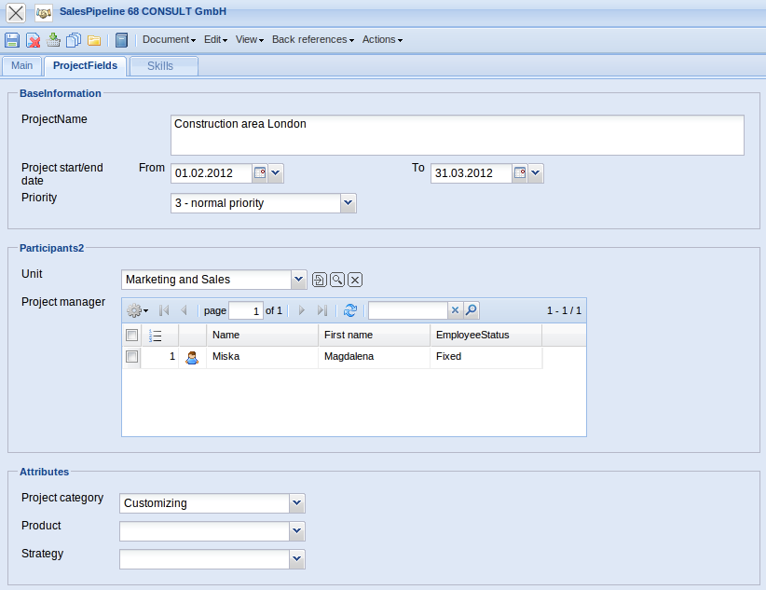
On the “Project Fields ” tab:
- Project Name: This field identifies the upcoming project.
- Project Time Span from/to: The field “from” defines the prospective project begin and the field “to” defines the prospective project end of the potential project.
- Priority: This field specifies the priority of the potential project.
- Unit: In this field the responsible unit for the upcoming project is specified (usually a location or a department. Units can be modified in the Unit form.
- Project Manager: This field specifies the potential project manager for the upcoming project.
- Project category:
- Product:
- Strategy:
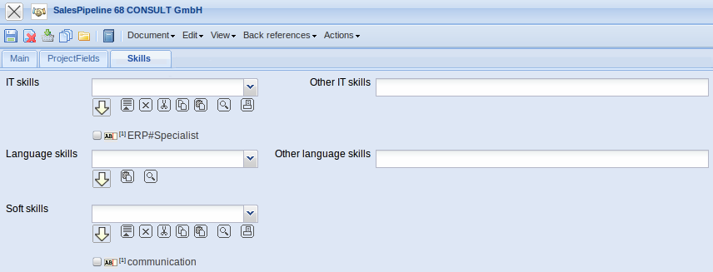
On the “Skills” tab:
- IT skills:
- Other IT skills:
- Language skills:
- Other language skills:
- Soft skills:

