2.01.14 Campaign
The campaign form adminisiters the marketing and distribution campaign in the system. Among others, the person responsible for the campaign, the class and status, the time span, the target group and goals, as well as the financial parameters of the campaign are administered here.
Tip: For more on this subject see chapter 4.1.04 The Contact System4.1.04 Das Kontaktsystem.
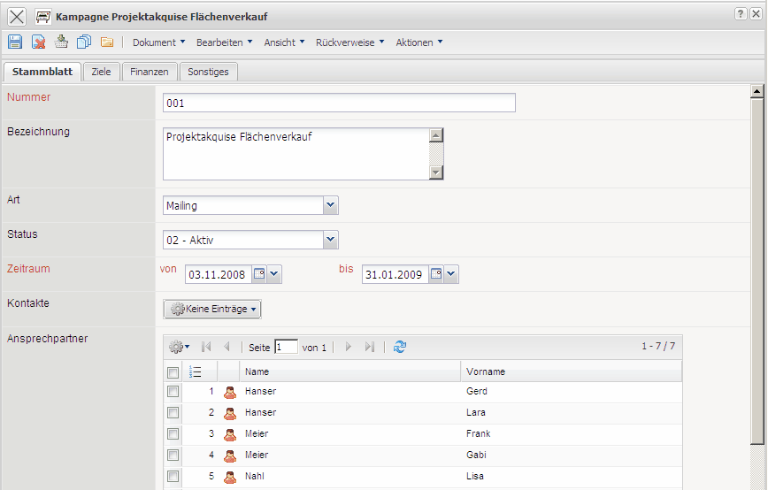
The form consists of the following elements:
On the “Main” tab:
- Number: The element number specifies distinctly the campaign in the system.
- Description: This field describes the project.
- Person Responsible: This field specifies the person responsible for the campaign.
- Type: In the field Type, the in Collections (see administration guidelines/manual) defined types of campaigns (e.g. email, television, mailing, exhibition, etc.) can be assigned.
- Status: This field specifies if the campaign is recorded(erfasst), active or completed. When creating a new campaign, the system sets this field with recorded by default. Further characteristics (halted, discontinued) can be defined by the administrator.
- Time Span from/to: This field “from” defines the estimated begin of the campaign and the field “to” defines the estimated end of the campaign. An entry for these fields is manditory.
- Customers: This field specifies the firm as the target group for the campaign. The contacts can be defined and modified in the Contacts mask.
- Contact Persons: This field specifies the customer's contact person (see Contact Person mask).
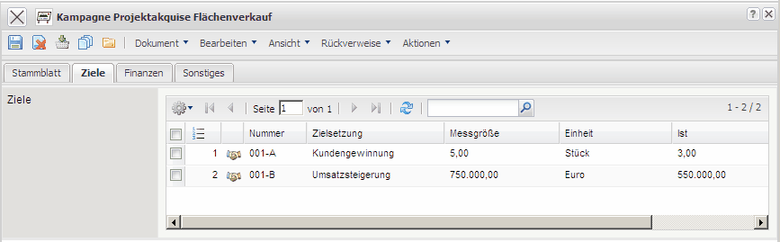
On the “Objectives” tab:
- Objectives: The campaign goals can be defined here. These goals can be administered in the Campaign Goals mask.
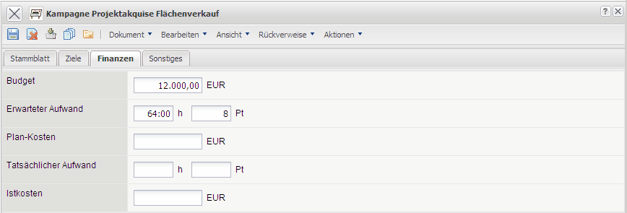
On the “Financial data” tab:
- Budget: The campaign budget can be entered here.
- Estimated Effort: This field defines the expected expenditure for the campaign.
- Estimated Costs: The planned costs for the campaign can be entered here.
- Actual Effort: The rendered expenditure for the campaign are entered here.
- Actual Costs: The incurred costs of the campaign are entered here.
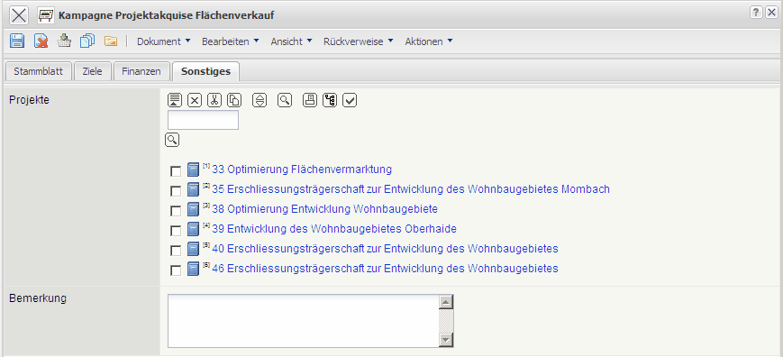
On the “Misc” tab:
- Projects: The projects which have been acquired through the campaign can be assigned here. The projects can be defined and modified here.
- Comments: Comments on the customers can be entered in this field.

