2.01.12 Customer
The “Customer” form administers the business contacts. All information about the company of the customer, like the description, address and ways of communication are stored and saved here. For a better overview of all the structural business contacts and for better processing, it is possible to save and store information related to the category, the reference, contact type, as well as the corresponding branch. Furthermore, the currency and the charge rate can be administered as well. This data is needed for defining projects in the document type project and is necessary for posting proposals and invoicing into the billing document Billing Module.
Tip: Further information to this topic can be found in chapter 3.11.04 The Contact System.
The form contains the following elements:
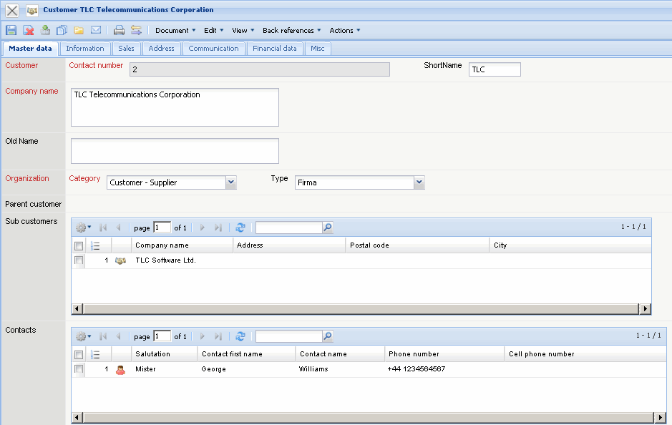
On the “Master Data List” tab:
- Number and Abbreviation: The element “Number” specifies the exact contact within the system and the “Abbreviation” can be used for the number range or be used for the quick search.
- Company Name and Previous Company Name: These alphanumeric fields describe the current company names and where applicable the previous company names.
- Category: In the field “Category” it is possible to define the types of contact (for example: Customer, Interested Party, etc.)and allocate them into “Collections” (see also Administration Guide).
- Type: In the field “Type” it is possible that defined contact types (for example: Company, Network, Association, etc.) can be allocated into the “Collections” (see Administration Guide).
- Parent Customer: The field “Parent Customer” characterises the existence of a superior contact (for example a “Holding”) and creates the company's structure in Projectile. If this element is not filled, then the contact is itself a superior contact. When applying a subordinate contact then this field will be automatically filled.
- Sub Customer: This element contains a register of all allocated subordinate contacts. After the definition of “Subsidiaries”, they will then be automatically transferred into the subordinate contact.
- Contact: This field specifies the contact person from the customer (see also Contact).
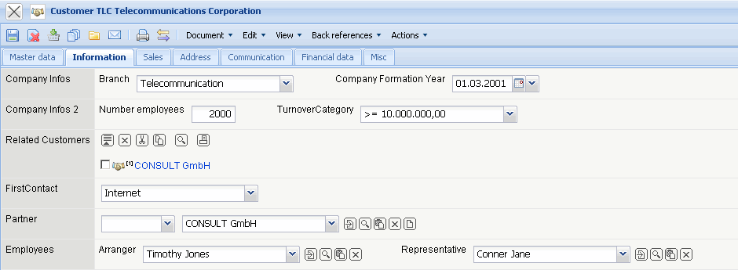
On the “Information” tab (implementation example):
- Branch and Establishment: Here is where the branches of the contact and the date of the establishment can be stored and saved. The branch can be defined in “Collections” (see also Administration Guide)
- Number of Employees and Revenue (Revenue Class): Here is where the number of employees and the revenues of the contact can be stored and saved. These fields can be used as the selection criteria (for example for “Mailings”).
- Known Customers: Here is where various defined contacts can be allocated.
- First Customers: Here is where the first contact type (“Internet”, “Campaign”, “Cold Call”, “Partner”, ...) can be entered.
- Partner (and possible Commission): Here is where the sales partner, with the respective commission, can be entered.
- Arranger and Representative: Here is where the customer service agent can be entered. This/these employee(s) are responsible for the contact.
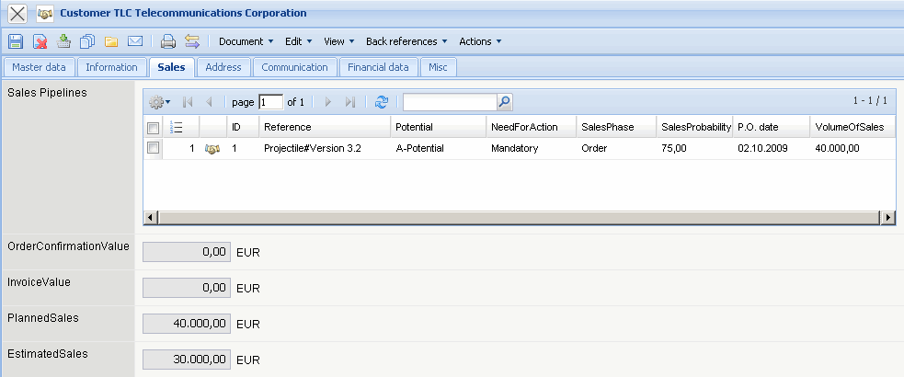
On the tab “Sales” (implementation example):
- Sales Representative (no pre-set): Here is where the distribution goals for the sales representatives can be entered.
- Campaign: Here is where all the campaigns from the system will be allocated, where the defined contact is included in the target group. The campaigns are administered in the form “Campaigns”.
- Sales Outlet: Here is where all the sales outlets for the customer are listed. The sales outlet are administered in the form “Sales Outlet”
- Order Value and Invoice Value: Here is where the system lists the sum of all order confirmations as the “Order Value” and the sum of all complete bills from all of the projects of the customer as “Invoice Value”.
- Projected and estimated Order Value: The projected order value will be directly out of the form “Sales Outlet” defined, the estimated order value will be, in respect to the possible order probability, defined.
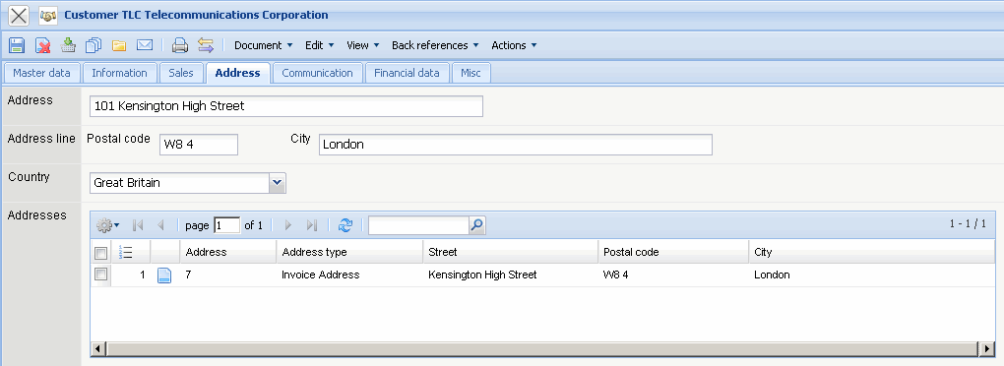
On the tab “Address”:
- Address, Zip Code, Location and Country: These fields specify the complete address of the customer and are needed, with the proposal preparation and invoicing .
- Address, Zip Code, City and Country: These fields specify the customer's complete address and are needed for quotation and invoicing. The countries can be defined and modified in Collections (Administration form).
- Region: The contact's distribution region for chart results can be entered here.
- Further Addresses: Further customer addresses can be entered here. If the billing address/delivery address differs from the company address, it can be specified here. These addresses will be managed here.
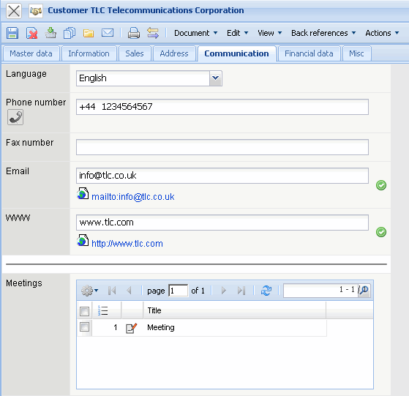
On the “Communication” tab:
- Languages: The language field defines the customer's language. The languages can be defined and changed in Collections.
- Telephone, Fax: These fields define the customer's accessibility per telephone and fax.
- Email Address, Web: These fields define the email addresses and the customer's URL (internet address). Clicking on the email address opens the user's standard email program with the registered email address. Clicking on the web field opens the standard browser with the respective URL.
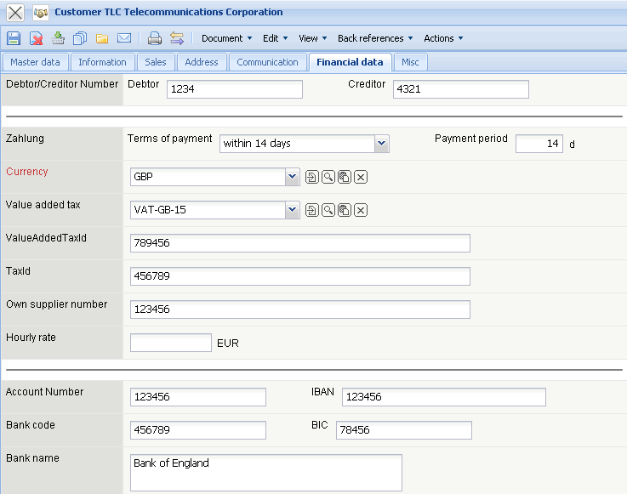
On the “Financial data” tab:
- Debtor number/Creditor number: The finance accounting interface (Fibu-Schnittstelle) of the debtor number(customer) and/or creditor number(supplier)can be stored here.
- Term of Payment, Payment Arrangements: This field defines the term of payment and the payment arrangements of the customer.
- Currency: This field defines the general currency of the customer. This currency is the standard for all projects for this customer. But, this can be overriden for the project's currency. The currency can be defined and modified in the currency mask.
- Value-added Tax: In this field the value-added tax is assigned from the drop down form. By default, the field tax rate is allocated from the country which has been assigned in the configuration mask. The value-added tax can be defined and modified in the value-added tax form. This value is used as the allocation for issuing a quotation and invoicing.
- Value-added Tax ID and Tax Number: The value-added tax ID and tax number (relevant for the invoicing) can be assigned here.
- External Hourly Rate: This field defines the amount the customer would usually charge for one hour project work. This amount is only relevant with fixed-price projects or outline agreements and can be overwritten with a project-specific hourly rate. The project hourly rate is assigned in the Project mask; activity-related hourly rates can be defined in the Activity mask (also see Pricing).
- Discount: A discount for the contact can be entered here. This discount will be used, if necessary, with the quotation and invoicing when creating the discount positions (when using the billing module - see chapter 2.4).
- Additional Charge for Variable Costs: This value is needed for additional charges with third-party positions, when these positions are based on the variable costs. When invoicing, When an invoice is issued, Projectile checks if the added third-party positions belong to the supplier and adds, when necessary, this position as additional charge. If there is an additional charge or not, is controlled in the type of costs, through the same-named flag. The additional third-party costs are stored in the form of two fields in Project and Contact.
- Bank Data (account number, bank code number (identification code), name of bank, IBAN, BIC): This field defines the customer's bank account data.
- Own Supplier number: Your own supplier number can be defined here. This number can be used when creating the invoice numbers.
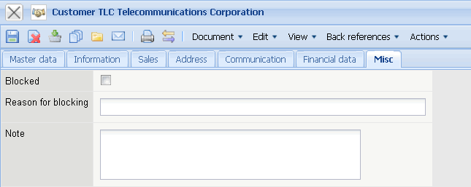
On the “Misc” tab:
- Blocked, Reason: This box can be checked when the customer should no longer be consulted as a client for a project. The reason for being blocked (insolvency, payment practice, ...) can be entered in the next field.
- Comments: This field allows entering comments about the customer.
The document/form type contains the following actions:
- Create Staff Records by Customer: Using this this action, price tables can be defined customer-ralated for the staff (see also Pricing and Staff Records by Customer).
- Create Staff Records by Customer: With the help of this action all defined staff records will be displayed.
- Create Staff Records by Customer: With the help of this action all price tables for the operations/activities can be defined client-related (see also Pricing and Customer-based Occupations.)
- Create Staff Records by Customer: With the help of this action all defined client-based operations are displayed.

