2.01.12 Automobile
The menu “Automobile” administers the automobiles within the system. The automobiles will be issued a holder and an appointment for the inspection. The automobiles will be needed for the transportation billing.
Tip: further information on this topic can be found under article 4.1.02 Administration of Key Data.
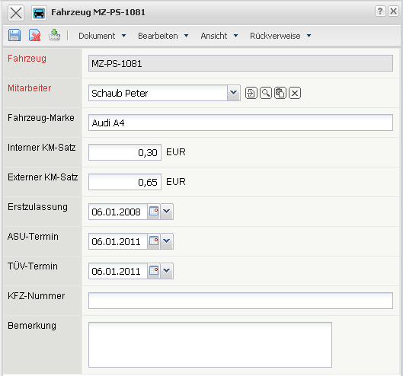
The menu contains the following elements:
- Automobile: The alphanumeric field “Automobile” specifies the destinct type of automobile used.
- Employee: In the field “Holder” the holder to the corresponding car will be designated. Only the employees, who are entered and listed in the system, are considered for this field. (see also the menu “Employees”)
- Automobile-Type: This field specifies the model of the car.
- Internal Kilometer Price: This is where the car-specified car costs per kilometer can be entered. These cost are pulled down for the bill of charges. If this field is not filled, then the distance flatrate out of the menu configuration will be pulled-down and used for the bill of charges.
- External Kilometer Price: This is where the car-specified rates for the transfer costs per kilometer are entered. If this field is not filled, then the distance flatrate out the menu configuration will pulled-down and used for the bill of charges.
- Date of First Registration: In the field “Date of First Registration” the date of first registration will be entered. The system calculates automatically out of this the expiration date of the emmission's test (ASU) and of the technical inspection (TÜV).
- Emmission's Test (ASU) and Technical Inspection's Test (TÜV): Both fields are there to specify the date of the emmision's test and the date of the technical inspection. On the basis of the first date of registration, the fields for “Emmission's Test (ASU) and Technical Inspection's Test (TÜV)” in accordance with the lawful regulated specifications, are set by default automatically from the system.
- Car Identification Number: This field administers the information within the car's registration papers.
- Comment: This field is designated for comments.

