2.01.10 Cost Type
The menu “Cost Type” administers groupable cost types for the budget management and the cost input. The system deciphers between project costs and common costs, that are subdivided in any order. Many project costs (voyage costs, travel costs, external services) are urgently needed and can not (like the chief cost types such as project costs and common costs) be erased. The grouping of the cost types will be defined over the chief cost type.
Tip: further information on this topic can be found under article 4.1.03 Administration of Cost Types.
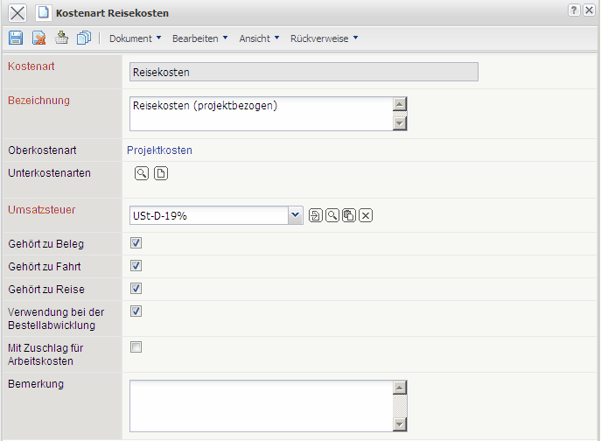
The menu contains the following elements:
- Cost Type: This alphanumeric field specifies the exact cost types in the system for further usage with the budget administration, cost accounting and billing module.
- Description: The field “Description” allows for the description of the cost type and has informal characters.
- Chief Cost Type: The field “Chief Cost Type” characterises the existence of a higher cost type. If the option's menu is empty, then the cost type is not subdivided; such as a chief cost type. The chief cost types in the system (project costs and common costs) can not be erased.
- Sub Cost Types: This multiple option contains all derived cost types of the defined cost type.
- Purchase Tax: In this field the purchase tax will be used as the default.
- Fibu-Account (only when using Billex): This field allows the allocation of an account out of accounting to define the cost type. This allocation, when using the “Dative-Interface” or with the “Fibu-Interface”, will be needed (Billex module).
- Pertains to Voucher, Trip, Voyage or Order Handling: These attributes adjust the usage of the defined cost type in the cost accounting.
- With Surcharge for Labour Costs: This attribute is needed for surcharges with foreign cost positions, when these postions are based on labour costs. Projectile verifies during billing if in a bill a foreign cost position belongs to a supplier and adds, if applicable, theses positions with a surcharge. If a surcharge is available or not available, will be adjusted in the cost type over the correspondent flag. The foreign surcharge cost will be saved in the form of two fields labeled “Project” or “Contact”.
Annotations:
- Field labeled “Surcharge for Labour Costs” in “Contact” (the rider labeled “Miscellaneous”)
- Field labeled “Surcharge for Labour Costs” in “Project”, will be handed-down from the customer (the rider labeled “Finances”)
- Cost type with a new field labeled “With Surcharge for Labour Costs”
- When the foreign cost position is takenover in a bill, the surcharge will be considered. When the attribute in the cost type is set, then within the project the position of the surcharge will be pulled down, otherwise the surcharge is set to the customer of the project.
- Description: This field allows for the entry of descriptions for the cost type.

