2.01.09 Flat Rate
The “Flat Rate” form administers the country-specified lawful daily allowance flat rates and overnight flat rates. The internal daily allowances are needed for the employee to calculate the payments of the daily allowance rates and the overnight rates within the range of the travel expenses and can be billed (by appropriate agreement) to the customer.
Tip: Further information on this topic can be found in chapter 3.11.02 Administration of Key Data.
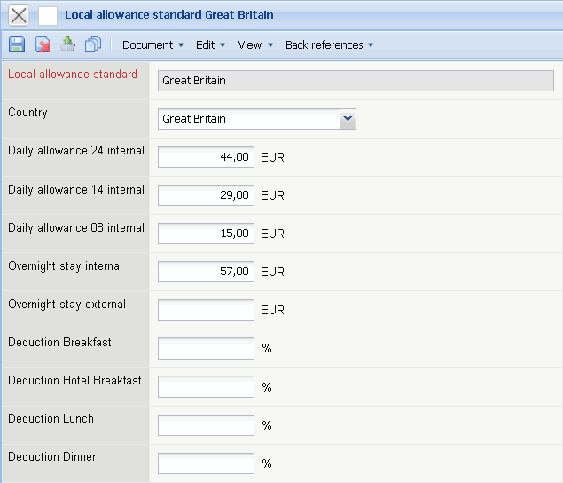
The form contains the following elements:
- Flat Rate: This field specifies the exact flat rate for the daily allowance and the overnight flat rate. Hereby the various flat rates are adjusted with the cost of living within a country. Great Britain, for example, there exist three flat rates for the country Great Britain as well as London and Manchester.
- Country: This field specifies the country, for which the flat rate is valid.
- Daily Allowance for Absence as of 24hrs., 14hrs. and 8hrs.: These fields define the rates of the daily allowances for trips. The system automatically determines the daily allowance according to the times the employee is absent, when posting the travel expenses.
- Overnight Stay (Internal and External): In these fields it is where the rates for calculated overnight accommodations are determined. If the sales representative takes one overnight stay, then it is his free choice to either have the overnight accommodation billed per invoice or according to the overnight flat rate have the employer pay him/her out.
- Deduction Mealtimes (%): Percentile deduction of the mealtime condition for the calculation of the extra catering costs when traveling abroad.

