2.01.07 Exchange Rates
The document type “Exchange Rates” administers the currency exchange rate between two currencies. For this, a source currency and a target currency factor will be defined with the corresponding rate. The conversion ratio is necessary for the conversion of the currency fields.
Tip: Further information on this topic can be found in chapter 3.11.02 Administration of Key Data.
Note I: Rates can be “frozen” for projects, receipts and invoices until cutoff date.
Note II: In case a second currency is to be used, then the quotation between the local currency and the second currency are to be defined (see also Document Type Configuration and the further comments in the Administration Guide).
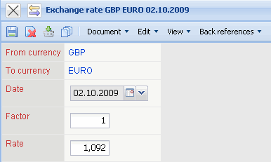
The form contains the following elements:
- Source Currency: In this field the source currency can be chosen for the conversion. The displayed entries of this list can be defined in Currencies.
- Target Currency: In this field the target currency can be chosen for the conversion. The displayed entries of this list can be defined into Currencies.
- Date: This field specifies the date, as soon as the specified quote is pulled up system-wide into the conversion and overwrites as of this date older specifications.
- Factor: This field is used for the entry of the factor of the source currency for the conversion of the currencies. This field has Factor 1 as the default.
- Rate: This field is used for the entry of the exchange rate between the currencies. In the example above a conversion ratio from EURO to US Dollars valid as of 03.03.2004 is defined. Here it is noted that 1 EURO is exactly 1,2105 USD.

