2.01.07 Exchange Rates
The document type “Exchange Rates” administers the currency exchange rate between two currencies. For this there will be a source currency and a target currency factor defined. The conversion ratio is needed for the conversion of the quotation fields.
Tip: further information on this topic can be found under article 4.1.02 Administration of Key Data.
Annotation I: Rates can be “frozen” for projects, vouchers and invoices up until cutoff date. Annotation II: In case a second currency is to be used, then the quotation between the local currency and the second currency are to be defined (see also Document Type Configuration and the further comments in the Administration Guide).
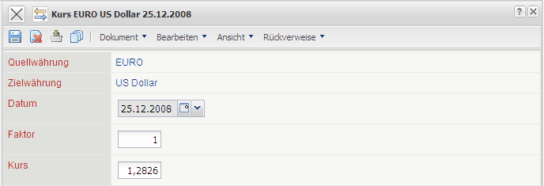
The menu contains the following elements:
- Source Currency: In this field the source currency is allowed to chose the conversion. The displayed entries of this list can be defined into currencies.
- Target Currency: In this field the target currency is allowed to chose the conversion. The displayed entries of this list can be defined into currencies.
- Date: This field specifies the date, as soon as the specified quote is pulled up system-wide into the conversion and overwrites as of this date older specifications.
- Factor: This field is used for the entry of the factor of the source currency for the conversion of the currencies. This field has Factor 1 as the default.
- Exchange Rate: This field is used for the entry of the conversion ratio between the currencies. In the example above there is a conversion ratio from EURO to US Dollars valid as of 03.03.2004 defined. Here it is noted that 1 EURO is exactly 1,2105 USD.

