2.01.04 Calendar
The Calendar form administers the business calendar of all the locations for the system. Here is where it is possible for every business location to specify the days and hours worked weekly such as the number of workdays per week. This data is needed for the overview and resource planning (especially for the policy of the designated working hours). Furthermore, this is where the parameters for the working hours can be managed.
Tip: further information on this topic can be found under article 3.11.02 Administration of Key Data.
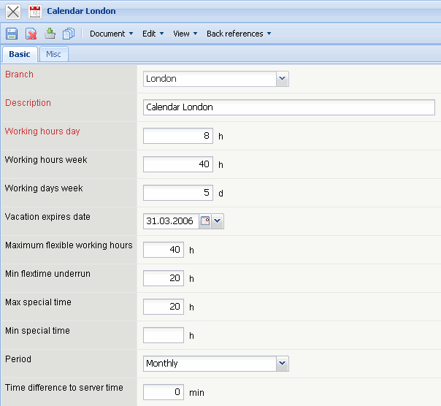
The form contains the following elements:
On the “Master Data List” tab:
- Location: The field “Location” specifies the exact location, that is valid for the business calendar.
- Description: This field allows for the description of the calendar for more accurate specification.
- Working Hours per Day: The field “Working Hours per Day” specifies the normal working hours per day. These hours of work are needed for the calculation of the capacities and overtime hours (e.g.: 8 h working hours per day)
- Working Hours per Week: The field “Working Hours per Week” specifies the normal hours of work per week (e.g.: 40 h working hours per week).
- Work Days per Week: The field “Work Days per Week” specifies the number of days per week. Thereby numerical values between 0 and 7 can be entered (e.g.: also the description of a 5,5 days per week). When entering the days worked and the weekly working hours, this field is filled automatically.
- Expiry Date for Remaining Leave: The expiry date will be specified for the time administration in this date field. If the remaining leave from the calendar year is not taken by this date, then the remaining leave is forfeited during posting of the vacation items. Remark: Here is where only the date specification, day and month, is relevant; the year specification will be ignored from the time administration.
- Maximum Flextime Buffer: This field specifies the flextime buffer for the time administration within the range of the flextime.
- Allowed Target Time Lower Deviation: This value specifies the maximum lower deviation for the target time.
- Maximum Extra Hours Buffer: This value specifies the maximum extra hours buffer (is not supported in the standard version).
- Allowed Extra Hours Lower Deviation: This value specifies the allowed extra hours lower deviation (is not supported in the standard version).
- Period: The check box “Period” specifies the time period for the fields: “Maximum Flextime Buffer”, “Allowed Target Time Lower Deviation”, “Maximum Extra Hours Buffer” and “Allowed Extra Hours Lower Deviation” within the range of the time administration.
- Time Shift: This value specifies the amount of hours from the time shift of the calendar in accordance with the server time. This field can also accept negative values.
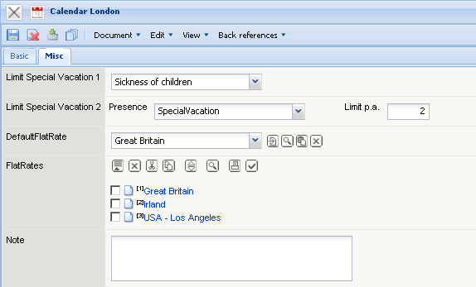
On the “Miscellaneous” tab:
- Limitation of Special Absences: Here is where for the types of absences (special leave, child's illness, ...) the maximum amount of days per year as a basis for plausibilities of absences can be entered. In “TimeTracker” the rules for these absences are checked. Remark: The absences vacation and sick leave only are included in the standard version.
- Standard-Flat Rate: Here is where the default of the flat rate will be entered into the travel cost entry (see also the form “Voyage”).
- Comment: This field is designated for comments.

