2.01.03 Timed Action
The “Timed Action” form administers the system services for periodic actions within Projectile. This includes for example, reminders or information per e-mail to various users or user groups as well as automatically generating evaluations and similar procedures. For every Timed Action a On the tab "Miscellaneous": and a Period can be defined in here.
Tip: further information on this topic can be found under article 3.11.01 System Data Administration.
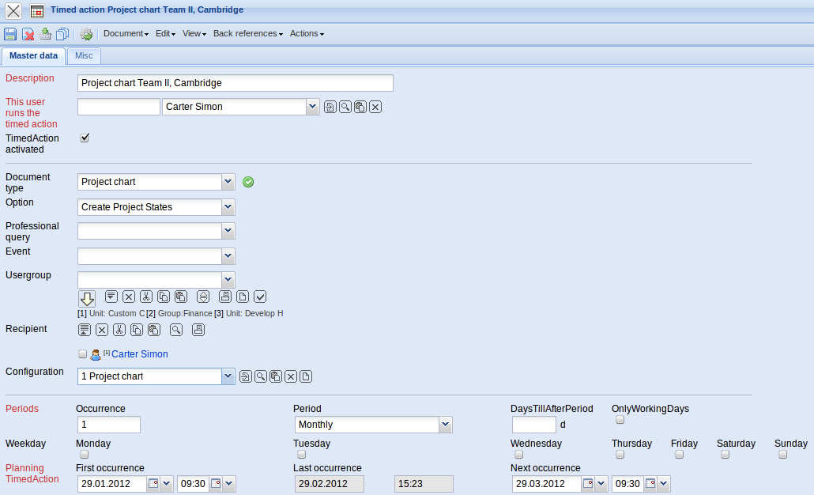
This form contains the following elements:

On the "Master Data List" tab:
- Description: This field specifies and allows for the description of the time service.
- This user runs the time service: In here the user of the time service is defined.
- Time Service active: This field shows if the time service is active.
- Document Type: This field specifies the document type, upon which the time service is based and allows for the correct allocation of a corresponding option. If this field is not filled, then the option available is the standard time services (reminders, status messages...).
- Option: This element specifies the type of service. Herewith the following options are allowed: document-type action (forms) and standard time services (a detailed listing of this is located in the Administration Guide).
- Professional Search: This selective box lists all available professional searches of the system, that have allocated report definitions. If a professional search is allocated here, then this request will be periodically executed through the time service and sent to the recipient.
- Event: The events that will trigger the time service will be shown here (in case the time service is not to be adjusted periodically).
- User Group: This field specifies the recipient (based on the authorized groups in the system) of the time service.
- Recipient: This field specifies the recipient (based on the employees in the system) of the time service.
- Configuration: If an action is chosen as an option for the time services within a document type (for example an analysis), then this action has to be configured here.
- Repeating after x Periods: This field indicates the number of periods for which the time service is to be repeated.
- Periods: This field indicates the maximum periods for the time service. The user can select between “yearly”, “monthly”, “weekly”, “defined days”, “daily” and “hourly”. Then defined time service starts the execution of a defined action within this period.
- Difference to Period Beginning: This field defines the difference to the beginning of the period.
- Only working Days: In this box a check mark is only set, if the period applies only to working days.
- Weekday (Monday until Sunday): These fields define the days and they are only for the period “defined days” relevant. The defined time service starts with this option on each of the selected day(s).
- First, Last and Next Time Service: These fields record the first, last and next call of the service time. These fields are required for the processing of the periodic time services.
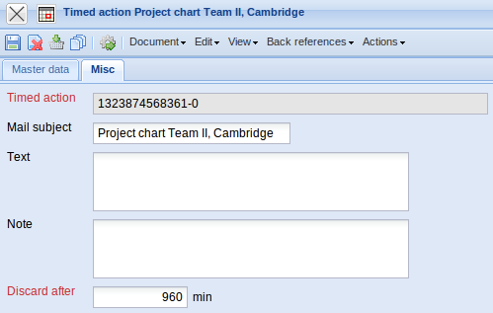
On the “Misc” tab:
- Time service: In this field a name for the time service is defined.
- Mail-Subject: This element allows the specification of the subject heading for the generated e-mail.
- Text: Here, as a reminder, is where a text for a generated e-mail can be written.
- Note: This field allows the entry of comments on time service.
- Discard to: In case the system is overloaded with the processing of all time services, then it is possible to enter into this field how many minutes after the deadline a time service is still valid. If a time service is after this deadline no longer valid, then the time service will be given the next appointment.
The Document Type includes the following actions:
- Execute now: With the help of this action, it is possible to execute a time service immediately. The result (for example a configured analysis) will also be shown in the application.
- Setting the Configuration: With the help of this action the configuration of the time service will be set. In case analysis is chosen as document type, then the corresponding analysis will be opened. The desired selection criteria will be specified and the analysis stored.

