2.01.02 System
The menu “System” administers the parameters for the system in Projectile. This includes the path for the billing documents and other system properties.
Tip: further information on this topic can be found under article 4.1.01 Administration of System Data.
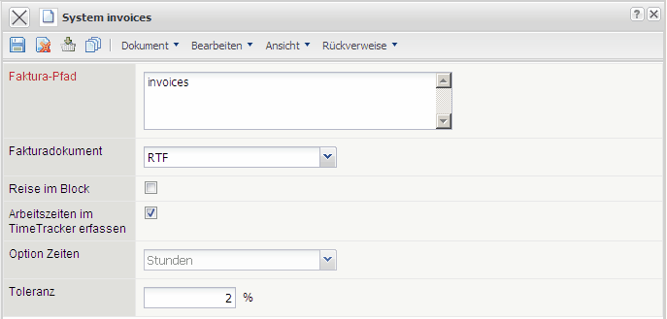
The menu contains the following elements:
- Billing Path: This field specifies the path, where the generated billing documents (offers, bills and payment reminders)will be saved. This path is present throughout the entire system., in case there no other paths defined in the xml configuration. This specification will be used only however, if in the system control there are no valid paths entered (see also the administration guidelines).
- Billing Document: This element specifies the type, in which the billing document will be generated. With the type HTML there will be a HTML file generated and shown within the standard browser and with the type RTF there will be a corresponding text file generated and opened with the standard text program. The pre-requisite: the corresponding templates are available and are defined in the system control (see also the administration guidelines).
- Voyage in the Block: This field determines the billing of the voyage within the bill. If this field is active, then all costs entailing the voyage (for example the outward and the return journey, the vouchers for the overnight stay and for the catering,...) will be taken over as one item within the bill. Is this field not active, then all the costs will be listed and written as seperate items within the bill.
- Enter Working Hours into TimeTracker: This field allows the adaptation of the time registration. When this field is activated, then the work hours can also be entered into the time registration. Furthermore, in the time-referenced analysis the work hours will be considered. If this field is not activated then the project-referenced times will be registered and considered during analysis.
- Option Times: This option is no longer of use.
- Tolerance: This option is no longer of use.

