2.01.01 Configuration
The “Configuration” form administers the parameters for the entire system. This includes the company-specified parameters for: location, On the "Master Data List" tab:, language and the currencies that will be used as default, where the master data will be entered. Furthermore, this is where the distance flat-rate and On the tab "Master Data List": will be saved and the parameter for the target payment will be defined. In addition, lunch periods and bonuses can be specified worldwide from here.
Tip: Further information on this topic can be found under article 3.11.01 Key Data Administration.
The form contains the following elements:
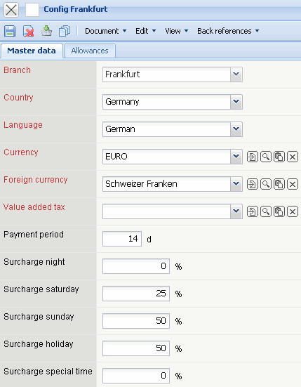

On the "Master Data List" tab:
- Location: This element specifies the configuration setting for the chosen location.
- Country: This field specifies the country's configuration for the location and will be used as a preset for the master data.
- Language: This field specifies the language for the system and determines herewith the descriptions and the document output. Furthermore, this field determines, as of version 2.2, also the type of numbers and date settings.
- Currency: The field “Currency” defines the standard currency of the company. This currency will be pulled up first by default with all currency fields. The currencies can be specified and changed under the the form Currency.
- Second Currency: The field “Second Currency” specifies the alternative currency of the company. This currency will be pulled up as “Second Currency” by default within all currency fields (exception: in the “Billing Module” the “Project Currency” will be pulled up as the “Second Currency”). The currencies can be specified and changed under the form Currency. A “Second Currency” within the system can also be disabled throughout the entire system via the system controls.
- Value-Added Tax: In this field the value-added tax will be entered as a default value out of the option's form. The value-added tax can be specified and changed in the Value-added Tax form. When doing input costs, issuing a quotation and issuing an invoice the default value will be used here.
- Payment Target: The field “Payment Target” specifies the desired time span between an outgoing invoice and payments received.
- Bonuses: The bonuses can be either used for internal clearing invoices (in case employees are guaranteed such bonuses), or be used as a basis for the bonus charge in issuing the invoice (external clearing invoice). These range of functions must be configured accordingly from the manufacturer.
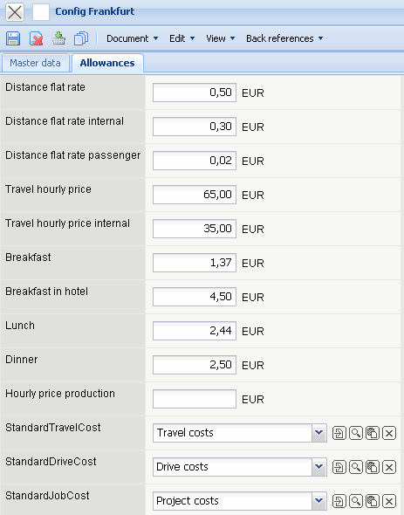

On the "Flat-Rates" tab:
- Distance Flat-Rate (external and internal): The fields labeled “Distance Flat-Rate” are needed for the traveling expenses. When a “Distance Flat-Rate” is being cleared (see also Trips), Projectile calculates out of the the distance traveled and the internal flat-rate the travel expenses and with the external flat-rate the transfer of costs goes to the customer.
- Distance Flat-Rate Passenger: This rate can be guaranteed, per passenger, when on a business trip in an automobile.
- Travel Rate (external and internal): The fields “Hourly Travel Rates” are needed for traveling expenses. When a trip is to be calculated through the “Hourly Travel Rates” (see also Trips), Projectile calculates out of the time difference from tours and the internal “Hourly Travel Rates” the travel costs and with the external hourly rates the transfer of costs goes to the customer.
- Breakfast, Lunch, Meals: These rates specify the pecuniary advantage with a meal (exception: breakfast in a hotel as a pecuniary advantage).
- Breakfast in a Hotel: This field specifies the pecuniary advantage with breakfast in a hotel.
- Manufacturing Expenses: This element specifies the manufacturing costs of the work output per hour and will be used for the calculation of finished/unfinished output in the evaluation system (see also Assessment chart).
- Cost Categories (Voyages, Trips, Work Packages): These fields will be used by default with travel and trips, such as with the take-over of jobs in offers, order confirmations and bills.

