3 Range of Functions
The success of the application of all management software is especially dependent on the approval of its users. For this reason, high value was placed on uniform, simple and comfortable handling during conception and implementation. The layout and user guidance of each view of a document in the system has been created uniformly.
The user can freely choose the primary desktop and at the same time integrate, for example, self-defined tabular assessments (see illustration 2) or graphic asassessments (see illustration 3).
Moreover, Projectile provides a wide range of structuring and input aids, in order to make handling as comfortable as possible for you. For example, assistants support you when entering dates or planning projects.
Due to links, you can directly go to other documents from every type of document. With the aid of the central navigation, the database can be clearly browsed through and individual documents can be opened.
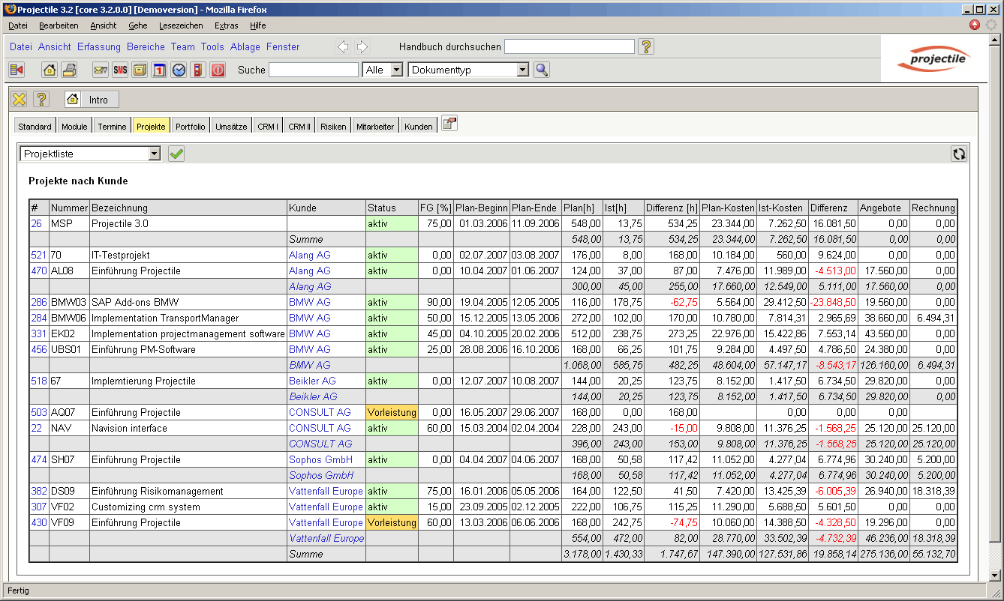
Illustration 2: Alternative primary desktops (project overview)
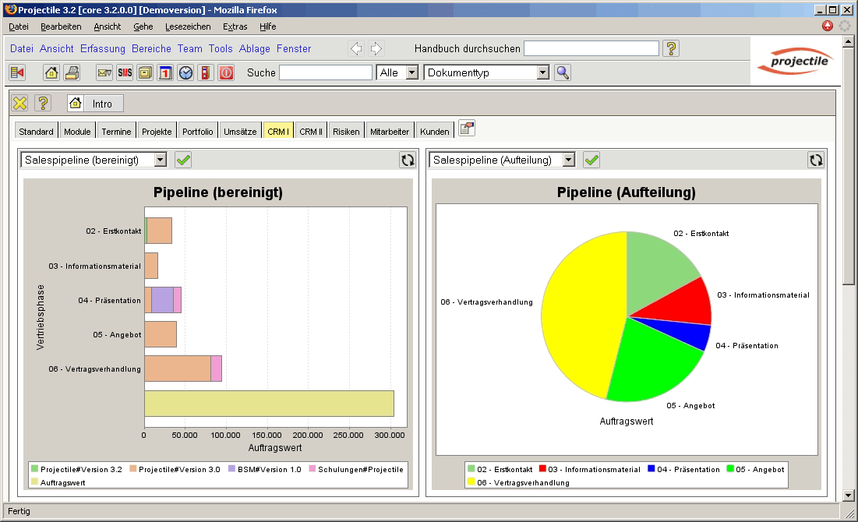
Illustration 3: Alternative primary desktops (appointment overview)

