Array Array

3.8 Report generator
In addition to these standard analyses, an optionally integrated report manager is available. The report manager provides a further possibility of analysing the Projectile database beyond the standard analyses.
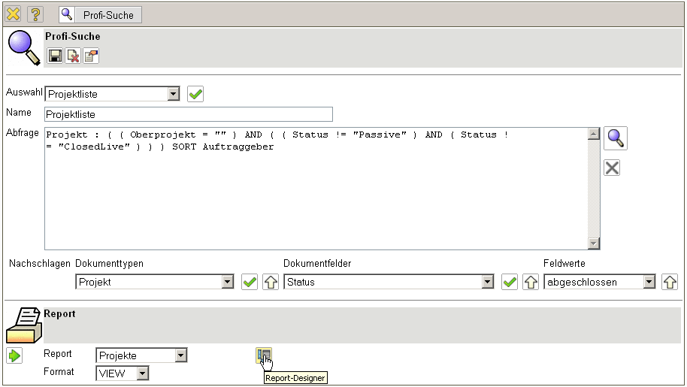
Illustration 26: Pro –search with report
With the help of the report designer, existing reports can be adapted and new reports drawn up. The following example shows the definition of a project-related report, which contains information about plan actual performances as well as the most important financial indexes.
In the report designer, columns can be selected (also of many tables), resorted and renamed, new columns calculated from existing information as well as aggregate functions utilized. Furthermore, configurations with and without sub-totals can be made, the layout of the report adapted or graphic analyses can be configurated.
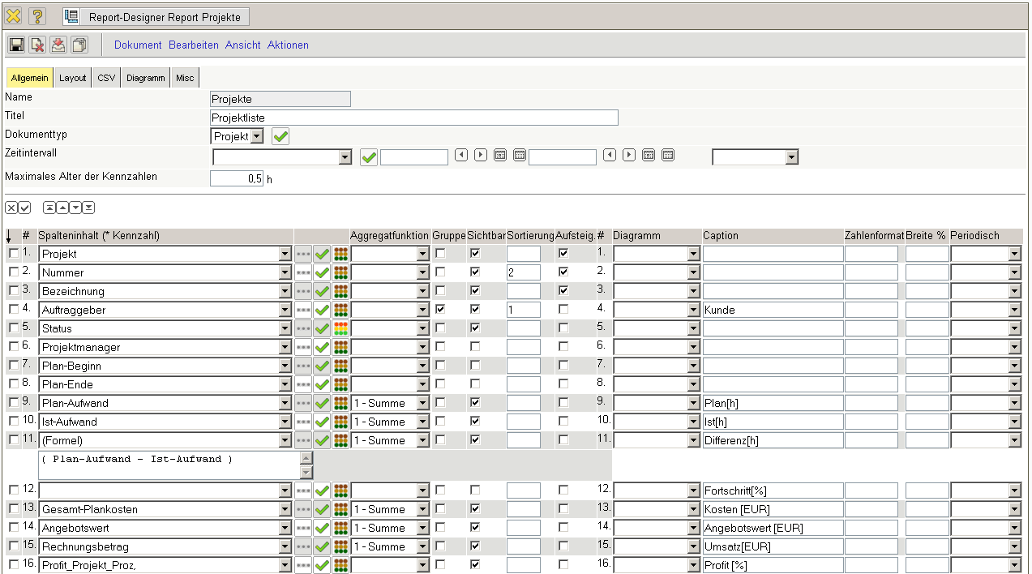
Illustration 27: Definition of a project report
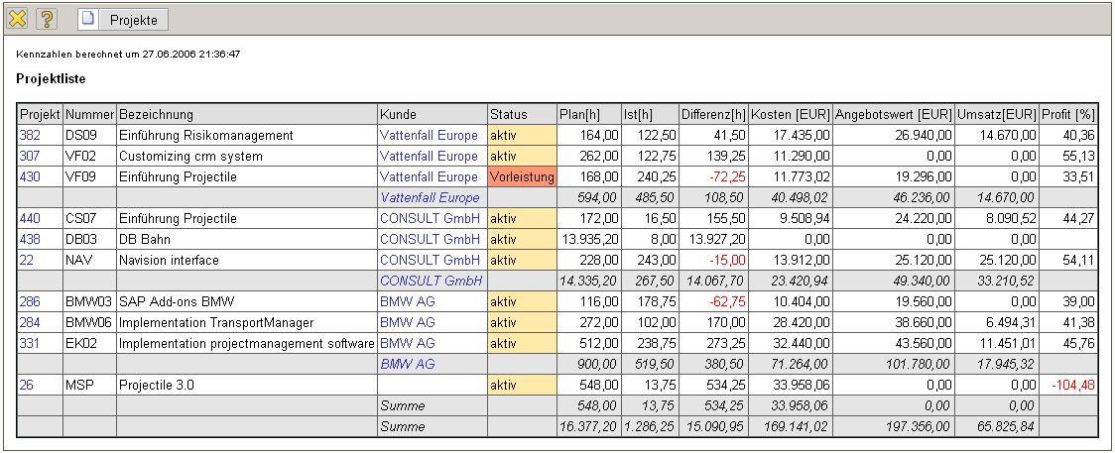
Illustration 28: Tabular report
The output format for the reports created can be selected from CHART (for graphic analyses like in illustration 27), CSV, EDIT (for editing master data), HTML, PDF, RTF (standard format for data processing), View (browser view like in Illustration 26), XML and XLS (MS EXCEL).
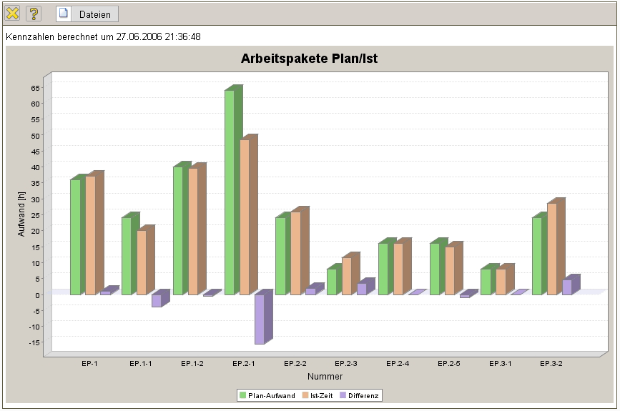
Illustration 29: Graphic report
In the pro-searches, parameters can be set that can be retrieved after implementation of the query in the retriequery manager.

