Array Array

3.5 Assessments
The basis for the assessments of the project information system are the documented project services. The whole database is available in the centre of the system and is processed by Projectile according to your selection criteria (projects, types of projects, customers, employees, time intervals, etc.) for extensive monitoring of your projects.
In Projectile, the following analyses are available among others:
- Gantt chart, project structure plan, milestone trend analysis, earned value analysis,
- Plan/actual value comparison of project-related services and costs,
- Allocation of employees and performance records for projects and customers,
- Presentation of the whole chain of income and costs from the offer over budgets and the actual costs to services, which can be invoiced, invoices presented and (still outstanding) payments.
The employee- and project-related analyses time-recording provide a current overview with regard to the allocation of employees in all ongoing projects. Furthermore, you can have total and individual time-recording drawn up thus record your services completed for the project.
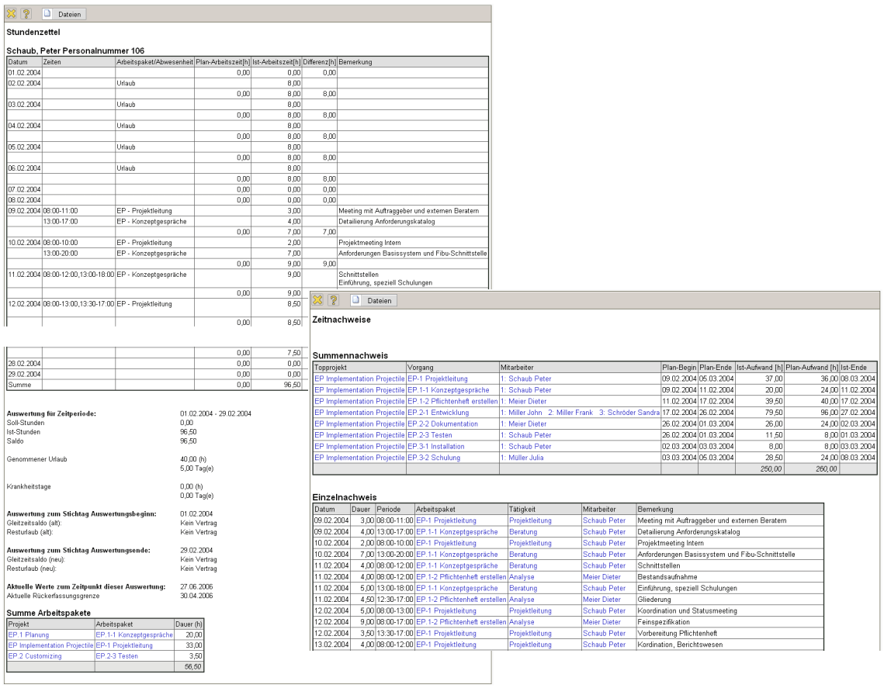
Illustration 17: Perfomanc records and time sheets
In the chart system, diverse analyses on the topic of resource management are available.
The workload overview shown (one of three variations) generates employee-related, an overview of all of the employees’ tasks and arranges these selectively according to your planned periods or priorities. These analyses also provide/have notes, if, due to lacking capacities, tasks cannot be completed in time.
The capacity analyses show concrete over- and underloading of the employees over freely definable periods, related to variable periods. At the same time, holidays and absence are taken into consideration.
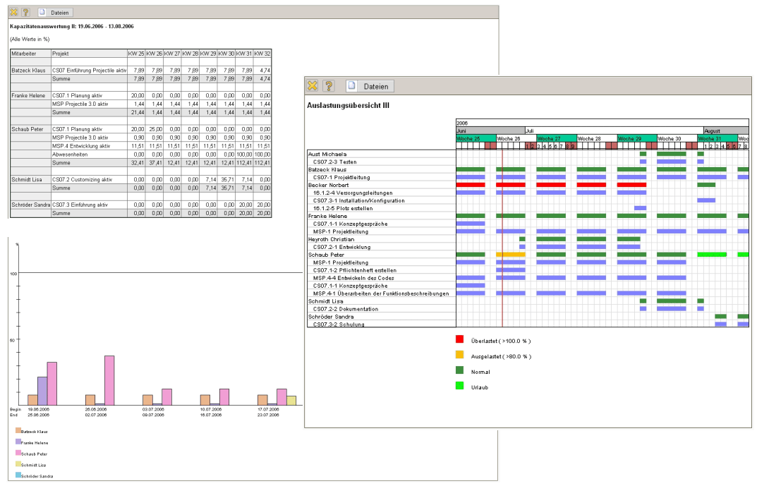
Illustration 18: Resource analyses
The project analysis facilitates diversified analyses regarding the process of individual projects and jobs: Target-performance comparison, project structure plans, milestone-trend analyses, etc.
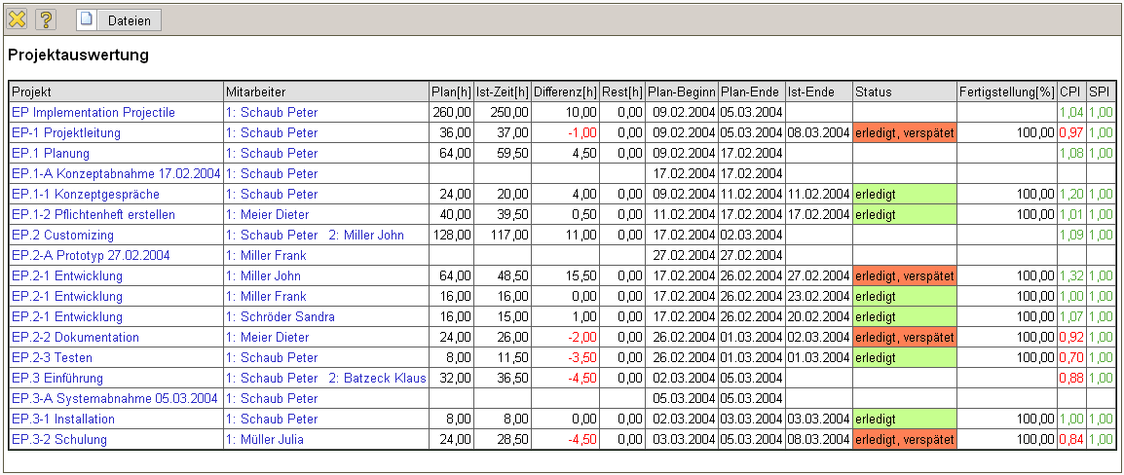
Illustration 19: Plan/performance comparison
With the milestone-trend analysis, you are provided with a future-orientated project-controlling instrument, with the help of which you can recognise deviations from the target (milestone deadline) at an early stage.
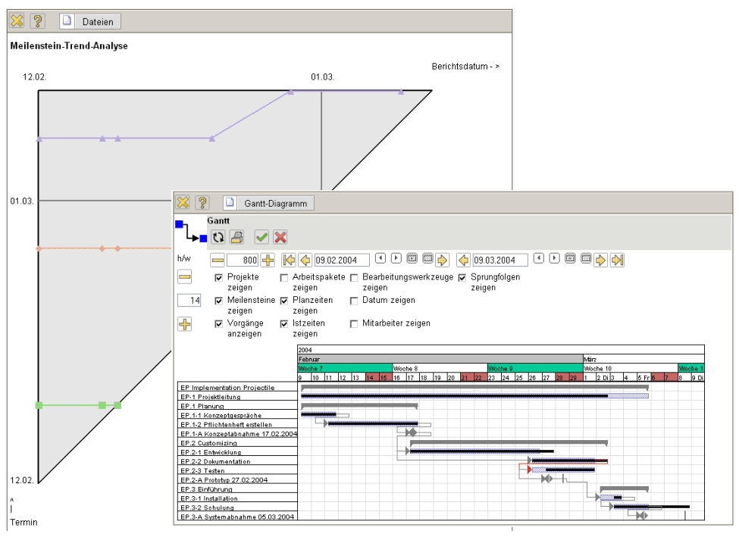
Illustration 20: Deadline analyses (Gantt chart, milestone-trend analysis)
The Gantt chart analysis visualises the project time-planning (plan) and the current temporal project status (performance) with the aid of bar diagrams.
The Earned-Value-Analysis lists the plan and performance efforts for a project over any period as well as the status. In the list, the times planned, the performance and progress per period (calendar weeks in this case) are grouped according to criteria (sub-projects in this case).
In the illustrations, the plan efforts, performance efforts and the comparative size Earned-Value are placed on the axes. Th Earned-Value supplies statements on work performed in comparison to the planned effort and effort performed.
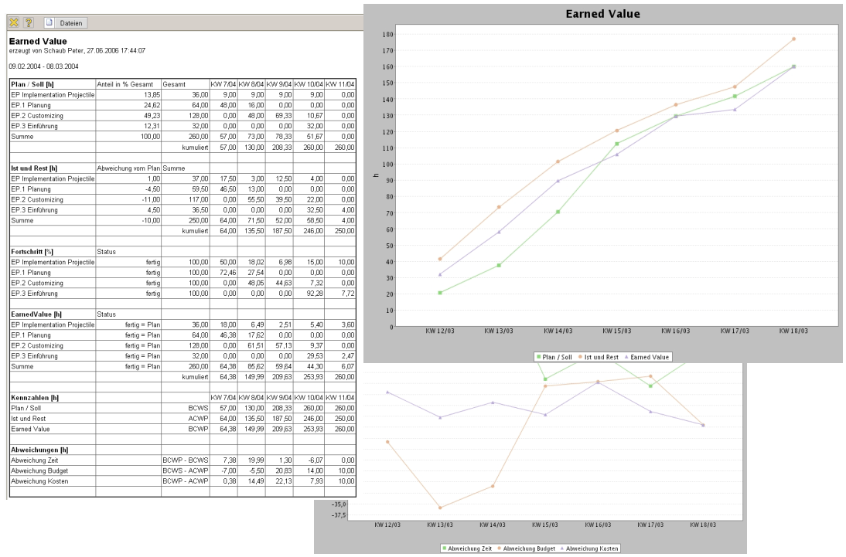
Illustration 21: Earned-Value-Analyse
The Earned Value (EV) results from the progress of the periods (difference between status of period observed and the period before) and the total plan effort, thus EV(t) = Progress(t) * Total plan effort.
The indexes BCWS, ACWP and BCWP denote the plan-cost sum line, the performance-cost sum line and the job value created as comparison value.
The cost analysis shows all the costs involved in the scope of the project – itemised according to the individual cost category/budget positions as a total overview and detailed according to each position. In this way, there is always transparency with regard to profitibility and performance of your project work.
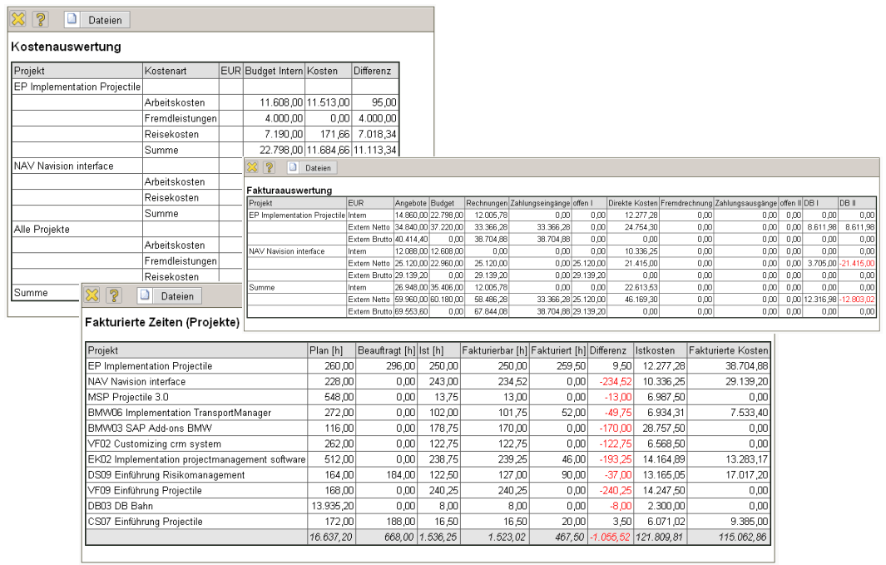
Illustration 22: Financial analysis
The financial analyses provide you with an effective instrument, in order to obtain a quick overview of the whole cost chain from the offer and the planned budget to the amount of invoice and the complete payment flow.

