Array Array

3.4 Invoicing
The invoice module serves the purpose of drawing up offers and invoices as well as internal settlement, enables the drawing up and further charging of incoming invoices and monitors incoming and outgoing payments.
With the foreign invoices component (see illustration 15), you have the possibility to record services by suppliers and to charge them to the project (incoming invoices). The outgoing invoice function provides an overview of all payments to your creditors.
Projectile supports several versions for the invoicing of services (see illustration 16): Outlays, fixed price, anticipated payment, completion and periodical invoicing. With the aid of various price models (project-related, customer-related, employee-related or combinations of these), you can invoice your customer in a flexible way depending on the agreement.
In the case of expenditure projects, you simply select the project or the sub-project you would like to invoice; Projectile enters all of the services that can be invoiced (jobs, receipts, travelling costs and other costs) into the invoice, whereby you can alter individual positions. Finally, you can have the invoice shown, have it printed out if desired and charge the services. On request, Projectile draws up the invoices/internal statements automatically at freely definable points in time (for example, at the end of the month/quarter for maintenance contracts or invoices for domains). Proof of time required for charging to your customary or “internal customer” can also be drawn up by Projectile at the touch of a button.
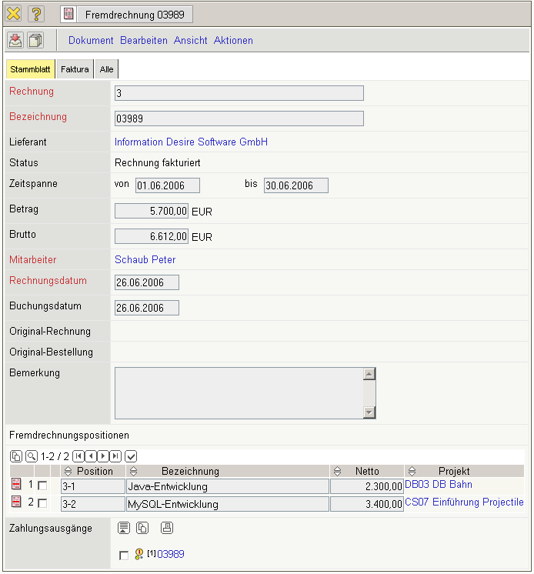
Illustration 15: Recording or import of incoming invoices
If you have invoiced your services, the corresponding invoice data rate will be adopted in the incoming payments. Projectile thus informs you of the status of payment and if desired, generates reminders.
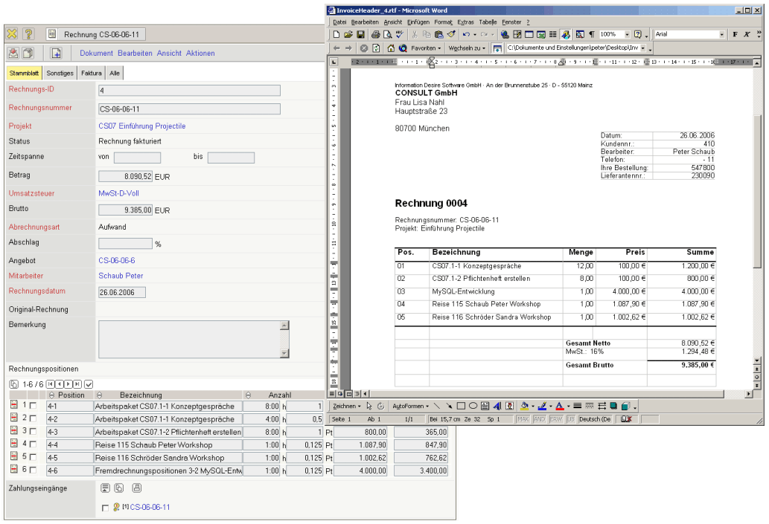
Illustration 16: Drawing up an invoice
The contracts in Projectile administer periodical invoicing with their general conditions. This functionality can, for example, be used for maintenance and support contracts. This function also supports the definition of payment plans according to milestones, deadlines and freely selectable dates.

