Array Array

3.3 Time and Cost Tracking
The basis for the project information system and project invoicing are time and cost tracking. Due to the acquisition components and the centralised filing of data, no project services are “lost”. Fast and simple filing is the foundation for the user to find the necessary approval.
The online time tracking ‘TimeTracker’ is a reliable and easy-to-use tool, in order to record all working and project times down to the minute. The appropriate project employee is only shown the tasks he/she is responsible for and which are still open when logging into the system. Each employee thus receives his/her personal ToDo list of the tasks still to be handled, randomly arranged according to various criteria.
The user-friendly guidance allows for assessments, for example, to be generated from the TimeTracker, time remaining and deadlines to be estimated, the closing of jobs and to be shown information about the individual tasks.
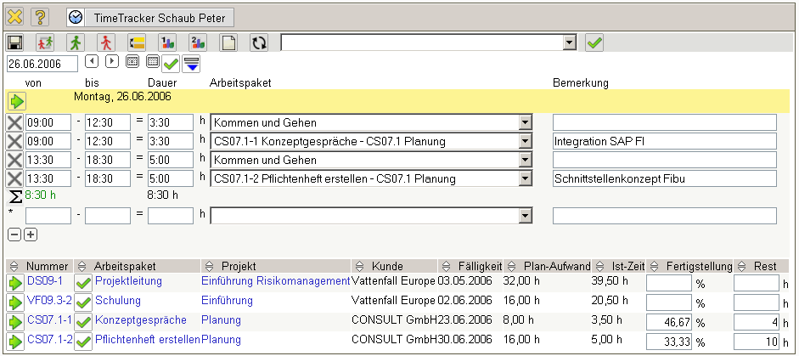
Illustration 12: Performance tracking in TimeTracker
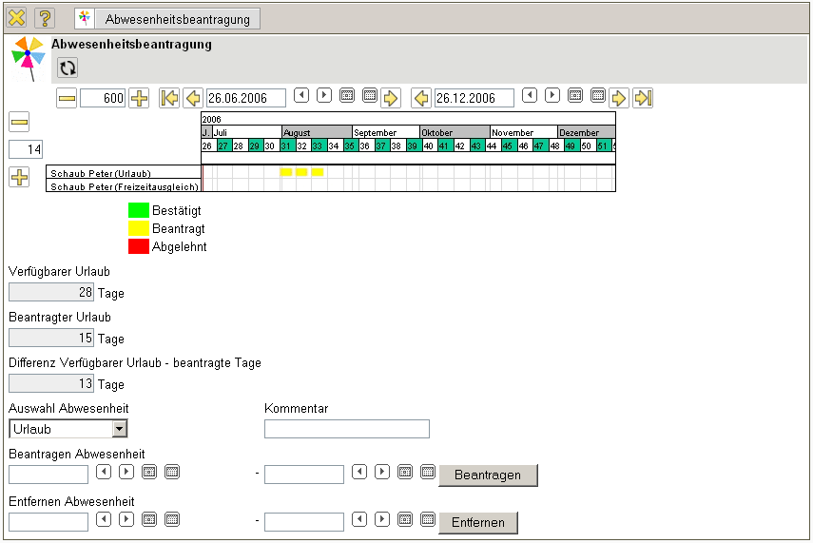
Illustration 13: Application for holiday in TimeTracker
In addition to that, with Projectile absence (holiday, for example) can be applied for and be recorded. Though this, comparisons with regard to working times and project times are possible and holiday overviews can be drawn up by the system (see illustration 13 and paragraph 3.7).
In the travelling expenses form complete business trips (including the corresponding journeys and expenses) recorded and allocated to the corresponding project. The system automatically calculates day-to-day accommodation and produces assessments on travelling costs.
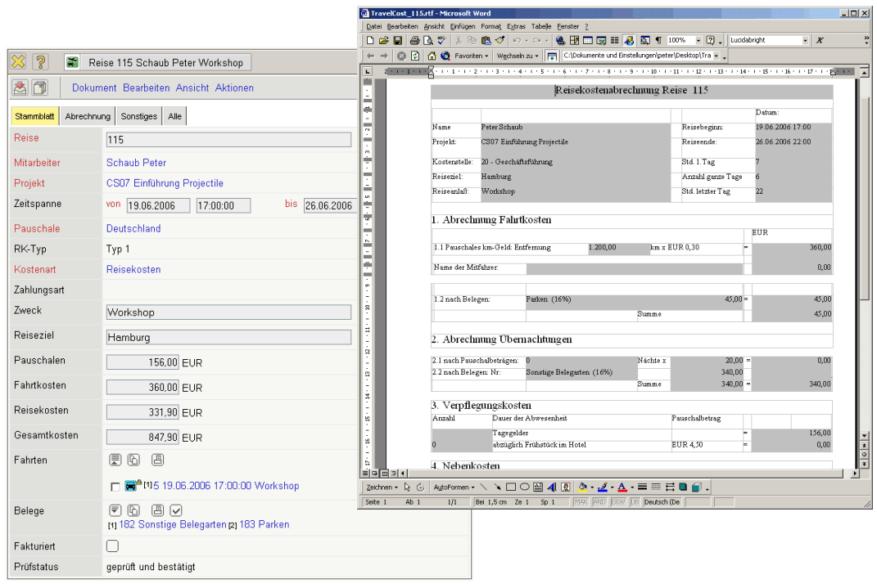
Illustration 14: Listing of travelling expenses
Material expenses and expenses are recorded in the receipt form. Due to the allocation of a receipt to a project, these can be invoiced directly to the customer; as far as they can be invoiced. The efficiency of your project work thus increases through the integrated cost tracking.
Projectile also enables the management of exterior services. These can be recorded as project-related foreign costs and invoiced in the scope of the contractual agreements. Such a pool of exterior services can be defined firm-specifically: Products/licences, appliances, software, services, free-lancers, expertise,..
Project-related deadlines can be estimated by the person responsible for the project. With the aid of this estimation, the system determines the project status (as planned, returned, ahead or done). If desired, the project status is sent by e-mail to a chosen group of users when a certain result occurs (regularly at freely definable points in time; non-scheduled in the case of exceeding deadlines and budgets.).

