Array Array

2 Processes supported
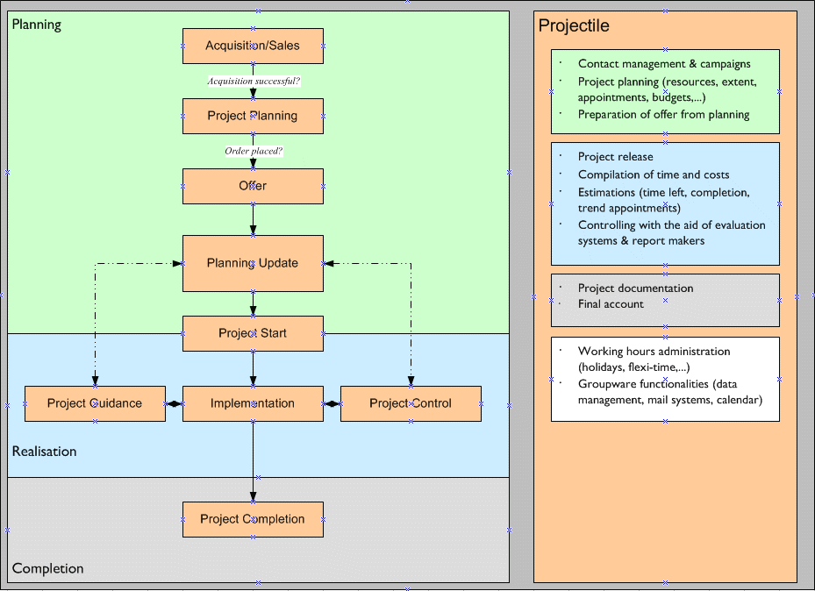
Illustration 1: Processes of project processing supported Illustration 1 shows the processes supported within project processing with Projectile:

Planning:
Projectile contains a contact system for marketing support. This contact system can also utilise contact data from exterior systems (MS Exchange, for example). The contact system comprises the following user desktops: Customer, Contact, Action and the ContactChart. The Contact desktop administers the company data with any number of contacts. Contacts can be customers, interested parties, suppliers, etc. The contacts can be allocated with freely definable actions (for the project acquisition, for example).
If the acquisition leads to an offer, project planning (rough planning) can begin. Projects can either be planned manually in Projectile with the help of various assistants, generated on the basis of project templates (model projects, Best Practise) or imported from other systems (MS Project, for example). During planning, resources, appointments, expenditure and thus labour costs are planned. These planning costs can be supplemented by other budgets if necessary, in order to set the basis for the preparation of an offer.
The preparation of an offer takes place after this rough planning, directly out of the project and based on the plan data. This plan data can accordingly be adjusted within the offer.
If the interested party does not accept the offer, the project can be marked as “lost” or deleted. If the customer accepts, the project planning must be updated, if necessary because either the project period or the scope of services has changed. Furthermore, other projects, which have to access the same resources, can be planned at a later point in time.

Realisation:
After the fine planning or optimisation, the project or individual part projects are released and, if necessary, an anticipated payment note is produced.
On clearance, the planned work packages are distributed to the employees, who can see their tasks in their ToDo lists. Within these components (TimeTracker), the employees then also carry out an acquisition of actual data and estimations are stored. For each task, the time remaining and/or the status is estimated, which enters the assessment system together with the plan and actual data. Delays are shown in the assessment system at an early stage, so that countermeasures can be taken accordingly.
During the realisation of a project, not only time but also project-related costs can be recorded. Travelling costs and additional purchases are parts of these, for example. These costs together with the times entered, are available for the assessment system and invoicing.
In the invoicing module, these services can be invoiced appropriately to the period. The basis for charging in the case of “effort” is either the recorded time and costs or services marked as billable.

Completion:
After completing the project, the final account can be charged, corresponding documentation be produced from the assessment system and the project archived if necessary.

