2.05.02 Cost Center Chart
The cost center chart generates the financial evaluations in the system. These include cost evaluations (plan/actual comparisons, that is, budgets for costs and detailed evaluations), general billing evaluations (quotations, budgets, invoices, costs, payment flows and contribution margin including detailed evaluations), overviews of billable and billed services, a list of open items and results evaluations.
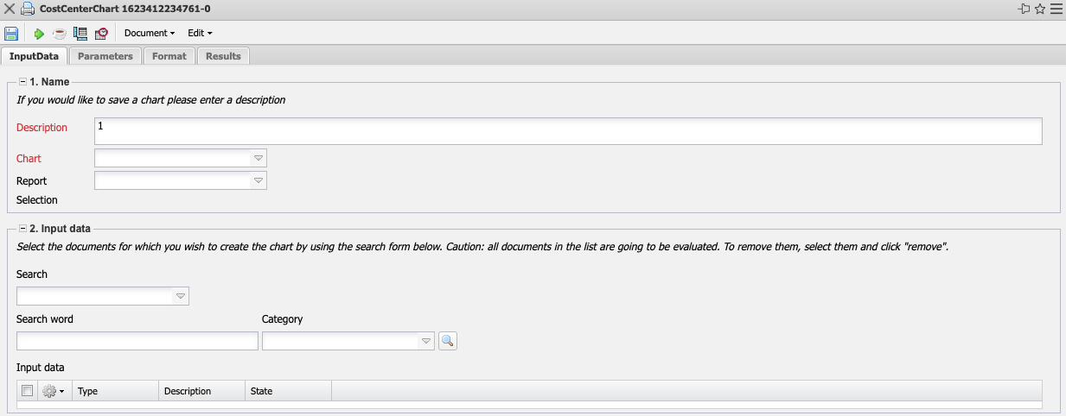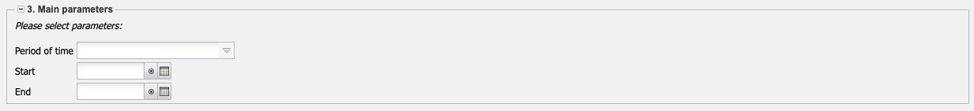
The mask consists of the following elements:

1. Name
- Name: In this field, you define the name of the evaluation if it is to be saved (for example, for time services or to manage the evaluation results).
- Evaluation: Billing evaluation contains the following evaluations:
- Cost Evaluation and Cost Evaluation Detail
- Billing Evaluation and Billing Evaluation Detail
- Billed Time and Billed Times (Projects)
- Evaluation of Results
- Outstanding Items
- Billable Project Times and Billable Customer Times
- Report Selection: In this field the new report selection can be selected.

2. Input Data
- Professional Search: This selection box allows you to use professional searches for the input data of the evaluation. However, these professional searches must refer to the supported categories.
- Search Engine: Quick Search and Category: Quick search and category: This element is used to filter the selected data from the categories. The document types contact, employee, project and unit are available as selection criteria. The operation of the search engine is also described in section 3.02.3 and can be executed here several times if necessary.
- Input Data: The selected selection criteria for the evaluation are listed below this field. These input data can come from the professional search, the standard search engine or the personal file.

3. Main Parameters
- Evaluation Period: This selection box refers to the evaluation period (Start and End elements) and allows a parameterized definition of the period for the time services. This selection (Current week, Current month, ..., Next week, Last week, ...) can also be used to simplify the manual definition of start and end.
- Start and End: In these fields, you can enter a time interval as a selection criterion to limit the analysis period for the evaluation.
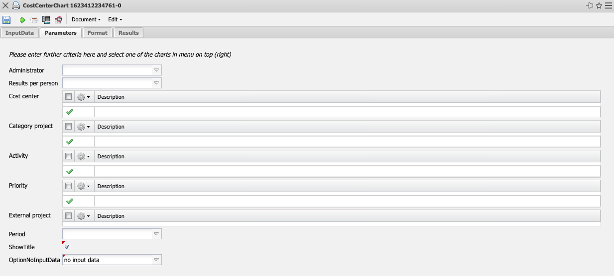

4. Other Criteria
- Cost Center: In this selection box you can choose cost centers as selection criteria. These cost centers refer to the cost center of the projects and restrict the selection of the projects considered accordingly (only projects that are assigned to this (these) cost center(s) are displayed).
- Project Type: In this selection box, you can choose project type as a selection criterion. These types refer to the category of the project and restrict the selection of the project accordingly (only projects assigned to this (these) project type(s) are displayed).
- Status: In this selection box you can choose statuses (passive, active, advance payment, ...) as selection criteria. This status refers to the project specifications and restricts the project selection accordingly (only projects with this status are displayed).
- Priority: In this selection box you can choose priority as a selection criterion. These values refer to the priority of the project (even if other priorities are assigned in the work packages) and restrict the selection of the project accordingly.
- External Order: This selection refers to the external indicator of the project and restricts the selection of the project accordingly (only external projects are displayed).
- Period: This selection controls the period display for periodic evaluations: daily, weekly, monthly or per quarter.
- Main Project only: This checkbox indicates whether only main projects without sub-projects are displayed in the generated evaluation.
- Filter Employee Unit: This checkbox controls the effectiveness of the selection of units or employees. If the checkbox is not set, the filter applies. If the checkbox is set, the system does not filter by the selected units/employees.
- Display Planned Times Column: This option only affects evaluations 09 and 10 and also displays the planned values of work packages and entries here.
- Work Packages in Detail: This option controls whether work packages or operations should be displayed in the evaluations.
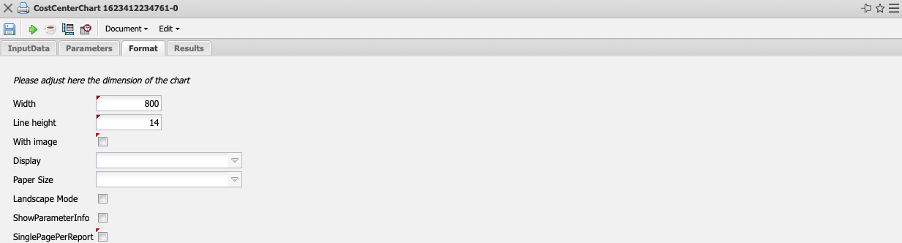

5. Settings for View
- Width: This field defines the width in pixels (px) of the graphic evaluation.
- Height: This field defines the height in pixels (px) of the graphic evaluation.
- With Illustration: With the help of this selection, in addition to the lists, graphics can be generated for some evaluations.
- Display: With the help of this selection the generated evaluation can be generated in different formats. Supported formats are HTML (standard setting), CSV, XLS, RTF and PDF.
- Chart Type: With the help of this selection a chart type can be chosen for the generated evaluation. Projectile offers various bar charts (2D, 3D, vertical, horizontal, ...), bar stacks, line and area charts, pie charts and bubble charts.
- Paper Size: In this selection box, the paper format can be specified. Based on the entered size of the sheet, the evaluation is displayed larger or smaller.
- Landscape Format: With the help of this option the evaluation can be displayed and printed as landscape format.
- Display Evaluation Parameters: Here you can select whether the evaluation parameters are to be displayed.
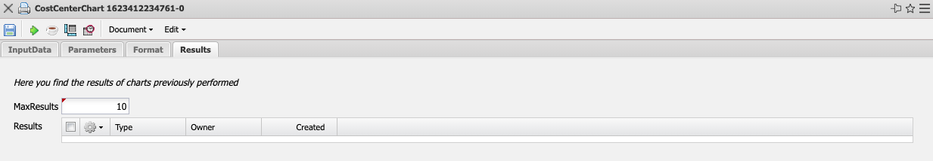

6. Results
This tab contains the maximum number of results and the results of evaluations already performed.

