2.04.07 Payment Plan
The payment plan mask manages the dates for invoicing. The payment plans in Projectile are part of contract management (see also Contract) and contain information about the date of invoicing or the required percentage of completion and the percentage or absolute discount of the partial invoices.
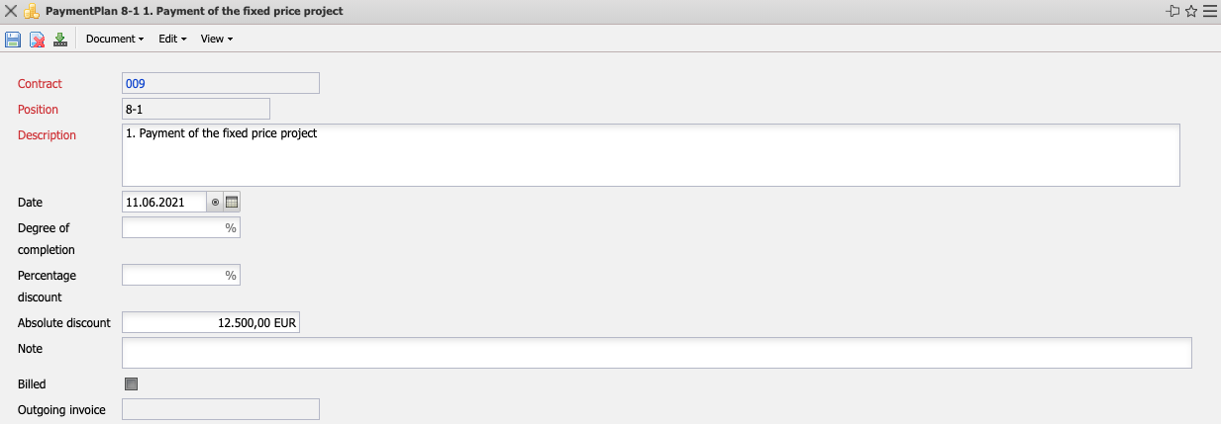
The document category payment plan consists of the following elements:
- Contract: This field assigns a unique identification number to the contract, which is assigned automatically by the system.
- Position: This field identifies the number of the contract item using a unique number that is automatically preset by the system.
- Description: This field indicates the description of the contract item.
- Date: This field indicates the date of partial billing.
- Degree of Completion: This field can be used as an alternative to the date if no fixed date has been agreed for the partial bill, but a percentage of completion.
- Percentage Discount: At this point, the discount is displayed as a percentage.
- Absolute Discount: At this point, the total amount of the discount is displayed.
- Note: This field allows you to enter remarks on the invoice item.
- Billed: This indicator is set if the payment plan has already been invoiced.
- Outgoing Invoice: This field contains the number of the created invoice. This invoice number can be used to access the existing invoice.

