2.04.06 Contract Item
The Contract Item mask manages the details for periodic invoicing, if the invoice for this is to contain items. These items can also contain external services.
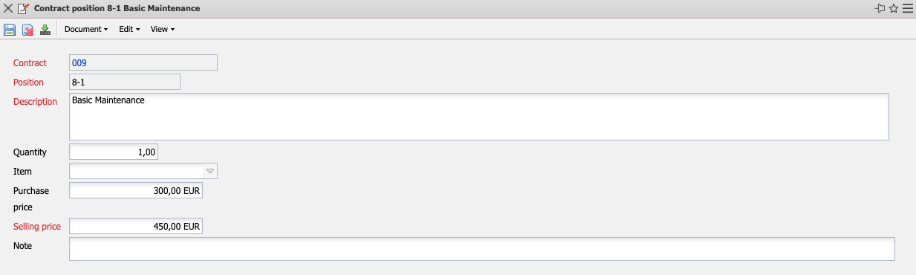
The mask consists of the following elements:
- Contract: This field assigns a unique identification number to the contract, which is automatically assigned by the system.
- Item: This field identifies the number of the contract item using a unique number that is automatically assigned by the system.
- Description: This field indicates the description of the contract item.
- Quantity, Article: The quantity and type of an external service can be specified here if the budget item refers to external services (for example, databases, hardware, and so on). After clicking on the green check mark, the internal and external budgets are determined by the system from the purchase and sales prices of the external service.
- Purchase Price/Sales Price: The purchase price or the sales price can be entered here.
- Comment: This field allows you to enter remarks on the invoice item.

