2.04.03 Order
The order mask manages the customer's orders. After acceptance of an offer, the order data can either be entered directly into the project or an order confirmation can be created. This order confirmation is necessary for projects that are not ordered as offered.
The mask consists of the following elements:

Master Sheet
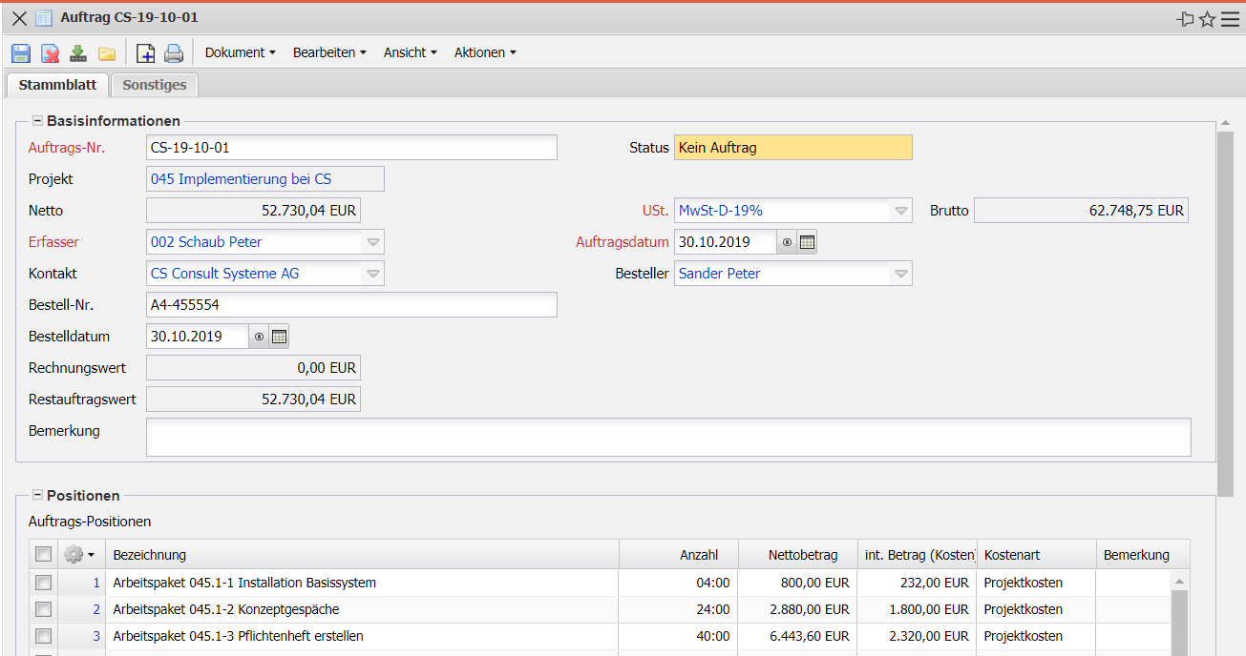
- Basic Information:
  - Order Number: This numeric field assigns a unique number to the order header, which is automatically proposed by the system.
  - Status: This field is determined by the system and indicates the status of the order on the basis of the actions carried out using the Action function. After a new order has been created, it automatically receives the status “No order”, when the order confirmation is copied, the status “Order completed” and after cancellation, the status “Order cancelled”.
  - Project: In this field the project for which the order is to be created is selected. Projects can be defined and changed in the Project mask. An order can only be created for an external project.
  - Net: In this field the net amount of the order is automatically entered by the system.
  - Sales Tax: In this field, the sales tax applicable to the order is entered from the selection menu. By default, this field is preset with the tax rate valid in the country assigned in the Configuration mask or from the sold-to parties of the assigned project. The VAT can be defined and changed in the sales tax mask.
  - Gross: In this field, the gross amount of the order is automatically entered by the system.
  - Creator: The creator of the order is entered in this field (usually prefilled with the logged on users).
  - Order Date: This field indicates the date of order entry. The current date is presented by the system as standard.
  - Ordering Party: This field indicates the ordering party of the order (the person at the customer's site who initiated the order).
  - Order Number: This field identifies the order number from the customer for this order (the number assigned by the customer).
  - Order Date: This field indicates the order date of the order (when did the customer initiate the order)
  - Comment: Here you can enter a comment about the order.
- Items:
  - Order Items: are listed here.

Miscellaneous
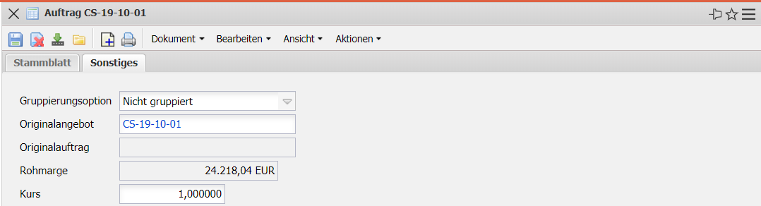
- Format:
  - Grouping Option: In this selection field, the following groupings can be selected (Grouped by employee, task, subproject, task, task and employee, task and employee list, not grouped and totals row top project.
- Technical Settings & Details:
  - Original Offer: This document link may link to the last valid quotation if the order was created from a quotation.
  - Original Order: This document link may link to the last order version if the order was created from a canceled order.
  - Gross Margin: This displays the difference between the order value and the imputed costs.
  - Exchange Rate: The exchange rate to the local currency is automatically displayed here (is = 1 if the project currency is the local currency).

