2.04.02 Offer Item
The mask offer position contains the reference to the offer as well as information about the position, description, number of hours or units, the external and internal amount of the offer position and the cost element. The offer value is determined from the amounts of the individual offer items.
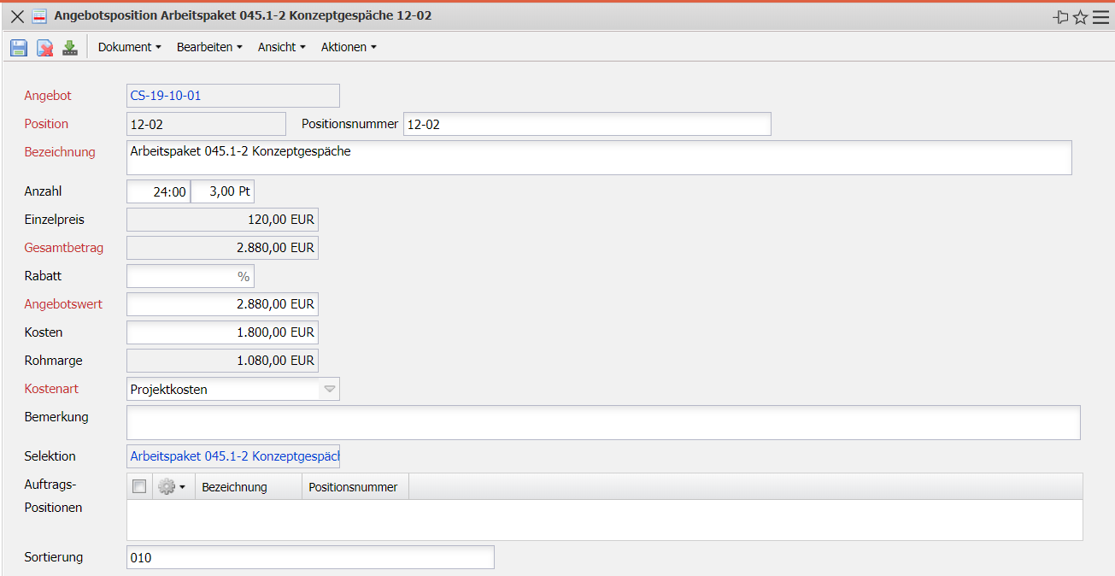
The mask consists of the following elements:
- Offer: This field indicates the offer to which the individual offer items belong.
- Item: This field identifies the number of the quotation item using a unique number that is automatically preassigned by the system.
- Description: The description of the quotation item is entered in this field. The system defaults to the names of the underlying work packages or costs.
- Number: This field indicates the number of hours or the number of items that are included in the quotation item when work packages are transferred. If you modify the value, the system automatically updates the external amounts in the quotation item.
- Unit Price: The unit price field is determined by the external amount in the line item divided by the hours. If the data has not been changed, the value in the External amount field (for work packages, the external hourly rate) is the same as the valid external hourly rate.
- Total Amount: The total price of the quotation item is calculated automatically for work packages or budgets and can be modified by the user.
- External Amount before Discount: This field provides an overview if a discount is granted on an item, as was the original amount of the item. This makes it easier to see how the value in the External Amount field is made up. The difference External Amount Before Discount Less Discount is the External Amount.
- Discount: This value specifies the percentage rate if a discount was granted for an item. The value can be set manually in the item or generated for all quotation items using the “Generate discount on all items” action.
- External Amount (Offer Value): This field indicates the external amount offered to the customer for this line item. This value is preassigned by the system from the planning data.
- Internal Amount (Costs): This field indicates the amount that is generated as internal costs. This value is preset by the system from the plan data.
- Gross Margin: This value shows the difference between the quotation value (net) and the calculated costs of the item.
- Cost Type: This field indicates the cost type of the offer item. The cost elements can be defined and changed in the cost type mask.
- Comment: This field allows you to enter remarks about the sales quotation line item.
- Selection: This field refers to the referenced projectile document of the line item (for example, work package, budget, external services).
- Order Item: The order items are automatically displayed here when an order is generated from the quotation.

