2.03.04 Trip
The mask trip enables the entry of project-related drives and their costs (commuting expenses), which the driver of a vehicle has caused in the context of a project. The travel costs can be assigned by selecting an already entered trip by marking this trip and are thus also displayed in the document category Trips with their corresponding cost element. It is basically possible to determine the travel costs by kilometer flat rate (distance from kilometer old and new), by settlement type hours (as difference between start and end of trip) or as a combination of both. The corresponding rates are stored in the configuration mask.
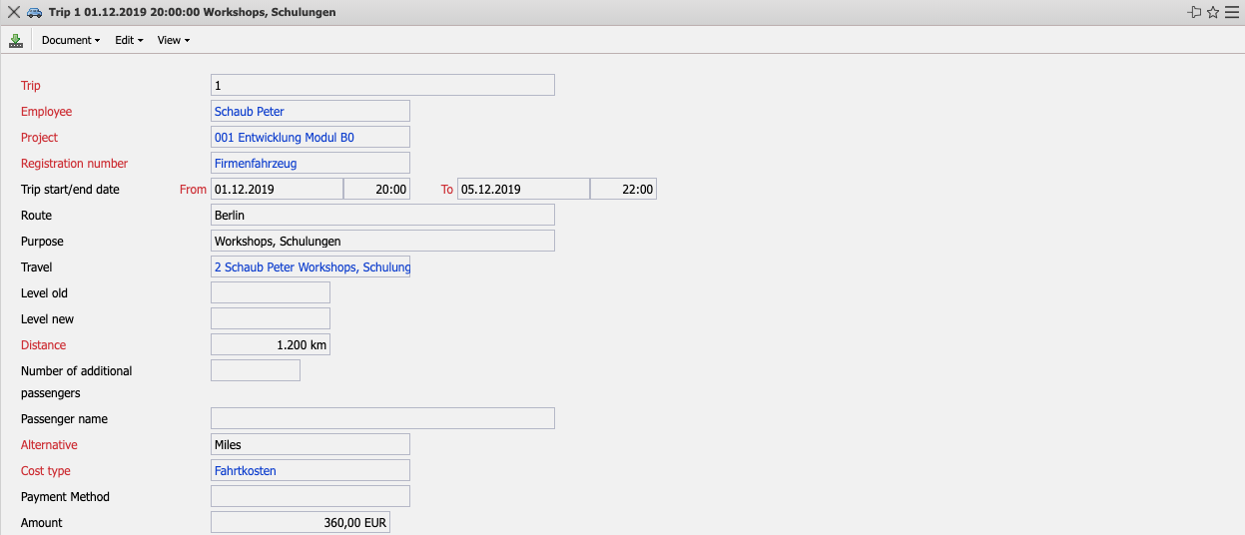
The mask consists of the following elements:
- Trip: This numeric field uniquely identifies the trip using an identification number that is automatically proposed by the system.
- Employee: The driver or creator of the logbook is defined in this field. The display of the selection menu can be defined and changed in the screen employee.
- Project: The Project field indicates the project to which the trip is assigned. Projects can be defined and changed in the mask project.
- Vehicle: In this field a vehicle is assigned to the trip. Vehicles can be defined and changed in the mask vehicle.
- Time Span (from/to): These fields indicate the date and time from start to end of the trip.
- Route: This field allows you to enter information on the route of the trip and must be filled in if the travel expenses entry is to serve as a tax statement in the form of a logbook.
- Purpose: This field allows you to enter information on the purpose of the trip and must be filled in if you want to use the travel expenses entry function as a tax statement in the form of a logbook.
- Travel: This field indicates a trip to which a trip can be assigned. All trips that were entered for the selected project are displayed. You define a trip in the trip mask.
- Old km Status: This field indicates the km status of the selected vehicle before the start of the trip.
- New km Status: This field indicates the Km-Registration of the selected vehicle after the end of the trip.
- Distance: This field indicates the distance travelled. This difference can be calculated from the fields Old Km-Registration and New Km-Registration or can be determined directly in the field.
- Number of Passengers: This field indicates the number of people who are travelling with the vehicle.
- Passengers: In this field the names of the passengers are entered.
- Settlement Type: This field indicates the settlement type of the travel costs. If you select the settlement by km, the travel costs (internal/external) are calculated from the driven distance, multiplied by the flat rates per km stored in the mask configuration. If billing by hours is entered, then the travel costs (internal/external) are calculated using the time interval from the start and end of the trip, multiplied by the hourly rates stored in the configuration mask. If billing by km and hours is selected, the two billing types are added together.
- Cost Type: This field indicates the cost type of the trip. The cost elements can be defined and changed in the mask Cost element. The cost element is also used as a criterion for the planned/actual comparison in the billing evaluation.
- Payment Type: This indicator determines whether the company or the employee has disbursed the costs of the trip.
- Amount: This field contains the internal costs for the selected trip. These costs are determined (if the Flat rate per kilometer indicator is set) from the difference in miles/kms and flat rate per kilometer or otherwise from the difference in hours and the trip hour rates. These flat rates are stored in the configuration mask.
- Comment: This field allows you to enter remarks about the displayed trip.
- Billable: In this selection, you can define different billings (no billing, complete, empty, according to effort).
- Invoiced: This element shows whether the trip has been billed.
- Invoice: In this field the description (invoice number) of the created invoice is displayed.

