2.03.02 Travel
The travel mask allows you to enter project-related trips that an employee has taken within the framework of a specific project. The trip duration (difference between the start and end of the trip) and the per diem and accommodations per diems/flat rates used as a basis are used to calculate the per diems/flat rates for employees. In addition, the amounts entered from receipts and trips can be assigned to a trip. Meal provision for overnight stays in a hotel is also taken into consideration.
The document category consists of the following elements:

General Data
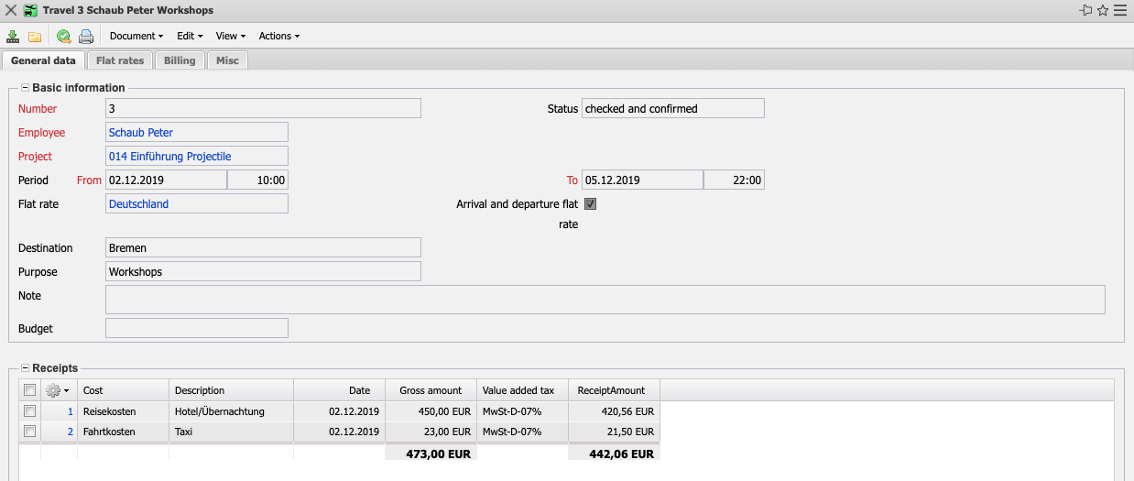
- Basic Information:
  - Number: This numeric field clearly identifies the trip. This number is proposed by the system.
  - Status: This status field is required for the review workflow. The status transitions during the check are set here (unchecked, check requested, checked and confirmed, ...).
  - Employee: This field assigns the employee who caused the travel expenses to the trip. Employees can be managed in the mask employees.
  - Project: This field indicates the project to which the trip can be assigned. Projects can be defined and changed in the mask Project
  - Time Period (from/to): These fields allow you to enter from the beginning to the end of the trip.
  - Flat Rate: The flat rate valid for the trip is selected in this field. The legally valid per diems and accommodations per diems can be defined and changed in the flat rate mask.
  - Overnight Stay Took Place: Here you can specify whether the employee's trip required an overnight stay.
  - Destination: This field indicates the trip destination. This entry is required for travel expenses.
  - Purpose: This field specifies the purpose of the trip. This entry is required for the travel expense report.
  - Note: In this field you can enter further remarks.
  - Budget: In the Budget field, a budget from the assigned project can be assigned to the travel expenses.
- Receipts: This element contains a list of all assigned receipts for the trip (see also the receipt mask).
- Trips: This element contains a list of all assigned trips for the trip (see also drive mask).

Additional Catering Expenses
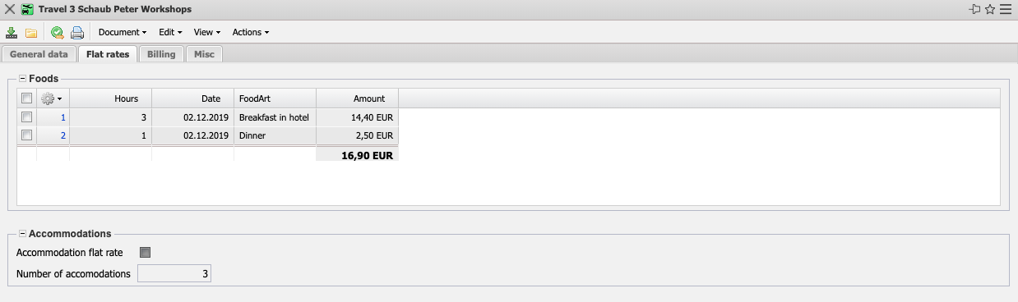
- Meals: This element contains a list of all assigned meals for the trip. These meals are used if the hotel costs or business meals contain meals that are to be deducted as imputed income (see also configuration).
- Accommodation Costs:
  - Accommodation per diem: This field is activated if the accommodation costs are to be settled in Travel Expenses according to the flat rate for the overnight stay from the flat rate mask.
  - Number of Overnight Stays: If the trip is to be settled according to the accommodations per diem, the number of nights is defined here. This number is preset by the system with the day difference between the start and end of the trip and must be changed if necessary.

Accounting
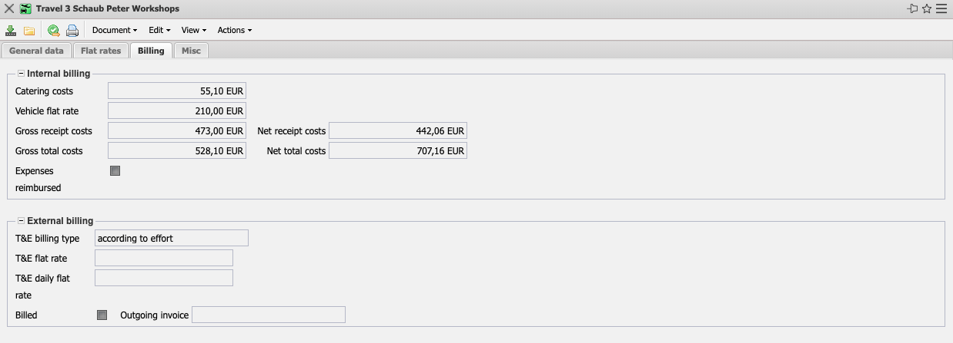
- Accounting:
  - Meal Costs: This field displays the amount for additional meals and per diems for overnight stays. If necessary, the meal costs (such as “breakfast in hotel”) are also deducted here.
  - Drive Costs: This field displays the amount for the travel expenses for the defined trip (receipts with cost element Travel expenses are not taken into account here).
  - Receipt Costs Gross: This field shows the gross amount for all receipts for the defined trip.
  - Receipt Net: Displays the net amount for all receipts for the defined trip.
  - Gross Total Expenses: Displays the gross amount for the entire trip.
  - Net Total Expenses: Displays the net amount for the entire trip.
  - Travel Expenses Reimpursed: This field indicates whether the employee has received the reimbursement.
- Travel Expense Accounting Project:
- Travel Expense Settlement Type, Travel Expense Flat Rate, Travel Expense Daily Flat Rate: Here you can store the rules for settling the project's trips (no settlement, by expense, per diem, per diem per day). The corresponding default settings can be stored in the project.
- Invoiced: This element indicates whether the trip has already been settled. This indicator is set automatically by the system if the trip is transferred to an invoice and this invoice has been billed.
- Invoice: This field shows the invoice number of the created invoice.

Misc
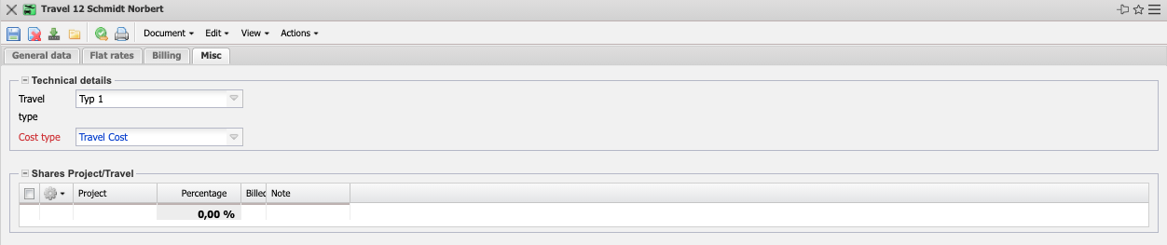
- Technical Settings & Details:
  - Travel Expense Type: Here you can assign travel expense categories to the trip. These types are used for taxation of travel expenses (for example, a customer's use of the trip for more than three months is not tax-privileged).
  - Cost Type: This field indicates the cost element of the trip. The cost types can be defined and changed in the cost type mask. The cost element is also used as a criterion for the plan/actual comparison in billing evaluation.
- Travel/Project Split: This field enables you to assign a trip to several projects. This assignment is only made on a percentage basis!

Actions
The document class contains the following actions:
- Set Check Status: This action enables you to set the check status manually.
- Travel Expense Check: This action initiates the check workflow for the trip.
- Reset Check Status: This action is used to reset the check status.

