2.02.14 Portfolio
The mask portfolio allows the administration of project portfolio management for any selected projects and qualitative characteristics. Project portfolio management is the planning, management and control of selected projects of an organization.
The basis of the project portfolio management are the compilations of projects. In this mask the projects can be compiled and the axes for the evaluations can be predefined.

General Data
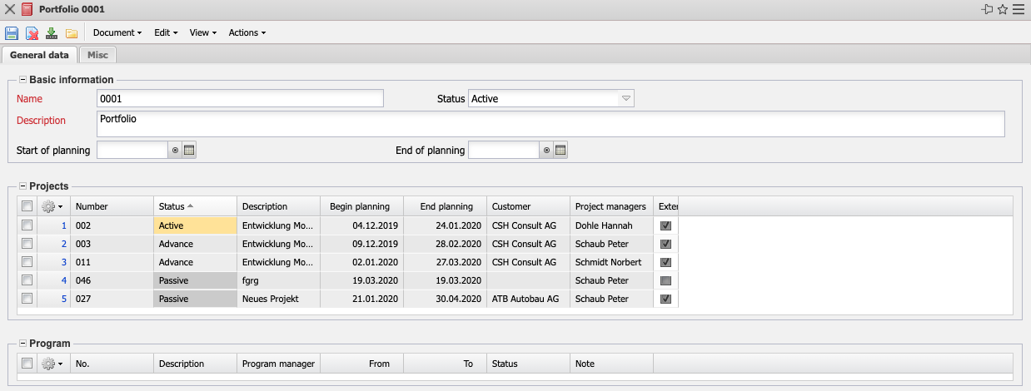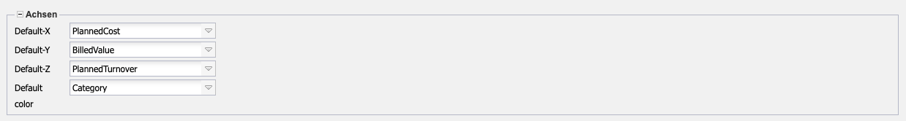
The mask contains the following elements:
- Basic Information:
  - Name: This alphabetical field uniquely identifies the portfolio in the system.
  - Description: These fields identify the portfolio (long text, 255 characters).
  - Start of Planning/End of Planning: The start and end of portfolio management is entered in these fields.
- Projects: In this multiple selection, any number of projects can be combined to form a portfolio.
- Programs: A portfolio can contain one or more programs, which can be managed here.
- Axes:
  - Default X, Default Y and Default Z: These values allow you to define the standard axes for the portfolio for portfolio evaluation. The key figures for the axes are, for example, planned effort, actual effort, planned costs, actual costs, planned revenues, quotation value, invoiced amount, probability and percentage of completion.
  - Default Color: This value allows you to define the category for the color of the bubbles in the bubble chart (portfolio evaluation). These categories include project category, priority and project status.

Misc
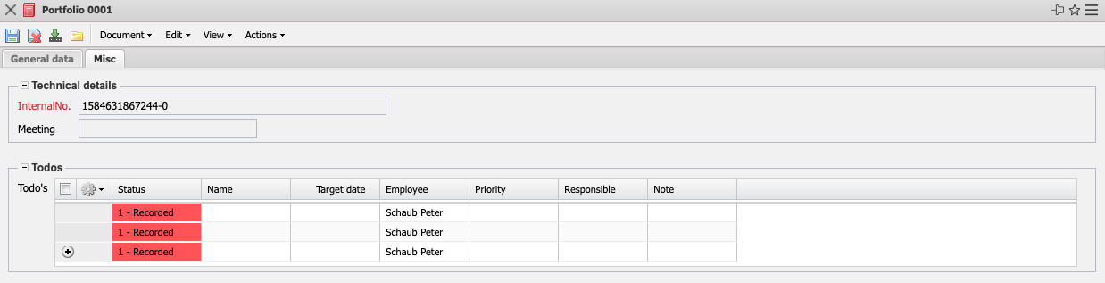
- Technical Details:
  - InternalNo.: This alphanumeric field clearly identifies the portfolio. This number is proposed by the system.
  - Meeting: If there is a meeting related to this portfolio, it is linked here.
- To Do's: The to do's of this portfolio can be entered and are then listed here.
The document class contains the following actions:
- Portfolio Chart: This action directly opens the portfolio chart for the selected portfolio.

